Transmission Timings Report Week - 32
4/08/2025 - 10/08/2025

SBR2 External Vendor Testing Environment (EVTE3)

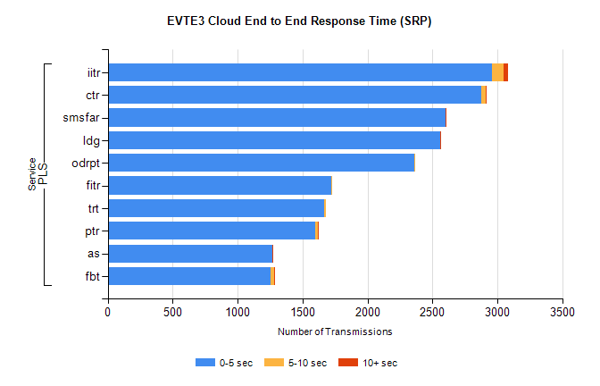
Stream | Service | 0-5 sec | 5-10 sec | >10 sec | Total | % within 5 sec timing target
PLS | iitr | 2962 | 83 | 38 | 3087 | 96.0%
PLS | ctr | 2879 | 35 | 3 | 2920 | 98.6%
PLS | smsfar | 2602 | 0 | 1 | 2603 | 100.0%
PLS | ldg | 2558 | 4 | 5 | 2572 | 99.5%
PLS | odrpt | 2358 | 2 | 0 | 2360 | 99.9%
PLS | fitr | 1720 | 3 | 0 | 1724 | 99.8%
PLS | trt | 1669 | 8 | 0 | 1677 | 99.5%
PLS | ptr | 1601 | 17 | 4 | 1624 | 98.6%
PLS | as | 1267 | 2 | 9 | 1305 | 97.1%
PLS | fbt | 1253 | 31 | 4 | 1290 | 97.1%

SBR2 External Vendor Testing Environment (EVTE3)

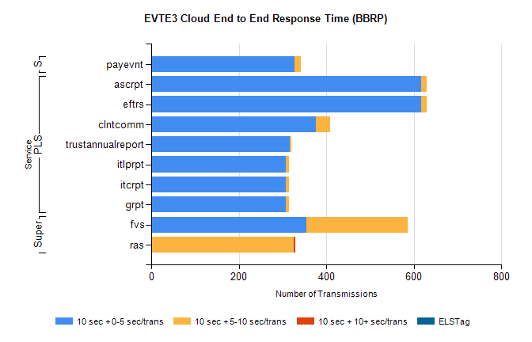
Stream | Service | 10 sec + 0-5 sec /trans | 10 sec + 5-10 sec /trans | 10 sec + >10 sec /trans | Processing Incomplete | ELStag | Total
PLS | eftrs | 616 | 14 | 0 | 0 | 0 | 636
PLS | ascrpt | 616 | 14 | 0 | 0 | 0 | 636
PLS | clntcomm | 376 | 33 | 0 | 21 | 0 | 430
PLS | trustannualreport | 316 | 5 | 0 | 0 | 0 | 321
PLS | grpt | 308 | 7 | 0 | 0 | 0 | 318
PLS | itcrpt | 308 | 7 | 0 | 0 | 0 | 318
PLS | itlprpt | 308 | 7 | 0 | 0 | 0 | 318
Super | fvs | 355 | 231 | 0 | 5 | 0 | 592
Super | ras | 0 | 325 | 5 | 0 | 0 | 336
STP | payevnt | 327 | 14 | 0 | 45 | 0 | 387

SBR2 External Vendor Testing Environment (EVTE3)

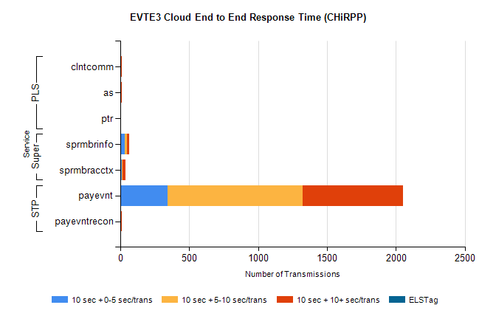
Stream | Service | 10 sec + 0-5 sec /trans | 10 sec + 5-10 sec /trans | 10 sec + >10 sec /trans | Total | % within 5 sec timing target
STP | payevnt | 346 | 976 | 730 | 2945 | 11.8%
STP | payevntrecon | 0 | 4 | 7 | 11 | 0.0%
Super | sprmbrinfo | 32 | 15 | 20 | 78 | 41.0%
Super | sprmbracctx | 10 | 8 | 19 | 46 | 21.7%
PLS | as | 0 | 3 | 10 | 18 | 0.0%
PLS | clntcomm | 0 | 3 | 9 | 18 | 0.0%
PLS | ptr | 0 | 0 | 6 | 6 | 0.0%

