Transmission Timings Report Week - 32
4/08/2025 - 10/08/2025

SBR2 Cloud Production2 - Single | Bulk or Batch Requests | (SRP, BBRP & CHiRPP)

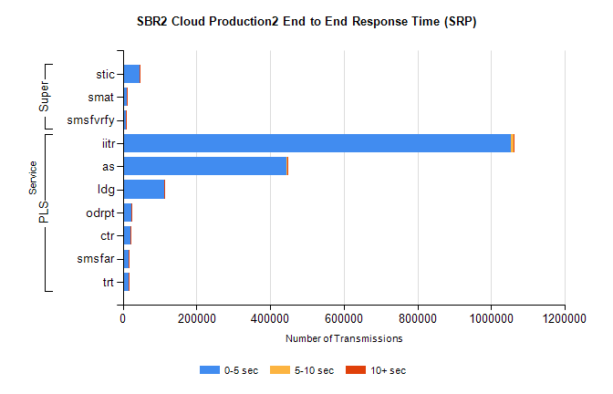
Stream | Service | 0-5 sec | 5-10 sec | >10 sec | Total | % within 5 sec timing target
PLS | iitr | 1053318 | 8680 | 2143 | 1064141 | 99.0%
PLS | as | 443916 | 1925 | 549 | 446390 | 99.4%
PLS | ldg | 112222 | 355 | 80 | 112657 | 99.6%
PLS | odrpt | 22266 | 1571 | 708 | 24545 | 90.7%
PLS | ctr | 20878 | 94 | 26 | 20998 | 99.4%
PLS | smsfar | 15191 | 47 | 28 | 15266 | 99.5%
PLS | trt | 14673 | 65 | 29 | 14767 | 99.4%
Super | stic | 45668 | 297 | 90 | 46055 | 99.2%
Super | smat | 11003 | 215 | 66 | 11284 | 97.5%
Super | smsfvrfy | 7209 | 71 | 50 | 7330 | 98.3%

SBR2 Cloud Production2 - Single | Bulk or Batch Requests | (SRP, BBRP & CHiRPP)

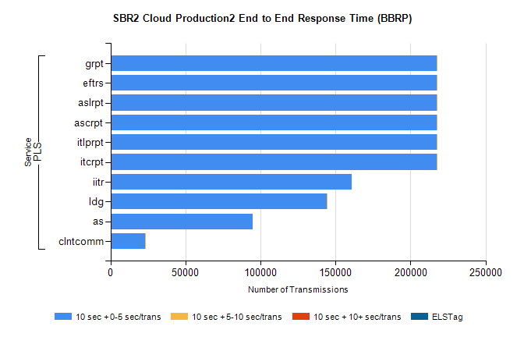
Stream | Service | 10 sec + 0-5 sec /trans | 10 sec + 5-10 sec /trans | 10 sec + >10 sec /trans | Processing Incomplete | ELStag | Total
PLS | itcrpt | 217212 | 1 | 0 | 0 | 0 | 217215
PLS | itlprpt | 217212 | 1 | 0 | 0 | 0 | 217215
PLS | ascrpt | 217212 | 1 | 0 | 0 | 0 | 217215
PLS | aslrpt | 217212 | 1 | 0 | 0 | 0 | 217215
PLS | eftrs | 217212 | 1 | 0 | 0 | 0 | 217215
PLS | grpt | 217212 | 1 | 0 | 0 | 0 | 217215
PLS | iitr | 160955 | 0 | 0 | 0 | 0 | 160955
PLS | ldg | 144202 | 3 | 0 | 0 | 0 | 144205
PLS | as | 94716 | 0 | 0 | 0 | 0 | 94716
PLS | clntcomm | 23011 | 1 | 0 | 0 | 0 | 23012

SBR2 Cloud Production2 - Single | Bulk or Batch Requests | (SRP, BBRP & CHiRPP)

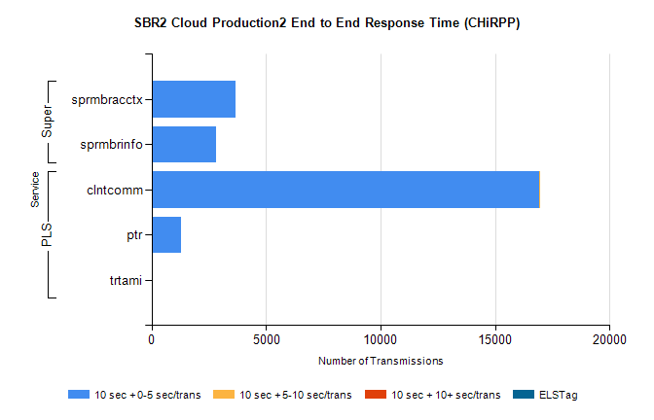
Stream | Service | 10 sec + 0-5 sec /trans | 10 sec + 5-10 sec /trans | 10 sec + >10 sec /trans | Total | % within 5 sec timing target
PLS | clntcomm | 16915 | 1 | 0 | 16917 | 100.0%
PLS | ptr | 1296 | 0 | 0 | 1296 | 100.0%
PLS | trtami | 28 | 0 | 0 | 28 | 100.0%
Super | sprmbracctx | 3659 | 0 | 0 | 3659 | 100.0%
Super | sprmbrinfo | 2795 | 0 | 0 | 2795 | 100.0%

SBR1 Production Transactions

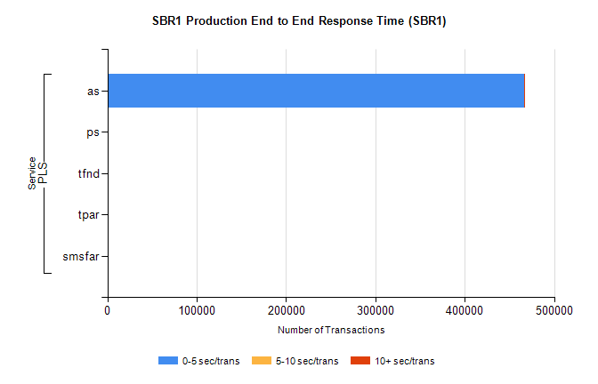
Stream | Service | 0-5 sec/trans | 5-10 sec/trans | 10+ sec/trans | Total | % within 5 sec timing target
PLS | as | 466012 | 137 | 825 | 466974 | 99.8%
PLS | ps | 249 | 164 | 290 | 703 | 35.4%
PLS | tfnd | 312 | 39 | 11 | 362 | 86.2%
PLS | tpar | 31 |  |  | 31 | 100.0%
PLS | smsfar | 2 | 19 | 1 | 22 | 9.1%

