Transmission Timings Report Week - 33
11/08/2025 - 17/08/2025

SBR2 External Vendor Testing Environment (EVTE3)

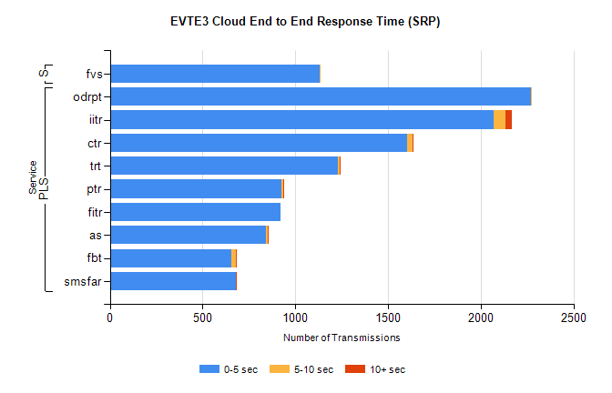
Stream | Service | 0-5 sec | 5-10 sec | >10 sec | Total | % within 5 sec timing target
PLS | odrpt | 2270 | 1 | 0 | 2272 | 99.9%
PLS | iitr | 2067 | 68 | 34 | 2219 | 93.2%
PLS | ctr | 1604 | 27 | 7 | 1664 | 96.4%
PLS | trt | 1230 | 10 | 3 | 1244 | 98.9%
PLS | ptr | 927 | 10 | 1 | 948 | 97.8%
PLS | fitr | 921 | 0 | 0 | 926 | 99.5%
PLS | as | 844 | 7 | 7 | 902 | 93.6%
PLS | fbt | 656 | 25 | 1 | 684 | 95.9%
PLS | smsfar | 678 | 0 | 1 | 679 | 99.9%
Super | fvs | 1132 | 3 | 0 | 1135 | 99.7%

SBR2 External Vendor Testing Environment (EVTE3)

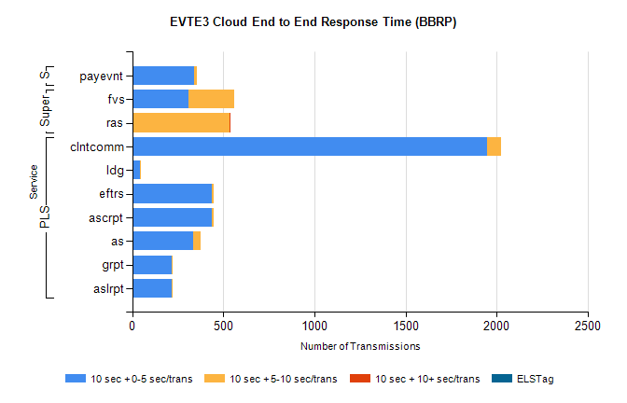
Stream | Service | 10 sec + 0-5 sec /trans | 10 sec + 5-10 sec /trans | 10 sec + >10 sec /trans | Processing Incomplete | ELStag | Total
PLS | clntcomm | 1948 | 79 | 0 | 51 | 0 | 2078
PLS | ldg | 41 | 4 | 0 | 547 | 0 | 594
PLS | ascrpt | 438 | 10 | 0 | 0 | 0 | 448
PLS | eftrs | 438 | 10 | 0 | 0 | 0 | 448
PLS | as | 334 | 40 | 0 | 2 | 0 | 377
PLS | aslrpt | 219 | 5 | 0 | 0 | 0 | 224
PLS | grpt | 219 | 5 | 0 | 0 | 0 | 224
Super | fvs | 311 | 247 | 0 | 12 | 0 | 572
Super | ras | 0 | 532 | 5 | 0 | 0 | 547
STP | payevnt | 341 | 16 | 0 | 32 | 0 | 390

SBR2 External Vendor Testing Environment (EVTE3)

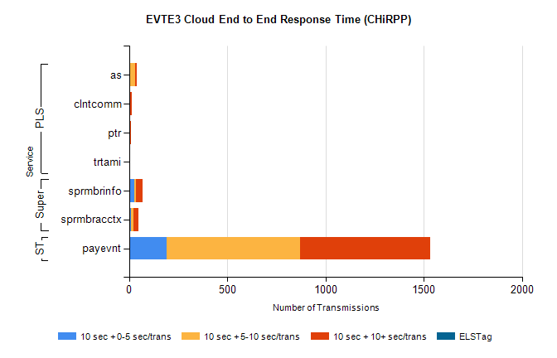
Stream | Service | 10 sec + 0-5 sec /trans | 10 sec + 5-10 sec /trans | 10 sec + >10 sec /trans | Total | % within 5 sec timing target
STP | payevnt | 192 | 677 | 663 | 2326 | 8.3%
Super | sprmbrinfo | 28 | 7 | 35 | 74 | 37.8%
Super | sprmbracctx | 11 | 13 | 25 | 62 | 17.7%
PLS | as | 0 | 31 | 9 | 44 | 0.0%
PLS | clntcomm | 0 | 0 | 14 | 14 | 0.0%
PLS | ptr | 0 | 0 | 8 | 8 | 0.0%
PLS | trtami | 0 | 0 | 6 | 6 | 0.0%

