Transmission Timings Report Week - 33
11/08/2025 - 17/08/2025

SBR2 Cloud Production2 - Single | Bulk or Batch Requests | (SRP, BBRP & CHiRPP)

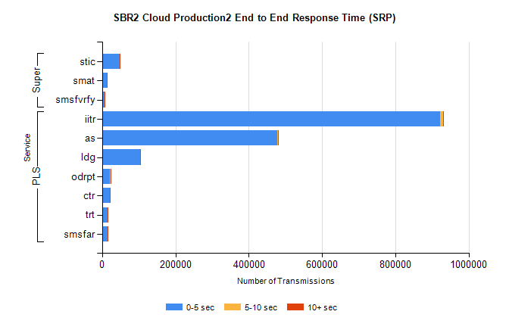
Stream | Service | 0-5 sec | 5-10 sec | >10 sec | Total | % within 5 sec timing target
PLS | iitr | 921225 | 9022 | 1828 | 932075 | 98.8%
PLS | as | 477043 | 2745 | 571 | 480359 | 99.3%
PLS | ldg | 104105 | 480 | 60 | 104645 | 99.5%
PLS | odrpt | 21950 | 1699 | 780 | 24429 | 89.9%
PLS | ctr | 22259 | 108 | 19 | 22386 | 99.4%
PLS | trt | 15045 | 80 | 28 | 15153 | 99.3%
PLS | smsfar | 14972 | 88 | 16 | 15076 | 99.3%
Super | stic | 47589 | 459 | 106 | 48154 | 98.8%
Super | smat | 12805 | 275 | 64 | 13144 | 97.4%
Super | smsfvrfy | 6987 | 83 | 34 | 7104 | 98.4%

SBR2 Cloud Production2 - Single | Bulk or Batch Requests | (SRP, BBRP & CHiRPP)

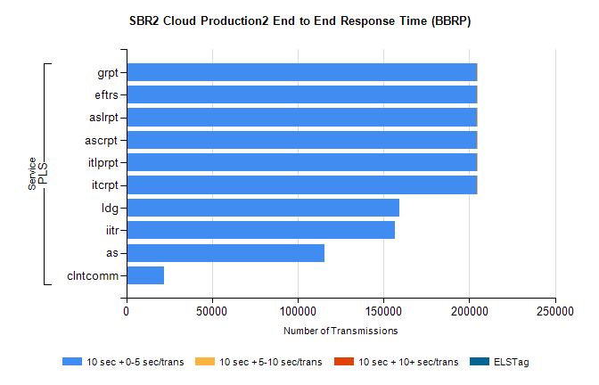
Stream | Service | 10 sec + 0-5 sec /trans | 10 sec + 5-10 sec /trans | 10 sec + >10 sec /trans | Processing Incomplete | ELStag | Total
PLS | itcrpt | 204272 | 2 | 0 | 0 | 0 | 204278
PLS | itlprpt | 204272 | 2 | 0 | 0 | 0 | 204278
PLS | ascrpt | 204272 | 2 | 0 | 0 | 0 | 204278
PLS | aslrpt | 204272 | 2 | 0 | 0 | 0 | 204278
PLS | eftrs | 204272 | 2 | 0 | 0 | 0 | 204278
PLS | grpt | 204272 | 2 | 0 | 0 | 0 | 204278
PLS | ldg | 159347 | 0 | 0 | 0 | 0 | 159347
PLS | iitr | 156756 | 0 | 0 | 0 | 0 | 156756
PLS | as | 115361 | 0 | 0 | 0 | 0 | 115361
PLS | clntcomm | 22148 | 0 | 0 | 0 | 0 | 22148

SBR2 Cloud Production2 - Single | Bulk or Batch Requests | (SRP, BBRP & CHiRPP)

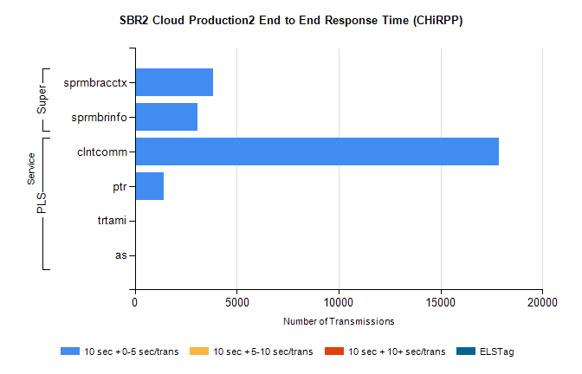
Stream | Service | 10 sec + 0-5 sec /trans | 10 sec + 5-10 sec /trans | 10 sec + >10 sec /trans | Total | % within 5 sec timing target
PLS | clntcomm | 17856 | 0 | 0 | 17856 | 100.0%
PLS | ptr | 1429 | 0 | 0 | 1429 | 100.0%
PLS | trtami | 30 | 0 | 0 | 30 | 100.0%
PLS | as | 8 | 0 | 0 | 8 | 100.0%
Super | sprmbracctx | 3847 | 0 | 0 | 3847 | 100.0%
Super | sprmbrinfo | 3078 | 0 | 0 | 3078 | 100.0%

SBR1 Production Transactions

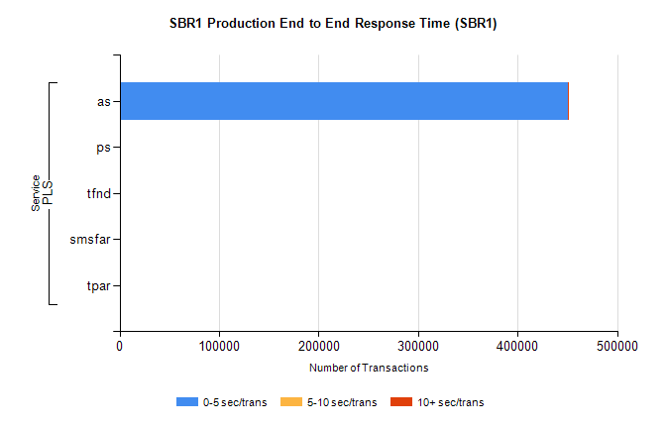
Stream | Service | 0-5 sec/trans | 5-10 sec/trans | 10+ sec/trans | Total | % within 5 sec timing target
PLS | as | 450301 | 230 | 198 | 450729 | 99.9%
PLS | ps | 186 | 134 | 317 | 637 | 29.2%
PLS | tfnd | 266 | 54 | 10 | 330 | 80.6%
PLS | smsfar | 11 | 18 | 1 | 30 | 36.7%
PLS | tpar | 10 |  |  | 10 | 100.0%

