Transmission Timings Report Week - 34
18/08/2025 - 24/08/2025

SBR2 External Vendor Testing Environment (EVTE3)

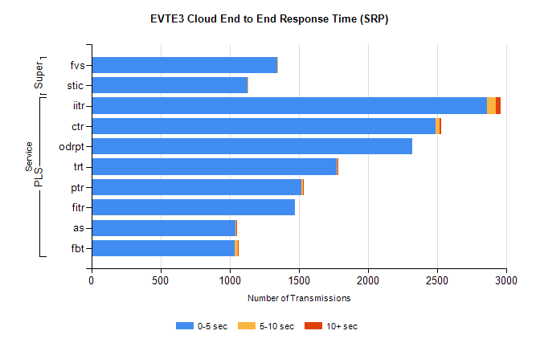
Stream | Service | 0-5 sec | 5-10 sec | >10 sec | Total | % within 5 sec timing target
PLS | iitr | 2862 | 64 | 37 | 3192 | 89.7%
PLS | ctr | 2488 | 33 | 7 | 2617 | 95.1%
PLS | odrpt | 2319 | 0 | 0 | 2321 | 99.9%
PLS | trt | 1775 | 7 | 6 | 1805 | 98.3%
PLS | ptr | 1518 | 11 | 2 | 1569 | 96.7%
PLS | fitr | 1473 | 0 | 0 | 1494 | 98.6%
PLS | as | 1042 | 7 | 3 | 1150 | 90.6%
PLS | fbt | 1035 | 28 | 1 | 1073 | 96.5%
Super | fvs | 1345 | 1 | 0 | 1346 | 99.9%
Super | stic | 1129 | 1 | 0 | 1131 | 99.8%

SBR2 External Vendor Testing Environment (EVTE3)

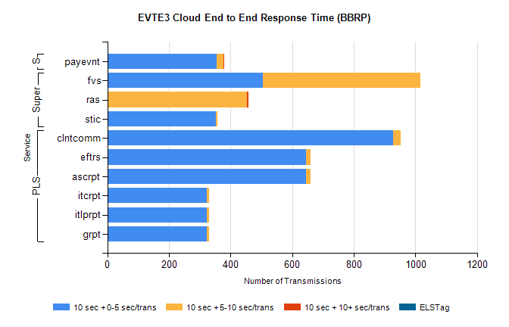
Stream | Service | 10 sec + 0-5 sec /trans | 10 sec + 5-10 sec /trans | 10 sec + >10 sec /trans | Processing Incomplete | ELStag | Total
PLS | clntcomm | 928 | 24 | 0 | 0 | 0 | 958
PLS | ascrpt | 646 | 14 | 0 | 8 | 0 | 668
PLS | eftrs | 646 | 14 | 0 | 8 | 0 | 668
PLS | grpt | 323 | 7 | 0 | 4 | 0 | 334
PLS | itlprpt | 323 | 7 | 0 | 4 | 0 | 334
PLS | itcrpt | 323 | 7 | 0 | 4 | 0 | 334
Super | fvs | 505 | 512 | 0 | 5 | 0 | 1023
Super | ras | 0 | 452 | 5 | 0 | 0 | 466
Super | stic | 352 | 5 | 0 | 8 | 0 | 366
STP | payevnt | 354 | 22 | 1 | 26 | 0 | 404

SBR2 External Vendor Testing Environment (EVTE3)

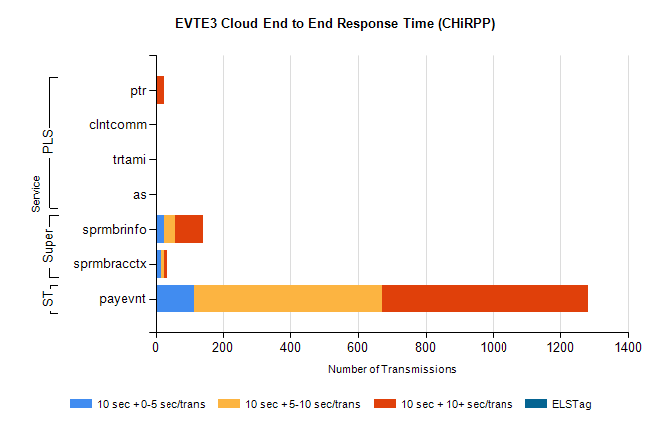
Stream | Service | 10 sec + 0-5 sec /trans | 10 sec + 5-10 sec /trans | 10 sec + >10 sec /trans | Total | % within 5 sec timing target
STP | payevnt | 115 | 556 | 613 | 1937 | 5.9%
Super | sprmbrinfo | 24 | 35 | 82 | 180 | 13.3%
Super | sprmbracctx | 14 | 10 | 8 | 41 | 34.1%
PLS | ptr | 2 | 2 | 19 | 24 | 8.3%
PLS | clntcomm | 1 | 1 | 3 | 5 | 20.0%
PLS | as | 0 | 0 | 4 | 4 | 0.0%
PLS | trtami | 0 | 0 | 4 | 4 | 0.0%

