Transmission Timings Report Week - 34
18/08/2025 - 24/08/2025

SBR2 Cloud Production2 - Single | Bulk or Batch Requests | (SRP, BBRP & CHiRPP)

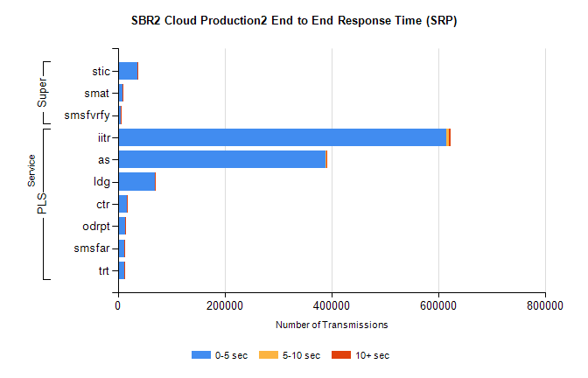
Stream | Service | 0-5 sec | 5-10 sec | >10 sec | Total | % within 5 sec timing target
PLS | iitr | 615217 | 5279 | 2424 | 622920 | 98.8%
PLS | as | 388566 | 1846 | 1854 | 392266 | 99.1%
PLS | ldg | 69889 | 290 | 416 | 70595 | 99.0%
PLS | ctr | 17043 | 66 | 47 | 17156 | 99.3%
PLS | odrpt | 12860 | 1205 | 1353 | 15418 | 83.4%
PLS | smsfar | 12620 | 55 | 42 | 12717 | 99.2%
PLS | trt | 11249 | 55 | 30 | 11334 | 99.3%
Super | stic | 36581 | 330 | 174 | 37085 | 98.6%
Super | smat | 8921 | 156 | 61 | 9138 | 97.6%
Super | smsfvrfy | 5408 | 63 | 63 | 5534 | 97.7%

SBR2 Cloud Production2 - Single | Bulk or Batch Requests | (SRP, BBRP & CHiRPP)

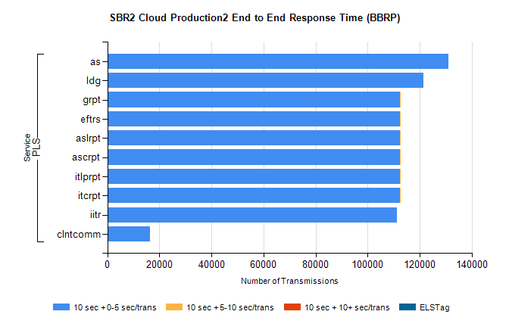
Stream | Service | 10 sec + 0-5 sec /trans | 10 sec + 5-10 sec /trans | 10 sec + >10 sec /trans | Processing Incomplete | ELStag | Total
PLS | as | 131163 | 0 | 0 | 0 | 0 | 131163
PLS | ldg | 121534 | 0 | 0 | 0 | 0 | 121534
PLS | itcrpt | 112312 | 2 | 0 | 0 | 0 | 112322
PLS | itlprpt | 112312 | 2 | 0 | 0 | 0 | 112322
PLS | ascrpt | 112312 | 2 | 0 | 0 | 0 | 112322
PLS | aslrpt | 112312 | 2 | 0 | 0 | 0 | 112322
PLS | eftrs | 112312 | 2 | 0 | 0 | 0 | 112322
PLS | grpt | 112312 | 2 | 0 | 0 | 0 | 112322
PLS | iitr | 111155 | 0 | 0 | 0 | 0 | 111155
PLS | clntcomm | 16505 | 0 | 0 | 0 | 0 | 16505

SBR2 Cloud Production2 - Single | Bulk or Batch Requests | (SRP, BBRP & CHiRPP)

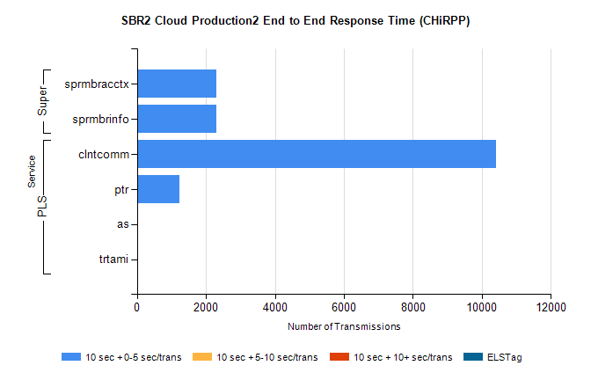
Stream | Service | 10 sec + 0-5 sec /trans | 10 sec + 5-10 sec /trans | 10 sec + >10 sec /trans | Total | % within 5 sec timing target
PLS | clntcomm | 10407 | 0 | 0 | 10407 | 100.0%
PLS | ptr | 1230 | 0 | 0 | 1230 | 100.0%
PLS | trtami | 1 | 0 | 0 | 1 | 100.0%
PLS | as | 1 | 0 | 0 | 1 | 100.0%
Super | sprmbracctx | 2304 | 0 | 0 | 2304 | 100.0%
Super | sprmbrinfo | 2294 | 0 | 0 | 2294 | 100.0%

SBR1 Production Transactions

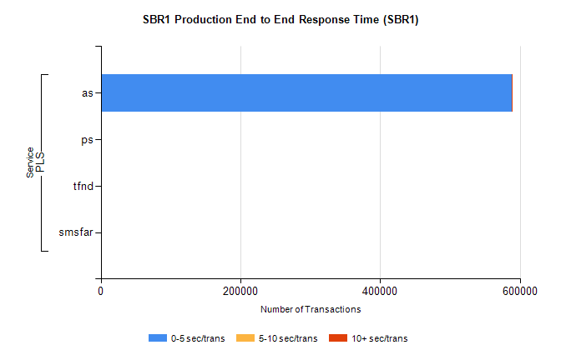
Stream | Service | 0-5 sec/trans | 5-10 sec/trans | 10+ sec/trans | Total | % within 5 sec timing target
PLS | as | 587898 | 238 | 1630 | 589766 | 99.7%
PLS | ps | 133 | 146 | 320 | 599 | 22.2%
PLS | tfnd | 237 | 46 | 9 | 292 | 81.2%
PLS | smsfar | 3 | 14 | 1 | 18 | 16.7%

