Transmission Timings Report Week - 35
25/08/2025 - 31/08/2025

SBR2 External Vendor Testing Environment (EVTE3)

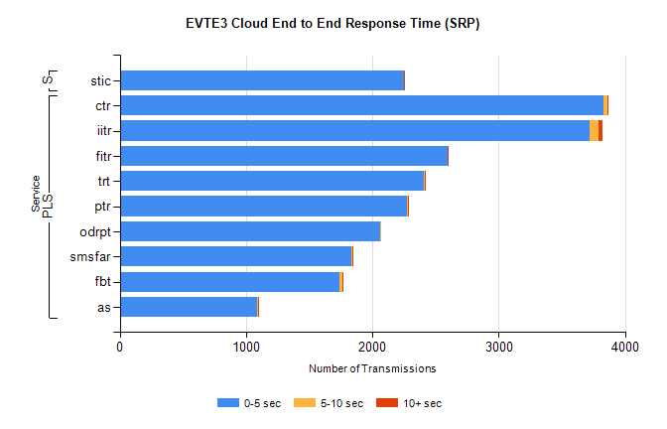
Stream | Service | 0-5 sec | 5-10 sec | >10 sec | Total | % within 5 sec timing target
PLS | ctr | 3831 | 28 | 6 | 3876 | 98.8%
PLS | iitr | 3720 | 71 | 33 | 3829 | 97.2%
PLS | fitr | 2595 | 2 | 1 | 2598 | 99.9%
PLS | trt | 2411 | 7 | 1 | 2424 | 99.5%
PLS | ptr | 2276 | 5 | 1 | 2282 | 99.7%
PLS | odrpt | 2059 | 6 | 0 | 2065 | 99.7%
PLS | smsfar | 1835 | 3 | 1 | 1839 | 99.8%
PLS | fbt | 1739 | 27 | 1 | 1779 | 97.8%
PLS | as | 1087 | 8 | 4 | 1216 | 89.4%
Super | stic | 2248 | 0 | 1 | 2249 | 100.0%

SBR2 External Vendor Testing Environment (EVTE3)

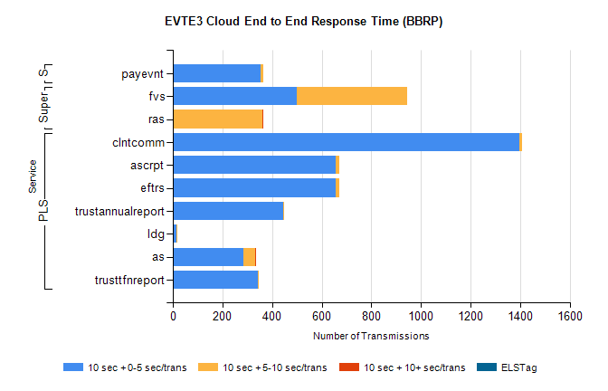
Stream | Service | 10 sec + 0-5 sec /trans | 10 sec + 5-10 sec /trans | 10 sec + >10 sec /trans | Processing Incomplete | ELStag | Total
PLS | clntcomm | 1395 | 14 | 0 | 0 | 0 | 1409
PLS | eftrs | 658 | 14 | 0 | 2 | 0 | 674
PLS | ascrpt | 658 | 14 | 0 | 2 | 0 | 674
PLS | trustannualreport | 445 | 4 | 0 | 0 | 0 | 449
PLS | ldg | 16 | 3 | 0 | 415 | 0 | 434
PLS | as | 286 | 47 | 2 | 35 | 0 | 373
PLS | trusttfnreport | 343 | 3 | 0 | 0 | 0 | 346
Super | fvs | 500 | 444 | 0 | 12 | 0 | 960
Super | ras | 1 | 359 | 4 | 0 | 0 | 366
STP | payevnt | 354 | 10 | 0 | 15 | 0 | 379

SBR2 External Vendor Testing Environment (EVTE3)

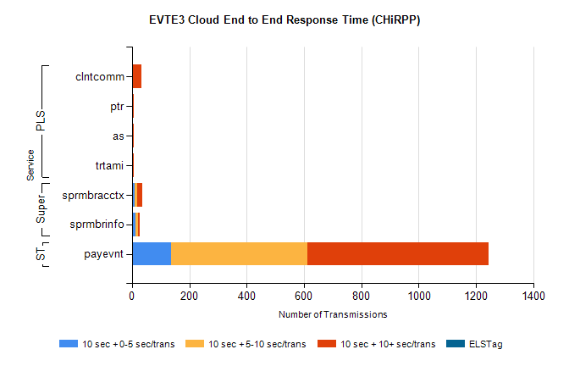
Stream | Service | 10 sec + 0-5 sec /trans | 10 sec + 5-10 sec /trans | 10 sec + >10 sec /trans | Total | % within 5 sec timing target
STP | payevnt | 136 | 476 | 632 | 1916 | 7.1%
Super | sprmbracctx | 10 | 7 | 18 | 47 | 21.3%
Super | sprmbrinfo | 12 | 8 | 7 | 38 | 31.6%
PLS | clntcomm | 0 | 0 | 32 | 39 | 0.0%
PLS | ptr | 0 | 1 | 5 | 7 | 0.0%
PLS | trtami | 0 | 0 | 6 | 6 | 0.0%
PLS | as | 0 | 0 | 6 | 6 | 0.0%

