Transmission Timings Report Week - 35
25/08/2025 - 31/08/2025

SBR2 Cloud Production2 - Single | Bulk or Batch Requests | (SRP, BBRP & CHiRPP)

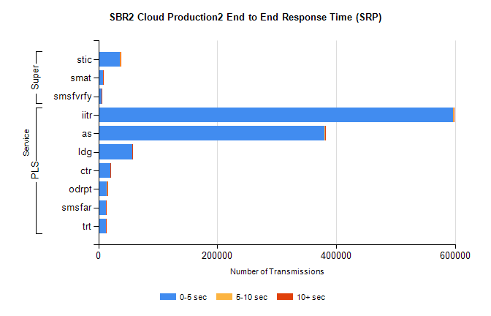
Stream | Service | 0-5 sec | 5-10 sec | >10 sec | Total | % within 5 sec timing target
PLS | iitr | 596803 | 1415 | 333 | 598551 | 99.7%
PLS | as | 380846 | 450 | 142 | 381438 | 99.8%
PLS | ldg | 56800 | 151 | 37 | 56988 | 99.7%
PLS | ctr | 19590 | 19 | 4 | 19613 | 99.9%
PLS | odrpt | 13862 | 927 | 181 | 14970 | 92.6%
PLS | smsfar | 13207 | 12 | 7 | 13226 | 99.9%
PLS | trt | 12925 | 14 | 1 | 12940 | 99.9%
Super | stic | 36666 | 170 | 126 | 36962 | 99.2%
Super | smat | 8211 | 22 | 3 | 8236 | 99.7%
Super | smsfvrfy | 5834 | 18 | 9 | 5861 | 99.5%

SBR2 Cloud Production2 - Single | Bulk or Batch Requests | (SRP, BBRP & CHiRPP)

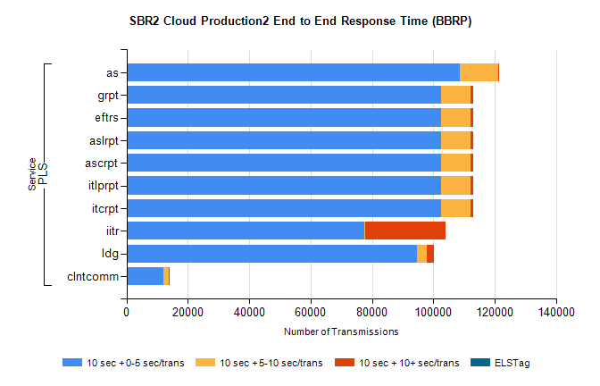
Stream | Service | 10 sec + 0-5 sec /trans | 10 sec + 5-10 sec /trans | 10 sec + >10 sec /trans | Processing Incomplete | ELStag | Total
PLS | as | 108759 | 12279 | 79 | 0 | 0 | 121427
PLS | itcrpt | 102501 | 9659 | 726 | 0 | 0 | 115231
PLS | itlprpt | 102501 | 9659 | 726 | 0 | 0 | 115231
PLS | ascrpt | 102501 | 9659 | 726 | 0 | 0 | 115231
PLS | aslrpt | 102501 | 9659 | 726 | 0 | 0 | 115231
PLS | eftrs | 102501 | 9659 | 726 | 0 | 0 | 115231
PLS | grpt | 102501 | 9659 | 726 | 0 | 0 | 115231
PLS | iitr | 77395 | 396 | 26261 | 0 | 0 | 106199
PLS | ldg | 94733 | 3264 | 2334 | 0 | 0 | 101747
PLS | clntcomm | 12163 | 1603 | 105 | 0 | 0 | 13999

SBR2 Cloud Production2 - Single | Bulk or Batch Requests | (SRP, BBRP & CHiRPP)

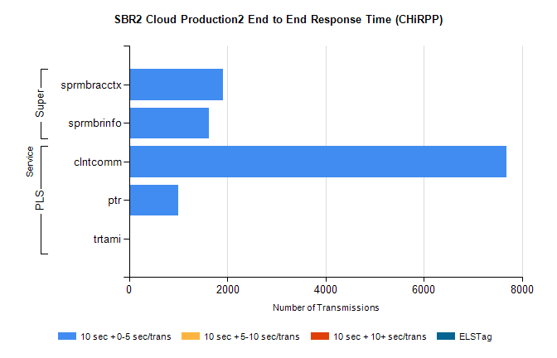
Stream | Service | 10 sec + 0-5 sec /trans | 10 sec + 5-10 sec /trans | 10 sec + >10 sec /trans | Total | % within 5 sec timing target
PLS | clntcomm | 7684 | 0 | 0 | 7684 | 100.0%
PLS | ptr | 997 | 0 | 0 | 997 | 100.0%
PLS | trtami | 21 | 0 | 0 | 21 | 100.0%
Super | sprmbracctx | 1912 | 0 | 0 | 1912 | 100.0%
Super | sprmbrinfo | 1624 | 0 | 0 | 1624 | 100.0%

SBR1 Production Transactions

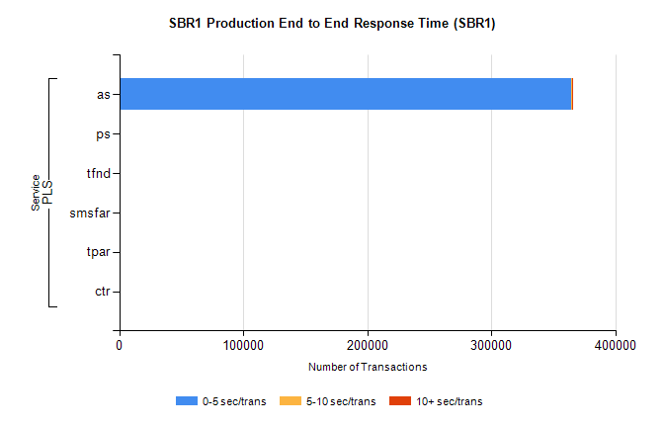
Stream | Service | 0-5 sec/trans | 5-10 sec/trans | 10+ sec/trans | Total | % within 5 sec timing target
PLS | as | 364481 | 576 | 193 | 365250 | 99.8%
PLS | ps | 109 | 127 | 252 | 488 | 22.3%
PLS | tfnd | 149 | 61 | 1 | 211 | 70.6%
PLS | smsfar | 12 | 21 |  | 33 | 36.4%
PLS | tpar | 10 |  |  | 10 | 100.0%
PLS | ctr |  |  | 1 | 1 | 0.0%

