Transmission Timings Report Week - 36
1/09/2025 - 7/09/2025

SBR2 External Vendor Testing Environment (EVTE3)

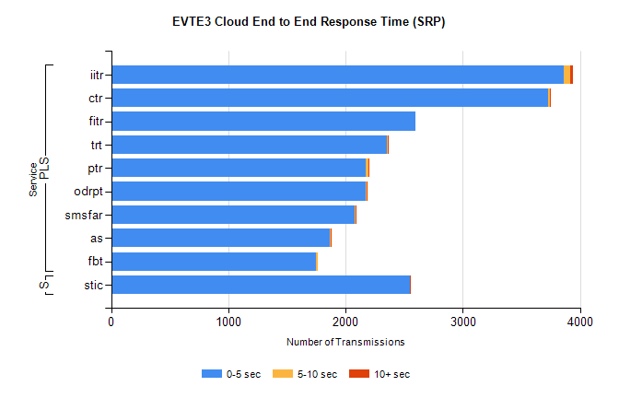
Stream | Service | 0-5 sec | 5-10 sec | >10 sec | Total | % within 5 sec timing target
PLS | iitr | 3859 | 59 | 22 | 3946 | 97.8%
PLS | ctr | 3727 | 19 | 1 | 3831 | 97.3%
PLS | fitr | 2599 | 0 | 0 | 2633 | 98.7%
PLS | trt | 2354 | 5 | 1 | 2398 | 98.2%
PLS | ptr | 2175 | 18 | 1 | 2220 | 98.0%
PLS | odrpt | 2174 | 6 | 3 | 2184 | 99.5%
PLS | smsfar | 2081 | 2 | 2 | 2085 | 99.8%
PLS | as | 1865 | 11 | 5 | 2028 | 92.0%
PLS | fbt | 1750 | 14 | 0 | 1867 | 93.7%
Super | stic | 2550 | 1 | 1 | 2552 | 99.9%

SBR2 External Vendor Testing Environment (EVTE3)

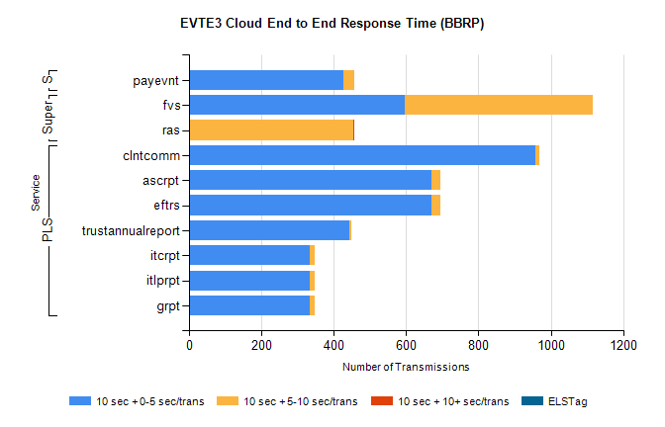
Stream | Service | 10 sec + 0-5 sec /trans | 10 sec + 5-10 sec /trans | 10 sec + >10 sec /trans | Processing Incomplete | ELStag | Total
PLS | clntcomm | 956 | 11 | 0 | 61 | 0 | 1028
PLS | eftrs | 670 | 24 | 0 | 2 | 0 | 696
PLS | ascrpt | 670 | 24 | 0 | 2 | 0 | 696
PLS | trustannualreport | 444 | 5 | 0 | 0 | 0 | 449
PLS | grpt | 335 | 12 | 0 | 1 | 0 | 348
PLS | itlprpt | 335 | 12 | 0 | 1 | 0 | 348
PLS | itcrpt | 335 | 12 | 0 | 1 | 0 | 348
Super | fvs | 596 | 520 | 0 | 11 | 0 | 1130
Super | ras | 3 | 450 | 3 | 0 | 0 | 468
STP | payevnt | 426 | 32 | 0 | 35 | 0 | 494

SBR2 External Vendor Testing Environment (EVTE3)

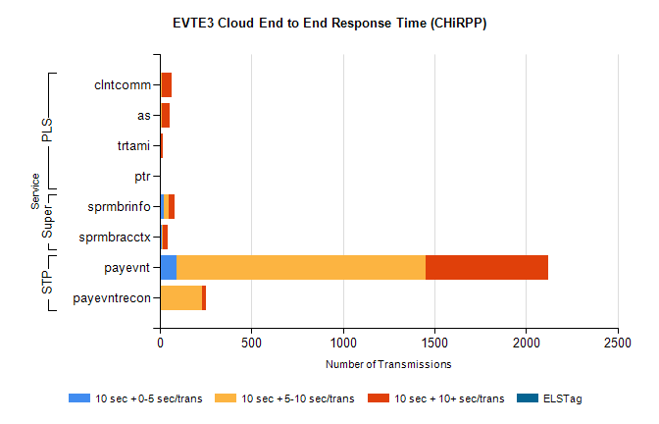
Stream | Service | 10 sec + 0-5 sec /trans | 10 sec + 5-10 sec /trans | 10 sec + >10 sec /trans | Total | % within 5 sec timing target
STP | payevnt | 94 | 1359 | 666 | 2733 | 3.4%
STP | payevntrecon | 0 | 231 | 19 | 262 | 0.0%
PLS | clntcomm | 5 | 7 | 54 | 97 | 5.2%
PLS | as | 5 | 6 | 41 | 58 | 8.6%
PLS | trtami | 0 | 6 | 12 | 18 | 0.0%
PLS | ptr | 0 | 0 | 3 | 3 | 0.0%
Super | sprmbrinfo | 23 | 26 | 30 | 106 | 21.7%
Super | sprmbracctx | 13 | 6 | 26 | 52 | 25.0%

