Transmission Timings Report Week - 36
1/09/2025 - 7/09/2025

SBR2 Cloud Production2 - Single | Bulk or Batch Requests | (SRP, BBRP & CHiRPP)

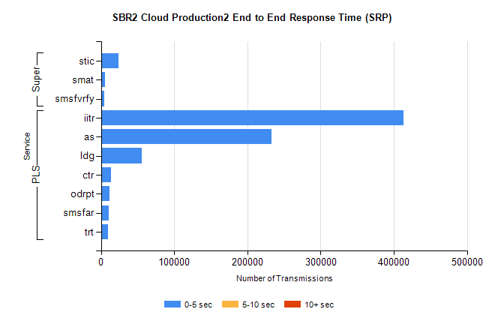
Stream | Service | 0-5 sec | 5-10 sec | >10 sec | Total | % within 5 sec timing target
PLS | iitr | 413503 | 0 | 0 | 413503 | 100.0%
PLS | as | 233066 | 0 | 0 | 233066 | 100.0%
PLS | ldg | 55645 | 0 | 0 | 55645 | 100.0%
PLS | ctr | 14111 | 0 | 0 | 14111 | 100.0%
PLS | odrpt | 11200 | 0 | 0 | 11200 | 100.0%
PLS | smsfar | 10410 | 0 | 0 | 10410 | 100.0%
PLS | trt | 9533 | 0 | 0 | 9533 | 100.0%
Super | stic | 24411 | 0 | 0 | 24411 | 100.0%
Super | smat | 5433 | 0 | 0 | 5433 | 100.0%
Super | smsfvrfy | 4009 | 0 | 0 | 4009 | 100.0%

SBR2 Cloud Production2 - Single | Bulk or Batch Requests | (SRP, BBRP & CHiRPP)

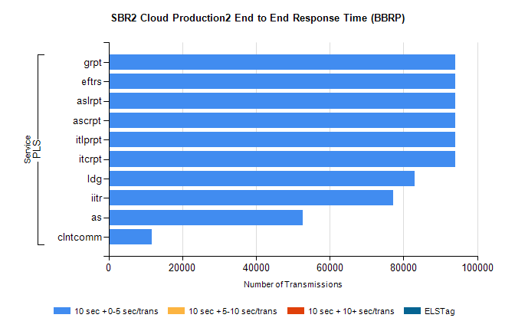
Stream | Service | 10 sec + 0-5 sec /trans | 10 sec + 5-10 sec /trans | 10 sec + >10 sec /trans | Processing Incomplete | ELStag | Total
PLS | itcrpt | 93940 | 0 | 0 | 0 | 0 | 93940
PLS | itlprpt | 93940 | 0 | 0 | 0 | 0 | 93940
PLS | ascrpt | 93940 | 0 | 0 | 0 | 0 | 93940
PLS | aslrpt | 93940 | 0 | 0 | 0 | 0 | 93940
PLS | eftrs | 93940 | 0 | 0 | 0 | 0 | 93940
PLS | grpt | 93940 | 0 | 0 | 0 | 0 | 93940
PLS | ldg | 82946 | 0 | 0 | 0 | 0 | 82946
PLS | iitr | 77291 | 0 | 0 | 0 | 0 | 77291
PLS | as | 52751 | 0 | 0 | 0 | 0 | 52751
PLS | clntcomm | 11634 | 0 | 0 | 0 | 0 | 11634

SBR2 Cloud Production2 - Single | Bulk or Batch Requests | (SRP, BBRP & CHiRPP)

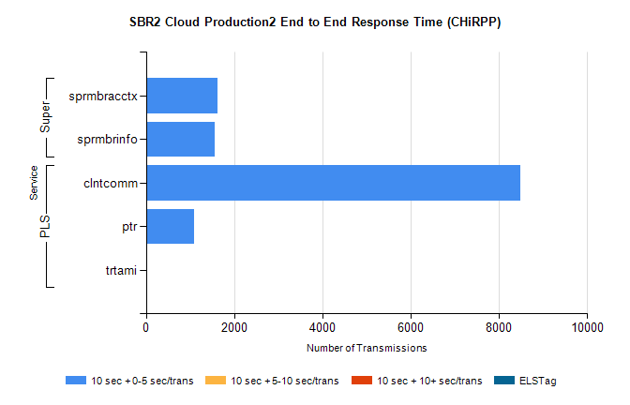
Stream | Service | 10 sec + 0-5 sec /trans | 10 sec + 5-10 sec /trans | 10 sec + >10 sec /trans | Total | % within 5 sec timing target
PLS | clntcomm | 8476 | 0 | 0 | 8476 | 100.0%
PLS | ptr | 1087 | 0 | 0 | 1087 | 100.0%
PLS | trtami | 27 | 0 | 0 | 27 | 100.0%
Super | sprmbracctx | 1628 | 0 | 0 | 1628 | 100.0%
Super | sprmbrinfo | 1560 | 0 | 0 | 1560 | 100.0%

SBR1 Production Transactions

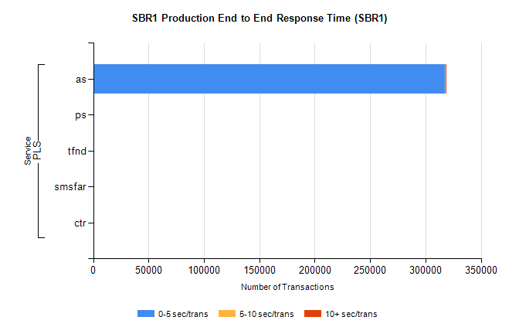
Stream | Service | 0-5 sec/trans | 5-10 sec/trans | 10+ sec/trans | Total | % within 5 sec timing target
PLS | as | 317660 | 190 | 851 | 318701 | 99.7%
PLS | ps | 71 | 87 | 180 | 338 | 21.0%
PLS | tfnd | 143 | 48 | 2 | 193 | 74.1%
PLS | smsfar | 1 | 21 | 1 | 23 | 4.3%
PLS | ctr |  |  | 1 | 1 | 0.0%

