Transmission Timings Report Week - 37
8/09/2025 - 14/09/2025

SBR2 External Vendor Testing Environment (EVTE3)

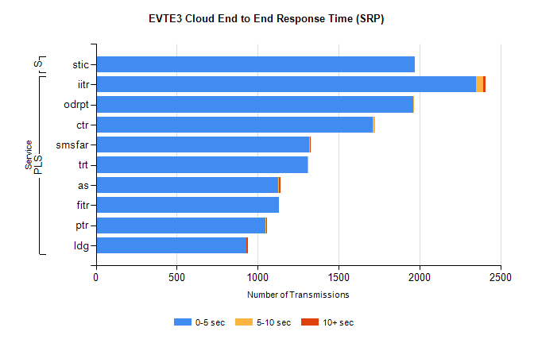
Stream | Service | 0-5 sec | 5-10 sec | >10 sec | Total | % within 5 sec timing target
PLS | iitr | 2348 | 43 | 19 | 2424 | 96.9%
PLS | odrpt | 1961 | 5 | 0 | 1966 | 99.7%
PLS | ctr | 1710 | 17 | 0 | 1735 | 98.6%
PLS | smsfar | 1318 | 3 | 2 | 1323 | 99.6%
PLS | trt | 1306 | 4 | 0 | 1310 | 99.7%
PLS | as | 1125 | 8 | 6 | 1159 | 97.1%
PLS | fitr | 1133 | 0 | 0 | 1134 | 99.9%
PLS | ptr | 1050 | 4 | 1 | 1055 | 99.5%
PLS | ldg | 930 | 1 | 7 | 961 | 96.8%
Super | stic | 1973 | 0 | 0 | 1973 | 100.0%

SBR2 External Vendor Testing Environment (EVTE3)

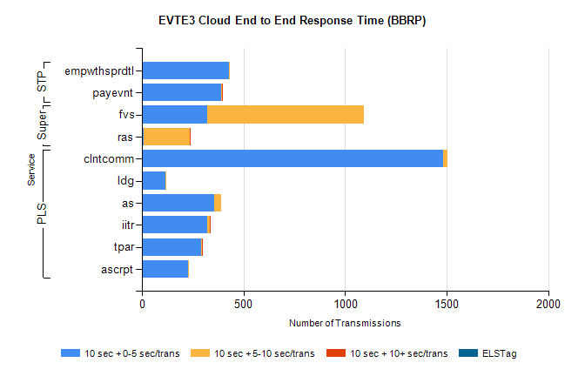
Stream | Service | 10 sec + 0-5 sec /trans | 10 sec + 5-10 sec /trans | 10 sec + >10 sec /trans | Processing Incomplete | ELStag | Total
PLS | clntcomm | 1482 | 24 | 0 | 36 | 0 | 1543
PLS | ldg | 115 | 2 | 0 | 376 | 0 | 493
PLS | as | 358 | 34 | 0 | 0 | 0 | 392
PLS | iitr | 320 | 14 | 1 | 0 | 0 | 341
PLS | tpar | 294 | 4 | 1 | 0 | 0 | 304
PLS | ascrpt | 228 | 4 | 0 | 0 | 0 | 232
Super | fvs | 320 | 775 | 0 | 4 | 0 | 1116
Super | ras | 8 | 227 | 3 | 0 | 0 | 261
STP | empwthsprdtl | 431 | 3 | 0 | 0 | 0 | 436
STP | payevnt | 390 | 5 | 2 | 37 | 0 | 434

SBR2 External Vendor Testing Environment (EVTE3)

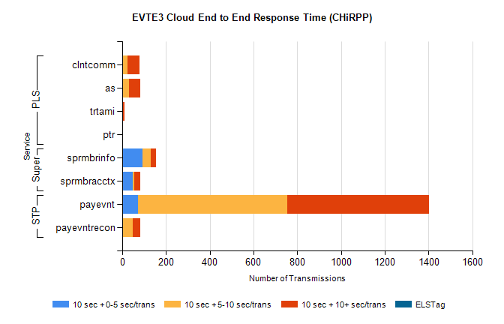
Stream | Service | 10 sec + 0-5 sec /trans | 10 sec + 5-10 sec /trans | 10 sec + >10 sec /trans | Total | % within 5 sec timing target
STP | payevnt | 72 | 681 | 650 | 1914 | 3.8%
STP | payevntrecon | 0 | 50 | 34 | 92 | 0.0%
Super | sprmbrinfo | 94 | 37 | 24 | 167 | 56.3%
Super | sprmbracctx | 49 | 8 | 27 | 91 | 53.8%
PLS | clntcomm | 0 | 25 | 54 | 119 | 0.0%
PLS | as | 0 | 30 | 52 | 96 | 0.0%
PLS | trtami | 0 | 3 | 9 | 12 | 0.0%
PLS | ptr | 0 | 0 | 3 | 3 | 0.0%

