Transmission Timings Report Week - 37
8/09/2025 - 14/09/2025

SBR2 Cloud Production2 - Single | Bulk or Batch Requests | (SRP, BBRP & CHiRPP)

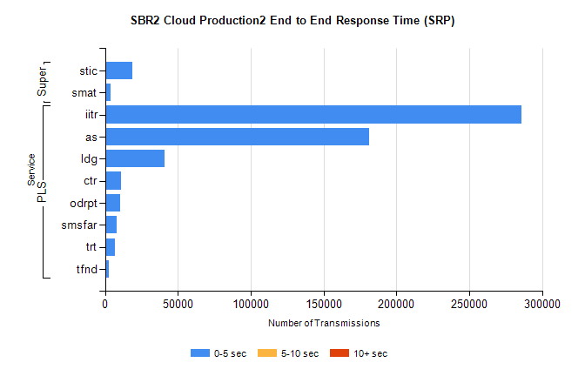
Stream | Service | 0-5 sec | 5-10 sec | >10 sec | Total | % within 5 sec timing target
PLS | iitr | 285662 | 0 | 0 | 285662 | 100.0%
PLS | as | 181371 | 0 | 0 | 181371 | 100.0%
PLS | ldg | 40859 | 0 | 0 | 40859 | 100.0%
PLS | ctr | 10750 | 0 | 0 | 10750 | 100.0%
PLS | odrpt | 10678 | 0 | 0 | 10678 | 100.0%
PLS | smsfar | 7843 | 0 | 0 | 7843 | 100.0%
PLS | trt | 6948 | 0 | 0 | 6948 | 100.0%
PLS | tfnd | 2773 | 0 | 0 | 2773 | 100.0%
Super | stic | 19019 | 0 | 0 | 19019 | 100.0%
Super | smat | 4039 | 0 | 0 | 4039 | 100.0%

SBR2 Cloud Production2 - Single | Bulk or Batch Requests | (SRP, BBRP & CHiRPP)

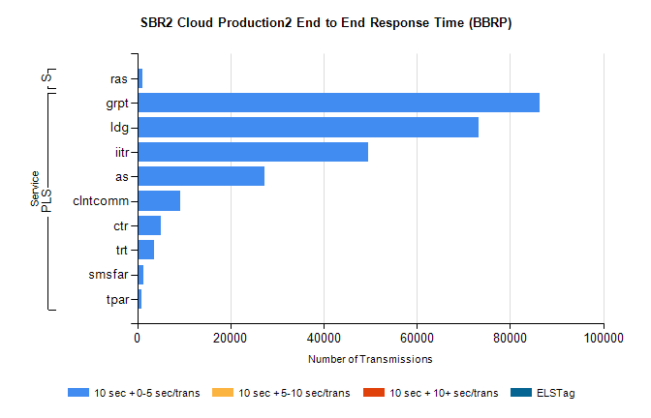
Stream | Service | 10 sec + 0-5 sec /trans | 10 sec + 5-10 sec /trans | 10 sec + >10 sec /trans | Processing Incomplete | ELStag | Total
PLS | grpt | 86256 | 0 | 0 | 0 | 0 | 86256
PLS | ldg | 73170 | 0 | 0 | 0 | 0 | 73170
PLS | iitr | 49488 | 0 | 0 | 0 | 0 | 49488
PLS | as | 27376 | 0 | 0 | 0 | 0 | 27376
PLS | clntcomm | 9234 | 0 | 0 | 0 | 0 | 9234
PLS | ctr | 4950 | 0 | 0 | 0 | 0 | 4950
PLS | trt | 3640 | 0 | 0 | 0 | 0 | 3640
PLS | smsfar | 1242 | 0 | 0 | 0 | 0 | 1242
PLS | tpar | 808 | 0 | 0 | 0 | 0 | 808
Super | ras | 1184 | 0 | 0 | 0 | 0 | 1184

SBR2 Cloud Production2 - Single | Bulk or Batch Requests | (SRP, BBRP & CHiRPP)

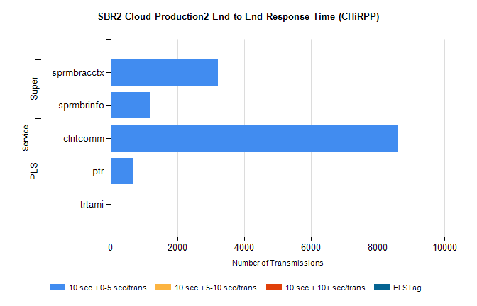
Stream | Service | 10 sec + 0-5 sec /trans | 10 sec + 5-10 sec /trans | 10 sec + >10 sec /trans | Total | % within 5 sec timing target
PLS | clntcomm | 8611 | 0 | 0 | 8611 | 100.0%
PLS | ptr | 694 | 0 | 0 | 694 | 100.0%
PLS | trtami | 32 | 0 | 0 | 32 | 100.0%
Super | sprmbracctx | 3206 | 0 | 0 | 3206 | 100.0%
Super | sprmbrinfo | 1169 | 0 | 0 | 1169 | 100.0%

SBR1 Production Transactions

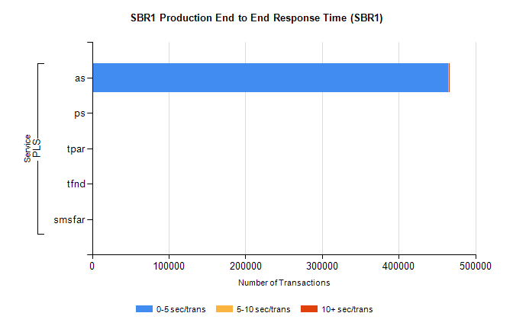
Stream | Service | 0-5 sec/trans | 5-10 sec/trans | 10+ sec/trans | Total | % within 5 sec timing target
PLS | as | 464922 | 263 | 830 | 466015 | 99.8%
PLS | ps | 52 | 102 | 178 | 332 | 15.7%
PLS | tpar | 317 |  |  | 317 | 100.0%
PLS | tfnd | 192 | 46 | 2 | 240 | 80.0%
PLS | smsfar |  | 11 | 2 | 13 | 0.0%

