Transmission Timings Report Week - 38
15/09/2025 - 21/09/2025

SBR2 External Vendor Testing Environment (EVTE3)

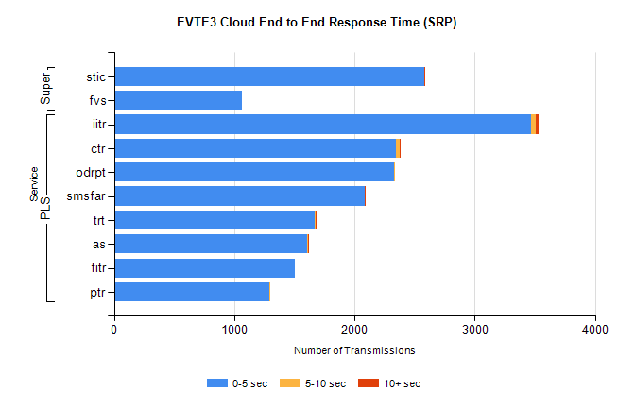
Stream | Service | 0-5 sec | 5-10 sec | >10 sec | Total | % within 5 sec timing target
PLS | iitr | 3466 | 44 | 22 | 3561 | 97.3%
PLS | ctr | 2348 | 24 | 1 | 2393 | 98.1%
PLS | odrpt | 2329 | 1 | 0 | 2334 | 99.8%
PLS | smsfar | 2086 | 3 | 4 | 2097 | 99.5%
PLS | trt | 1668 | 5 | 3 | 1687 | 98.9%
PLS | as | 1603 | 11 | 4 | 1658 | 96.7%
PLS | fitr | 1507 | 0 | 0 | 1514 | 99.5%
PLS | ptr | 1290 | 9 | 0 | 1309 | 98.5%
Super | stic | 2584 | 0 | 1 | 2585 | 100.0%
Super | fvs | 1064 | 0 | 0 | 1064 | 100.0%

SBR2 External Vendor Testing Environment (EVTE3)

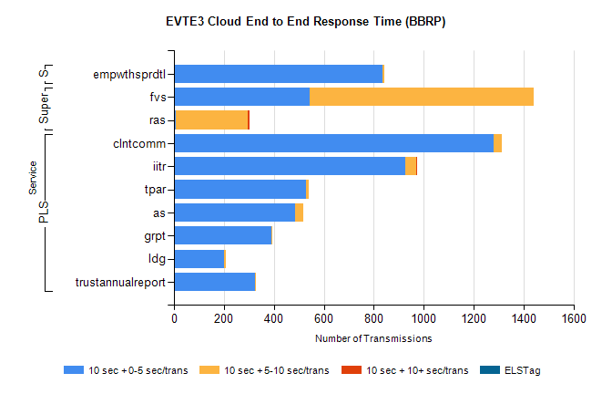
Stream | Service | 10 sec + 0-5 sec /trans | 10 sec + 5-10 sec /trans | 10 sec + >10 sec /trans | Processing Incomplete | ELStag | Total
PLS | clntcomm | 1279 | 34 | 0 | 54 | 0 | 1367
PLS | iitr | 927 | 43 | 2 | 0 | 0 | 978
PLS | tpar | 530 | 8 | 0 | 0 | 0 | 544
PLS | as | 485 | 33 | 0 | 3 | 0 | 523
PLS | grpt | 391 | 2 | 0 | 1 | 0 | 394
PLS | ldg | 202 | 4 | 0 | 136 | 0 | 342
PLS | trustannualreport | 323 | 1 | 0 | 0 | 0 | 324
Super | fvs | 543 | 899 | 0 | 19 | 0 | 1479
Super | ras | 8 | 288 | 5 | 0 | 0 | 326
STP | empwthsprdtl | 834 | 9 | 0 | 0 | 0 | 843

SBR2 External Vendor Testing Environment (EVTE3)

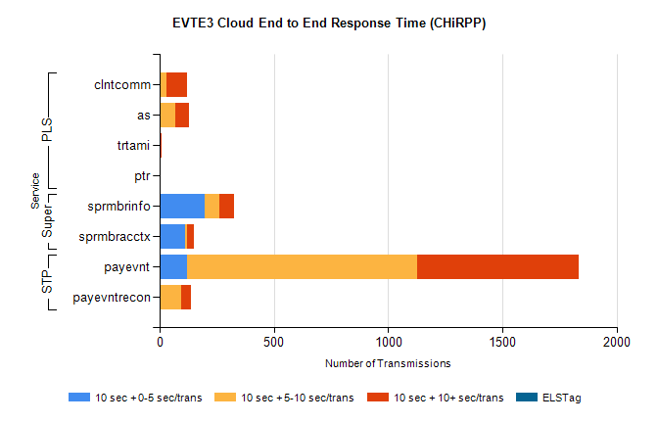
Stream | Service | 10 sec + 0-5 sec /trans | 10 sec + 5-10 sec /trans | 10 sec + >10 sec /trans | Total | % within 5 sec timing target
STP | payevnt | 119 | 1010 | 705 | 2589 | 4.6%
STP | payevntrecon | 0 | 93 | 43 | 151 | 0.0%
Super | sprmbrinfo | 199 | 64 | 62 | 359 | 55.4%
Super | sprmbracctx | 112 | 7 | 30 | 166 | 67.5%
PLS | clntcomm | 0 | 29 | 91 | 257 | 0.0%
PLS | as | 0 | 69 | 59 | 177 | 0.0%
PLS | trtami | 0 | 0 | 8 | 8 | 0.0%
PLS | ptr | 0 | 0 | 6 | 6 | 0.0%

