Transmission Timings Report Week - 38
15/09/2025 - 21/09/2025

SBR2 Cloud Production2 - Single | Bulk or Batch Requests | (SRP, BBRP & CHiRPP)

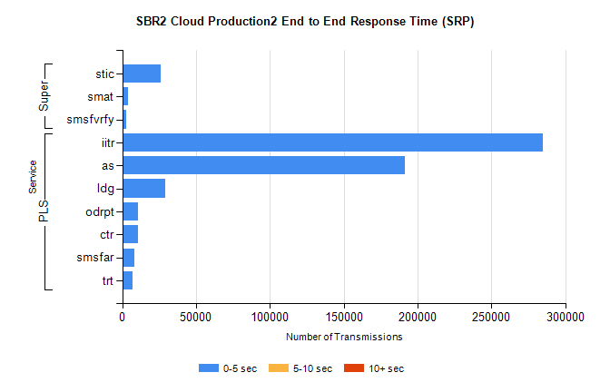
Stream | Service | 0-5 sec | 5-10 sec | >10 sec | Total | % within 5 sec timing target
PLS | iitr | 284531 | 0 | 0 | 284531 | 100.0%
PLS | as | 191620 | 0 | 0 | 191620 | 100.0%
PLS | ldg | 29377 | 0 | 0 | 29377 | 100.0%
PLS | odrpt | 10810 | 0 | 0 | 10810 | 100.0%
PLS | ctr | 10455 | 0 | 0 | 10455 | 100.0%
PLS | smsfar | 8167 | 0 | 0 | 8167 | 100.0%
PLS | trt | 6821 | 0 | 0 | 6821 | 100.0%
Super | stic | 25761 | 0 | 0 | 25761 | 100.0%
Super | smat | 4010 | 0 | 0 | 4010 | 100.0%
Super | smsfvrfy | 2710 | 0 | 0 | 2710 | 100.0%

SBR2 Cloud Production2 - Single | Bulk or Batch Requests | (SRP, BBRP & CHiRPP)

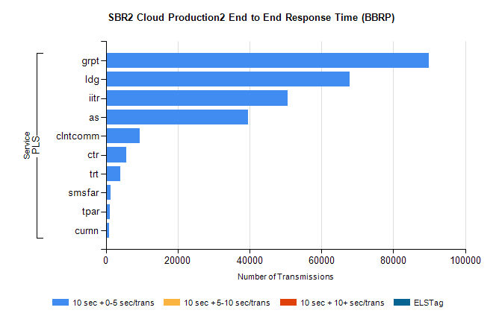
Stream | Service | 10 sec + 0-5 sec /trans | 10 sec + 5-10 sec /trans | 10 sec + >10 sec /trans | Processing Incomplete | ELStag | Total
PLS | grpt | 89932 | 0 | 0 | 0 | 0 | 89932
PLS | ldg | 67884 | 0 | 0 | 0 | 0 | 67884
PLS | iitr | 50578 | 0 | 0 | 0 | 0 | 50578
PLS | as | 39461 | 0 | 0 | 0 | 0 | 39461
PLS | clntcomm | 9506 | 0 | 0 | 0 | 0 | 9506
PLS | ctr | 5626 | 0 | 0 | 0 | 0 | 5626
PLS | trt | 3944 | 0 | 0 | 0 | 0 | 3944
PLS | smsfar | 1275 | 0 | 0 | 0 | 0 | 1275
PLS | tpar | 1089 | 0 | 0 | 0 | 0 | 1089
PLS | curnn | 867 | 0 | 0 | 0 | 0 | 867

SBR2 Cloud Production2 - Single | Bulk or Batch Requests | (SRP, BBRP & CHiRPP)

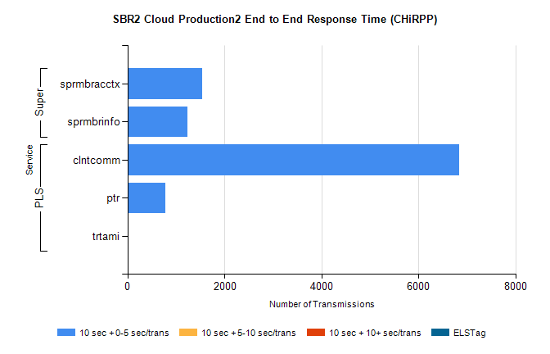
Stream | Service | 10 sec + 0-5 sec /trans | 10 sec + 5-10 sec /trans | 10 sec + >10 sec /trans | Total | % within 5 sec timing target
PLS | clntcomm | 6834 | 0 | 0 | 6834 | 100.0%
PLS | ptr | 779 | 0 | 0 | 779 | 100.0%
PLS | trtami | 16 | 0 | 0 | 16 | 100.0%
Super | sprmbracctx | 1545 | 0 | 0 | 1545 | 100.0%
Super | sprmbrinfo | 1239 | 0 | 0 | 1239 | 100.0%

SBR1 Production Transactions

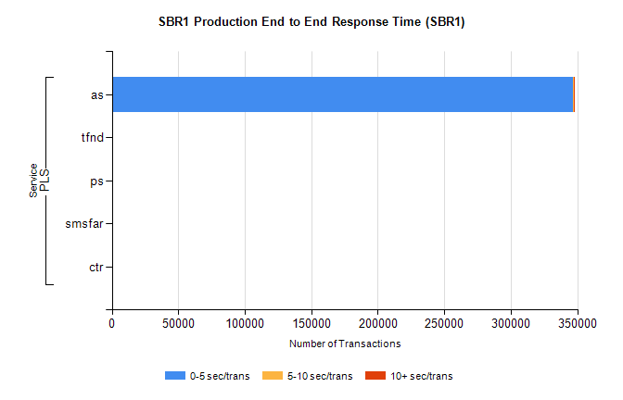
Stream | Service | 0-5 sec/trans | 5-10 sec/trans | 10+ sec/trans | Total | % within 5 sec timing target
PLS | as | 347060 | 397 | 403 | 347860 | 99.8%
PLS | tfnd | 193 | 53 | 4 | 250 | 77.2%
PLS | ps | 33 | 55 | 158 | 246 | 13.4%
PLS | smsfar | 2 | 9 |  | 11 | 18.2%
PLS | ctr |  |  | 1 | 1 | 0.0%

