Transmission Timings Report Week - 39
22/09/2025 - 28/09/2025

SBR2 External Vendor Testing Environment (EVTE3)

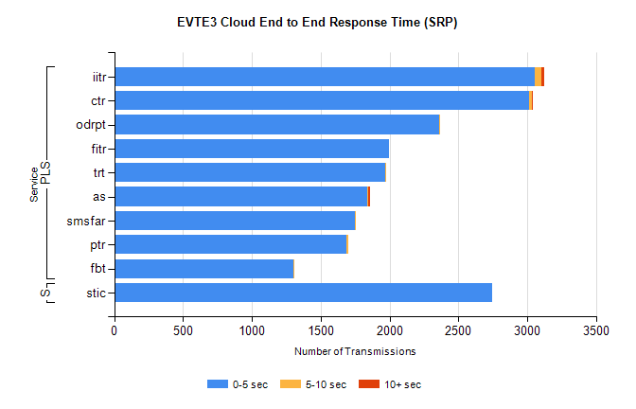
Stream | Service | 0-5 sec | 5-10 sec | >10 sec | Total | % within 5 sec timing target
PLS | iitr | 3054 | 50 | 18 | 3122 | 97.8%
PLS | ctr | 3016 | 19 | 1 | 3043 | 99.1%
PLS | odrpt | 2363 | 2 | 0 | 2366 | 99.9%
PLS | fitr | 1996 | 0 | 0 | 1996 | 100.0%
PLS | trt | 1970 | 9 | 0 | 1984 | 99.3%
PLS | as | 1840 | 8 | 8 | 1962 | 93.8%
PLS | smsfar | 1751 | 1 | 0 | 1752 | 99.9%
PLS | ptr | 1686 | 13 | 0 | 1699 | 99.2%
PLS | fbt | 1301 | 9 | 0 | 1315 | 98.9%
Super | stic | 2749 | 0 | 0 | 2749 | 100.0%

SBR2 External Vendor Testing Environment (EVTE3)

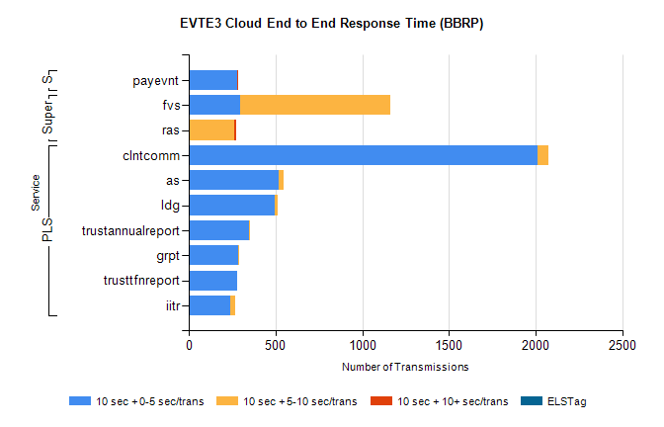
Stream | Service | 10 sec + 0-5 sec /trans | 10 sec + 5-10 sec /trans | 10 sec + >10 sec /trans | Processing Incomplete | ELStag | Total
PLS | clntcomm | 2012 | 61 | 0 | 42 | 0 | 2122
PLS | as | 516 | 31 | 0 | 43 | 0 | 590
PLS | ldg | 497 | 15 | 0 | 4 | 0 | 520
PLS | trustannualreport | 348 | 3 | 0 | 0 | 0 | 351
PLS | grpt | 283 | 2 | 0 | 0 | 0 | 285
PLS | trusttfnreport | 280 | 0 | 0 | 0 | 0 | 280
PLS | iitr | 240 | 27 | 0 | 0 | 0 | 278
Super | fvs | 299 | 863 | 0 | 5 | 0 | 1183
Super | ras | 0 | 264 | 8 | 0 | 0 | 280
STP | payevnt | 278 | 3 | 1 | 22 | 0 | 304

SBR2 External Vendor Testing Environment (EVTE3)

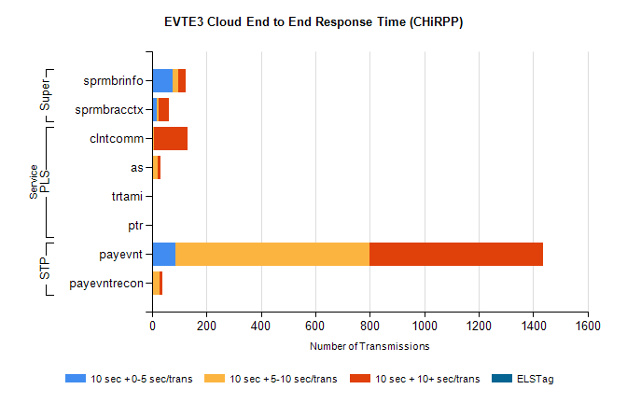
Stream | Service | 10 sec + 0-5 sec /trans | 10 sec + 5-10 sec /trans | 10 sec + >10 sec /trans | Total | % within 5 sec timing target
STP | payevnt | 85 | 713 | 637 | 2105 | 4.0%
STP | payevntrecon | 0 | 28 | 10 | 41 | 0.0%
PLS | clntcomm | 0 | 6 | 124 | 237 | 0.0%
PLS | as | 4 | 16 | 13 | 51 | 7.8%
PLS | ptr | 0 | 0 | 5 | 5 | 0.0%
PLS | trtami | 0 | 0 | 5 | 5 | 0.0%
Super | sprmbrinfo | 76 | 20 | 29 | 143 | 53.1%
Super | sprmbracctx | 18 | 5 | 39 | 75 | 24.0%

