Transmission Timings Report Week - 39
22/09/2025 - 28/09/2025

SBR2 Cloud Production2 - Single | Bulk or Batch Requests | (SRP, BBRP & CHiRPP)

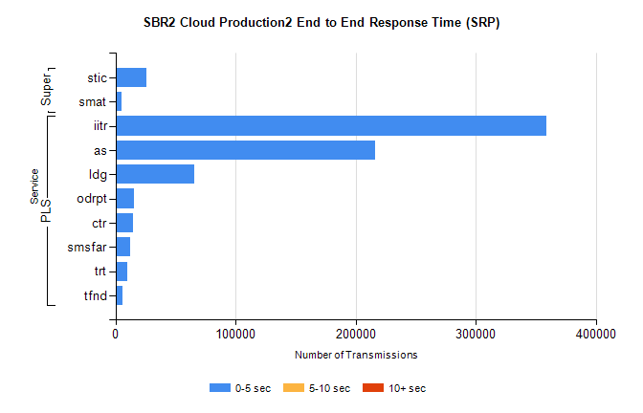
Stream | Service | 0-5 sec | 5-10 sec | >10 sec | Total | % within 5 sec timing target
PLS | iitr | 359035 | 0 | 0 | 359035 | 100.0%
PLS | as | 216217 | 0 | 0 | 216217 | 100.0%
PLS | ldg | 65367 | 0 | 0 | 65367 | 100.0%
PLS | odrpt | 15475 | 0 | 0 | 15475 | 100.0%
PLS | ctr | 14413 | 0 | 0 | 14413 | 100.0%
PLS | smsfar | 12028 | 0 | 0 | 12028 | 100.0%
PLS | trt | 9569 | 0 | 0 | 9569 | 100.0%
PLS | tfnd | 5874 | 0 | 0 | 5874 | 100.0%
Super | stic | 26217 | 0 | 0 | 26217 | 100.0%
Super | smat | 5454 | 0 | 0 | 5454 | 100.0%

SBR2 Cloud Production2 - Single | Bulk or Batch Requests | (SRP, BBRP & CHiRPP)

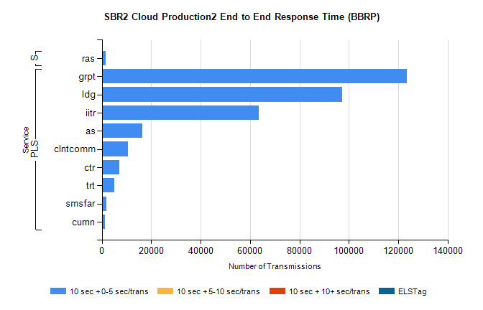
Stream | Service | 10 sec + 0-5 sec /trans | 10 sec + 5-10 sec /trans | 10 sec + >10 sec /trans | Processing Incomplete | ELStag | Total
PLS | grpt | 123529 | 0 | 0 | 0 | 0 | 123529
PLS | ldg | 97418 | 0 | 0 | 0 | 0 | 97418
PLS | iitr | 63446 | 0 | 0 | 0 | 0 | 63446
PLS | as | 16442 | 0 | 0 | 0 | 0 | 16442
PLS | clntcomm | 10636 | 0 | 0 | 0 | 0 | 10636
PLS | ctr | 7150 | 0 | 0 | 0 | 0 | 7150
PLS | trt | 4972 | 0 | 0 | 0 | 0 | 4972
PLS | smsfar | 1735 | 0 | 0 | 0 | 0 | 1735
PLS | curnn | 1165 | 0 | 0 | 0 | 0 | 1165
Super | ras | 1670 | 0 | 0 | 0 | 0 | 1670

SBR2 Cloud Production2 - Single | Bulk or Batch Requests | (SRP, BBRP & CHiRPP)

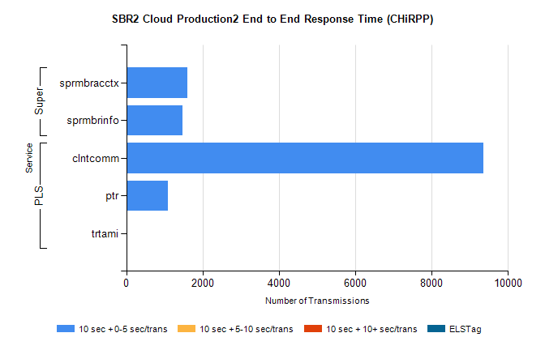
Stream | Service | 10 sec + 0-5 sec /trans | 10 sec + 5-10 sec /trans | 10 sec + >10 sec /trans | Total | % within 5 sec timing target
PLS | clntcomm | 9361 | 0 | 0 | 9361 | 100.0%
PLS | ptr | 1097 | 0 | 0 | 1097 | 100.0%
PLS | trtami | 16 | 0 | 0 | 16 | 100.0%
Super | sprmbracctx | 1596 | 0 | 0 | 1596 | 100.0%
Super | sprmbrinfo | 1461 | 0 | 0 | 1461 | 100.0%

SBR1 Production Transactions

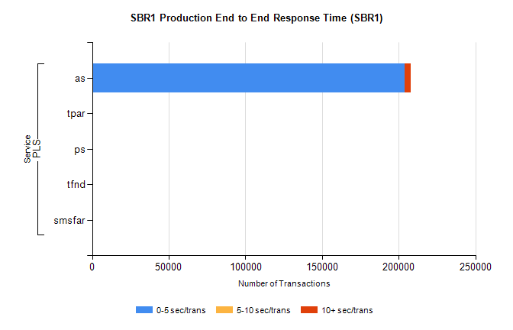
Stream | Service | 0-5 sec/trans | 5-10 sec/trans | 10+ sec/trans | Total | % within 5 sec timing target
PLS | as | 203718 | 132 | 4202 | 208052 | 97.9%
PLS | tpar | 350 |  |  | 350 | 100.0%
PLS | ps | 36 | 68 | 150 | 254 | 14.2%
PLS | tfnd | 184 | 51 | 7 | 242 | 76.0%
PLS | smsfar |  | 18 | 4 | 22 | 0.0%

