Transmission Timings Report Week - 40
29/09/2025 - 5/10/2025

SBR2 External Vendor Testing Environment (EVTE3)

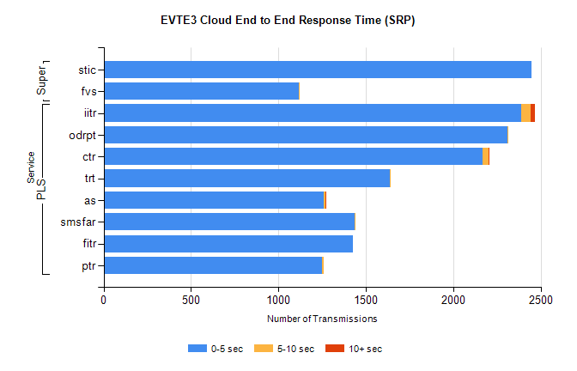
Stream | Service | 0-5 sec | 5-10 sec | >10 sec | Total | % within 5 sec timing target
PLS | iitr | 2389 | 51 | 26 | 2467 | 96.8%
PLS | odrpt | 2311 | 4 | 0 | 2316 | 99.8%
PLS | ctr | 2165 | 36 | 5 | 2219 | 97.6%
PLS | trt | 1636 | 6 | 0 | 1645 | 99.5%
PLS | as | 1260 | 10 | 4 | 1579 | 79.8%
PLS | smsfar | 1435 | 1 | 0 | 1436 | 99.9%
PLS | fitr | 1427 | 0 | 0 | 1427 | 100.0%
PLS | ptr | 1248 | 9 | 0 | 1258 | 99.2%
Super | stic | 2448 | 0 | 0 | 2448 | 100.0%
Super | fvs | 1116 | 2 | 0 | 1118 | 99.8%

SBR2 External Vendor Testing Environment (EVTE3)

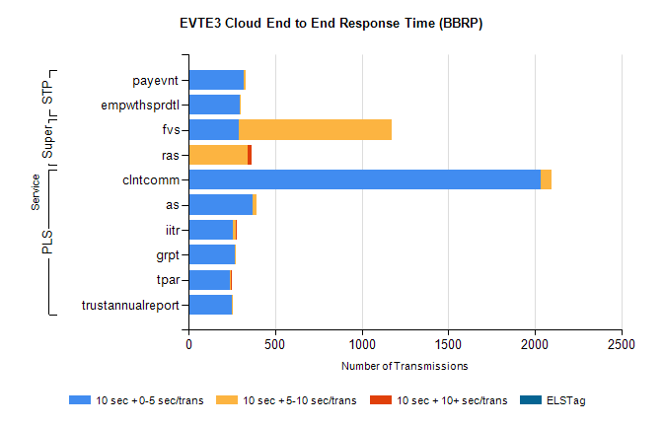
Stream | Service | 10 sec + 0-5 sec /trans | 10 sec + 5-10 sec /trans | 10 sec + >10 sec /trans | Processing Incomplete | ELStag | Total
PLS | clntcomm | 2037 | 62 | 0 | 50 | 0 | 2150
PLS | as | 372 | 23 | 0 | 1 | 0 | 397
PLS | iitr | 257 | 14 | 1 | 0 | 0 | 275
PLS | grpt | 268 | 4 | 0 | 0 | 0 | 273
PLS | tpar | 242 | 5 | 1 | 0 | 0 | 255
PLS | trustannualreport | 250 | 3 | 0 | 0 | 0 | 253
Super | fvs | 290 | 884 | 0 | 5 | 0 | 1214
Super | ras | 1 | 343 | 18 | 0 | 0 | 374
STP | payevnt | 321 | 9 | 0 | 178 | 0 | 510
STP | empwthsprdtl | 294 | 1 | 0 | 0 | 0 | 297

SBR2 External Vendor Testing Environment (EVTE3)

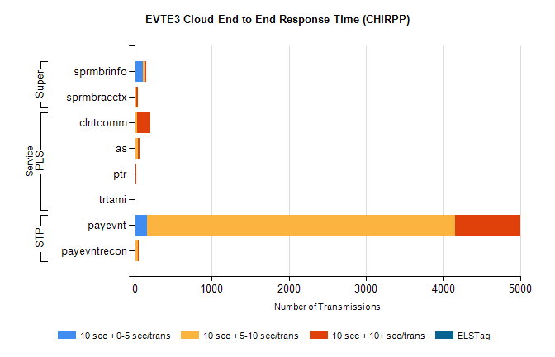
Stream | Service | 10 sec + 0-5 sec /trans | 10 sec + 5-10 sec /trans | 10 sec + >10 sec /trans | Total | % within 5 sec timing target
STP | payevnt | 159 | 4003 | 836 | 5987 | 2.7%
STP | payevntrecon | 0 | 48 | 10 | 61 | 0.0%
PLS | clntcomm | 0 | 33 | 169 | 286 | 0.0%
PLS | as | 0 | 44 | 26 | 84 | 0.0%
PLS | ptr | 0 | 1 | 18 | 19 | 0.0%
PLS | trtami | 0 | 1 | 12 | 13 | 0.0%
Super | sprmbrinfo | 105 | 21 | 30 | 170 | 61.8%
Super | sprmbracctx | 11 | 8 | 30 | 61 | 18.0%

