Transmission Timings Report Week - 40
29/09/2025 - 5/10/2025

SBR2 Cloud Production2 - Single | Bulk or Batch Requests | (SRP, BBRP & CHiRPP)

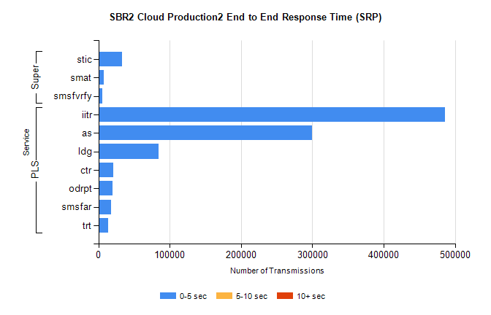
Stream | Service | 0-5 sec | 5-10 sec | >10 sec | Total | % within 5 sec timing target
PLS | iitr | 486004 | 0 | 0 | 486004 | 100.0%
PLS | as | 299259 | 0 | 0 | 299259 | 100.0%
PLS | ldg | 84511 | 0 | 0 | 84511 | 100.0%
PLS | ctr | 20381 | 0 | 0 | 20381 | 100.0%
PLS | odrpt | 19650 | 0 | 0 | 19650 | 100.0%
PLS | smsfar | 17604 | 0 | 0 | 17604 | 100.0%
PLS | trt | 13925 | 0 | 0 | 13925 | 100.0%
Super | stic | 33451 | 0 | 0 | 33451 | 100.0%
Super | smat | 7278 | 0 | 0 | 7278 | 100.0%
Super | smsfvrfy | 5792 | 0 | 0 | 5792 | 100.0%

SBR2 Cloud Production2 - Single | Bulk or Batch Requests | (SRP, BBRP & CHiRPP)

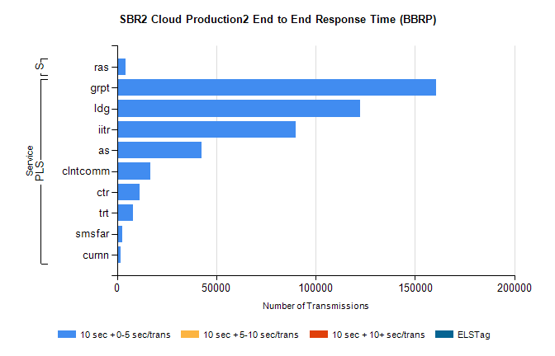
Stream | Service | 10 sec + 0-5 sec /trans | 10 sec + 5-10 sec /trans | 10 sec + >10 sec /trans | Processing Incomplete | ELStag | Total
PLS | grpt | 160739 | 0 | 0 | 0 | 0 | 160739
PLS | ldg | 122299 | 0 | 0 | 0 | 0 | 122299
PLS | iitr | 90133 | 0 | 0 | 0 | 0 | 90133
PLS | as | 42535 | 0 | 0 | 0 | 0 | 42535
PLS | clntcomm | 16740 | 0 | 0 | 0 | 0 | 16740
PLS | ctr | 11185 | 0 | 0 | 0 | 0 | 11185
PLS | trt | 8108 | 0 | 0 | 0 | 0 | 8108
PLS | smsfar | 2721 | 0 | 0 | 0 | 0 | 2721
PLS | curnn | 1607 | 0 | 0 | 0 | 0 | 1607
Super | ras | 4385 | 0 | 0 | 0 | 0 | 4385

SBR2 Cloud Production2 - Single | Bulk or Batch Requests | (SRP, BBRP & CHiRPP)

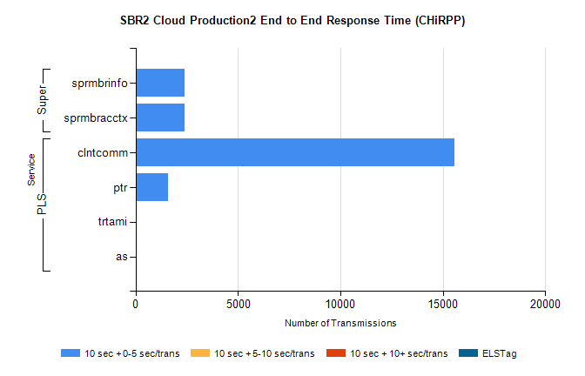
Stream | Service | 10 sec + 0-5 sec /trans | 10 sec + 5-10 sec /trans | 10 sec + >10 sec /trans | Total | % within 5 sec timing target
PLS | clntcomm | 15571 | 0 | 0 | 15571 | 100.0%
PLS | ptr | 1602 | 0 | 0 | 1602 | 100.0%
PLS | trtami | 42 | 0 | 0 | 42 | 100.0%
PLS | as | 21 | 0 | 0 | 21 | 100.0%
Super | sprmbrinfo | 2404 | 0 | 0 | 2404 | 100.0%
Super | sprmbracctx | 2403 | 0 | 0 | 2403 | 100.0%

SBR1 Production Transactions

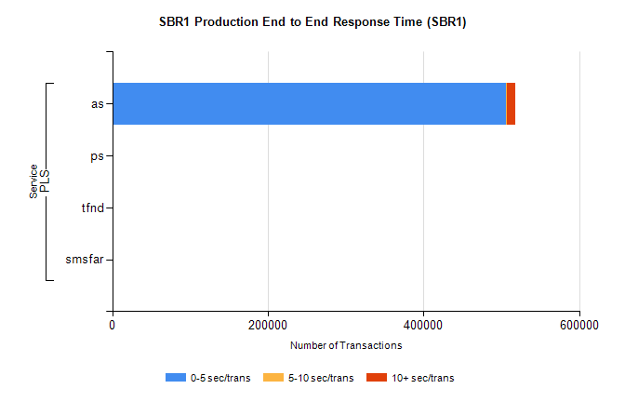
Stream | Service | 0-5 sec/trans | 5-10 sec/trans | 10+ sec/trans | Total | % within 5 sec timing target
PLS | as | 506284 | 425 | 11013 | 517722 | 97.8%
PLS | ps | 64 | 76 | 186 | 326 | 19.6%
PLS | tfnd | 221 | 45 | 4 | 270 | 81.9%
PLS | smsfar | 5 | 30 | 4 | 39 | 12.8%

