Transmission Timings Report Week - 41
6/10/2025 - 12/10/2025

SBR2 External Vendor Testing Environment (EVTE3)

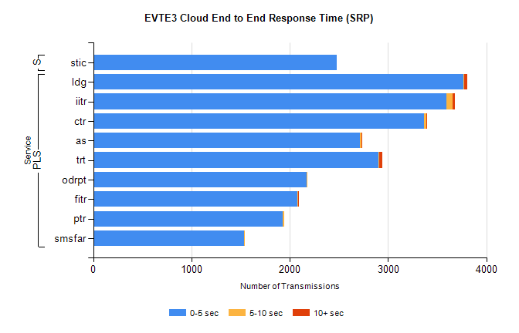
Stream | Service | 0-5 sec | 5-10 sec | >10 sec | Total | % within 5 sec timing target
PLS | ldg | 3770 | 6 | 26 | 3859 | 97.7%
PLS | iitr | 3594 | 64 | 23 | 3694 | 97.3%
PLS | ctr | 3368 | 24 | 5 | 3398 | 99.1%
PLS | as | 2715 | 14 | 4 | 3081 | 88.1%
PLS | trt | 2899 | 12 | 31 | 2946 | 98.4%
PLS | odrpt | 2174 | 2 | 0 | 2176 | 99.9%
PLS | fitr | 2081 | 2 | 2 | 2087 | 99.7%
PLS | ptr | 1932 | 8 | 0 | 1941 | 99.5%
PLS | smsfar | 1534 | 1 | 0 | 1535 | 99.9%
Super | stic | 2480 | 0 | 0 | 2520 | 98.4%

SBR2 External Vendor Testing Environment (EVTE3)

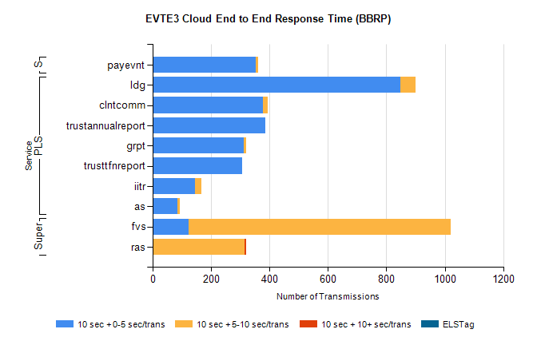
Stream | Service | 10 sec + 0-5 sec /trans | 10 sec + 5-10 sec /trans | 10 sec + >10 sec /trans | Processing Incomplete | ELStag | Total
PLS | ldg | 847 | 53 | 0 | 10 | 0 | 910
PLS | clntcomm | 378 | 17 | 0 | 30 | 0 | 425
PLS | trustannualreport | 386 | 0 | 0 | 0 | 0 | 386
PLS | grpt | 311 | 8 | 0 | 2 | 0 | 323
PLS | trusttfnreport | 305 | 0 | 0 | 0 | 0 | 305
PLS | iitr | 145 | 21 | 0 | 25 | 0 | 204
PLS | as | 85 | 9 | 0 | 59 | 0 | 153
Super | fvs | 123 | 897 | 0 | 10 | 0 | 1054
Super | ras | 0 | 315 | 6 | 0 | 0 | 335
STP | payevnt | 352 | 9 | 0 | 51 | 0 | 413

SBR2 External Vendor Testing Environment (EVTE3)

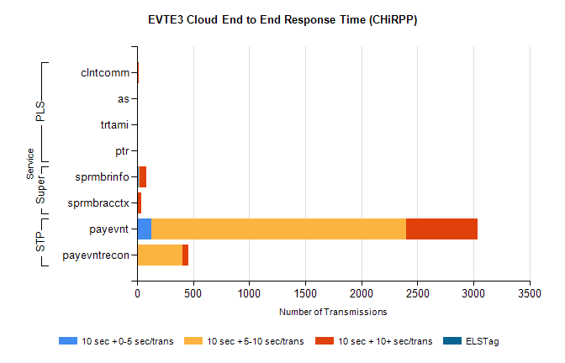
Stream | Service | 10 sec + 0-5 sec /trans | 10 sec + 5-10 sec /trans | 10 sec + >10 sec /trans | Total | % within 5 sec timing target
STP | payevnt | 130 | 2269 | 641 | 3730 | 3.5%
STP | payevntrecon | 11 | 393 | 55 | 480 | 2.3%
Super | sprmbrinfo | 16 | 9 | 60 | 101 | 15.8%
Super | sprmbracctx | 4 | 8 | 26 | 50 | 8.0%
PLS | clntcomm | 0 | 0 | 18 | 31 | 0.0%
PLS | as | 0 | 0 | 10 | 12 | 0.0%
PLS | trtami | 0 | 1 | 10 | 11 | 0.0%
PLS | ptr | 0 | 0 | 5 | 5 | 0.0%

