Transmission Timings Report Week - 41
6/10/2025 - 12/10/2025

SBR2 Cloud Production2 - Single | Bulk or Batch Requests | (SRP, BBRP & CHiRPP)

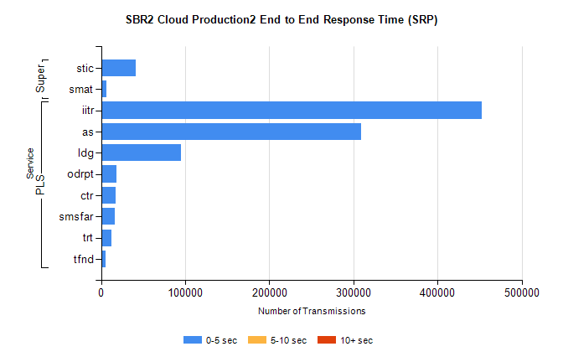
Stream | Service | 0-5 sec | 5-10 sec | >10 sec | Total | % within 5 sec timing target
PLS | iitr | 452675 | 0 | 0 | 452675 | 100.0%
PLS | as | 309300 | 0 | 0 | 309300 | 100.0%
PLS | ldg | 95175 | 0 | 0 | 95175 | 100.0%
PLS | odrpt | 18065 | 0 | 0 | 18065 | 100.0%
PLS | ctr | 16920 | 0 | 0 | 16920 | 100.0%
PLS | smsfar | 16790 | 0 | 0 | 16790 | 100.0%
PLS | trt | 12377 | 0 | 0 | 12377 | 100.0%
PLS | tfnd | 5532 | 0 | 0 | 5532 | 100.0%
Super | stic | 41560 | 0 | 0 | 41560 | 100.0%
Super | smat | 6774 | 0 | 0 | 6774 | 100.0%

SBR2 Cloud Production2 - Single | Bulk or Batch Requests | (SRP, BBRP & CHiRPP)

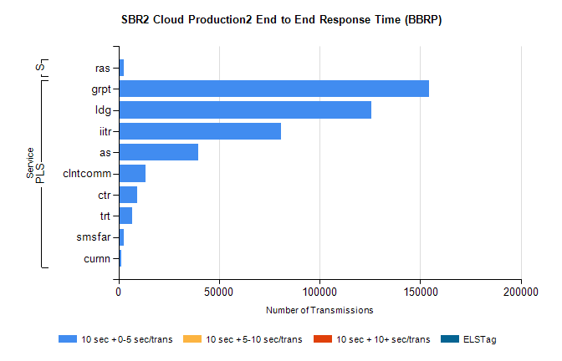
Stream | Service | 10 sec + 0-5 sec /trans | 10 sec + 5-10 sec /trans | 10 sec + >10 sec /trans | Processing Incomplete | ELStag | Total
PLS | grpt | 154389 | 0 | 0 | 0 | 0 | 154389
PLS | ldg | 125896 | 0 | 0 | 0 | 0 | 125896
PLS | iitr | 80899 | 0 | 0 | 0 | 0 | 80899
PLS | as | 39473 | 0 | 0 | 0 | 0 | 39473
PLS | clntcomm | 13387 | 0 | 0 | 0 | 0 | 13387
PLS | ctr | 9408 | 0 | 0 | 0 | 0 | 9408
PLS | trt | 6982 | 0 | 0 | 0 | 0 | 6982
PLS | smsfar | 2620 | 0 | 0 | 0 | 0 | 2620
PLS | curnn | 1437 | 0 | 0 | 0 | 0 | 1437
Super | ras | 2578 | 0 | 0 | 0 | 0 | 2578

SBR2 Cloud Production2 - Single | Bulk or Batch Requests | (SRP, BBRP & CHiRPP)

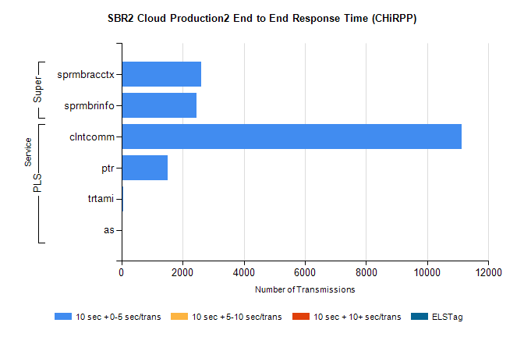
Stream | Service | 10 sec + 0-5 sec /trans | 10 sec + 5-10 sec /trans | 10 sec + >10 sec /trans | Total | % within 5 sec timing target
PLS | clntcomm | 11130 | 0 | 0 | 11130 | 100.0%
PLS | ptr | 1503 | 0 | 0 | 1503 | 100.0%
PLS | trtami | 63 | 0 | 0 | 63 | 100.0%
PLS | as | 4 | 0 | 0 | 4 | 100.0%
Super | sprmbracctx | 2619 | 0 | 0 | 2619 | 100.0%
Super | sprmbrinfo | 2447 | 0 | 0 | 2447 | 100.0%

SBR1 Production Transactions

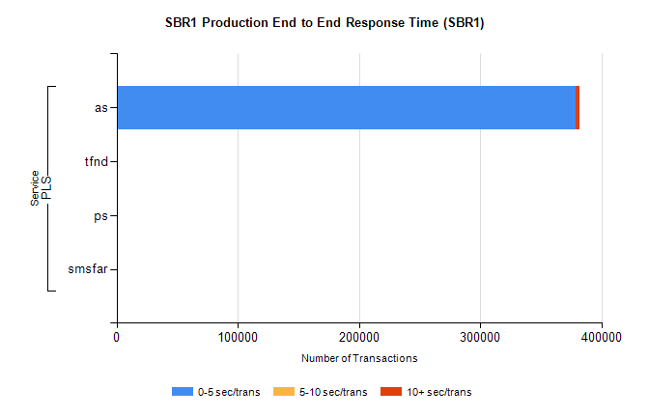
Stream | Service | 0-5 sec/trans | 5-10 sec/trans | 10+ sec/trans | Total | % within 5 sec timing target
PLS | as | 378538 | 121 | 2957 | 381616 | 99.2%
PLS | tfnd | 314 | 51 | 6 | 371 | 84.6%
PLS | ps | 23 | 48 | 123 | 194 | 11.9%
PLS | smsfar | 2 | 10 | 2 | 14 | 14.3%

