Transmission Timings Report Week - 42
13/10/2025 - 19/10/2025

SBR2 External Vendor Testing Environment (EVTE3)

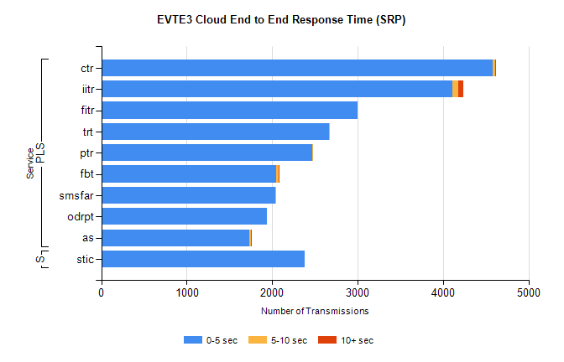
Stream | Service | 0-5 sec | 5-10 sec | >10 sec | Total | % within 5 sec timing target
PLS | ctr | 4584 | 30 | 5 | 4632 | 99.0%
PLS | iitr | 4110 | 69 | 57 | 4251 | 96.7%
PLS | fitr | 3003 | 0 | 0 | 3003 | 100.0%
PLS | trt | 2667 | 6 | 0 | 2684 | 99.4%
PLS | ptr | 2473 | 7 | 0 | 2491 | 99.3%
PLS | fbt | 2046 | 26 | 1 | 2073 | 98.7%
PLS | smsfar | 2033 | 2 | 0 | 2035 | 99.9%
PLS | odrpt | 1937 | 0 | 0 | 1969 | 98.4%
PLS | as | 1735 | 13 | 3 | 1866 | 93.0%
Super | stic | 2383 | 0 | 0 | 2490 | 95.7%

SBR2 External Vendor Testing Environment (EVTE3)

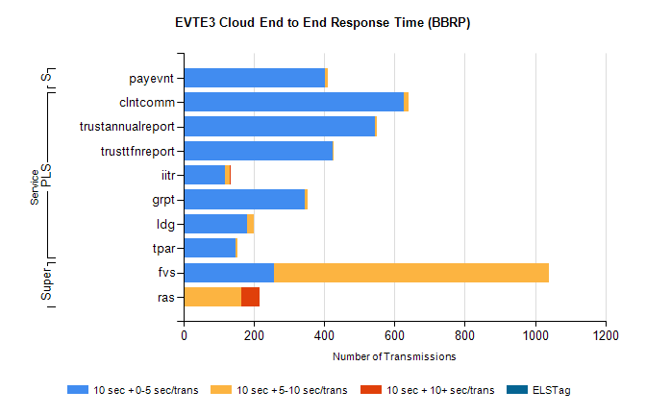
Stream | Service | 10 sec + 0-5 sec /trans | 10 sec + 5-10 sec /trans | 10 sec + >10 sec /trans | Processing Incomplete | ELStag | Total
PLS | clntcomm | 625 | 16 | 0 | 125 | 0 | 766
PLS | trustannualreport | 543 | 8 | 0 | 0 | 0 | 551
PLS | trusttfnreport | 424 | 2 | 0 | 0 | 0 | 426
PLS | iitr | 117 | 14 | 1 | 215 | 0 | 353
PLS | grpt | 345 | 7 | 0 | 0 | 0 | 352
PLS | ldg | 180 | 20 | 0 | 72 | 0 | 280
PLS | tpar | 147 | 5 | 0 | 0 | 0 | 161
Super | fvs | 256 | 784 | 0 | 48 | 0 | 1121
Super | ras | 0 | 164 | 52 | 79 | 0 | 300
STP | payevnt | 401 | 9 | 0 | 43 | 0 | 453

SBR2 External Vendor Testing Environment (EVTE3)

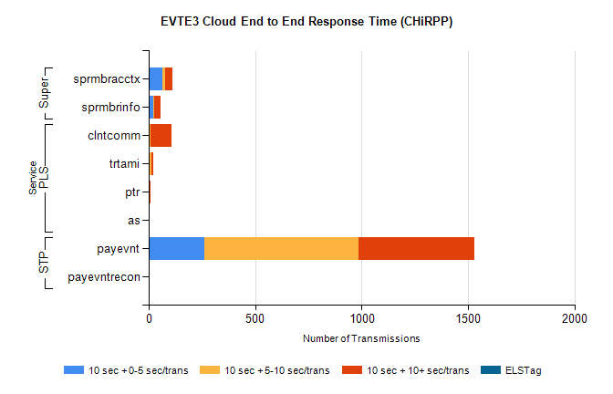
Stream | Service | 10 sec + 0-5 sec /trans | 10 sec + 5-10 sec /trans | 10 sec + >10 sec /trans | Total | % within 5 sec timing target
STP | payevnt | 264 | 723 | 543 | 2335 | 11.3%
STP | payevntrecon | 0 | 0 | 3 | 3 | 0.0%
Super | sprmbracctx | 67 | 10 | 34 | 128 | 54.5%
Super | sprmbrinfo | 24 | 3 | 29 | 69 | 38.1%
PLS | clntcomm | 0 | 8 | 99 | 118 | 0.0%
PLS | trtami | 0 | 14 | 9 | 25 | 0.0%
PLS | ptr | 0 | 1 | 9 | 10 | 0.0%
PLS | as | 0 | 0 | 5 | 5 | 0.0%

