Transmission Timings Report Week - 42
13/10/2025 - 19/10/2025

SBR2 Cloud Production2 - Single | Bulk or Batch Requests | (SRP, BBRP & CHiRPP)

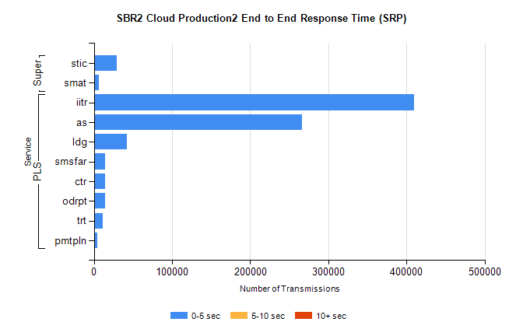
Stream | Service | 0-5 sec | 5-10 sec | >10 sec | Total | % within 5 sec timing target
PLS | iitr | 409458 | 0 | 0 | 409458 | 100.0%
PLS | as | 266257 | 0 | 0 | 266257 | 100.0%
PLS | ldg | 42379 | 0 | 0 | 42379 | 100.0%
PLS | smsfar | 14680 | 0 | 0 | 14680 | 100.0%
PLS | ctr | 14609 | 0 | 0 | 14609 | 100.0%
PLS | odrpt | 14558 | 0 | 0 | 14558 | 100.0%
PLS | trt | 11425 | 0 | 0 | 11425 | 100.0%
PLS | pmtpln | 4849 | 0 | 0 | 4849 | 100.0%
Super | stic | 29637 | 0 | 0 | 29637 | 100.0%
Super | smat | 6275 | 0 | 0 | 6275 | 100.0%

SBR2 Cloud Production2 - Single | Bulk or Batch Requests | (SRP, BBRP & CHiRPP)

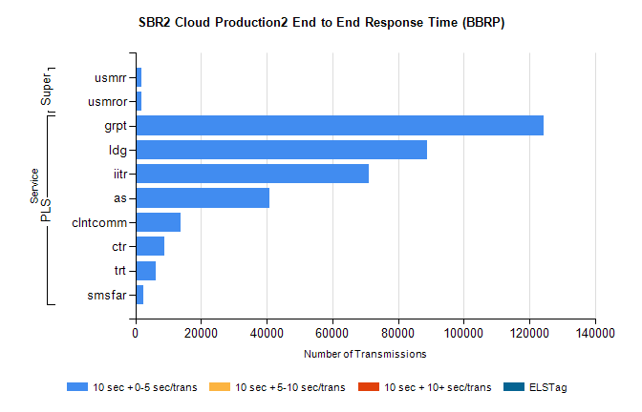
Stream | Service | 10 sec + 0-5 sec /trans | 10 sec + 5-10 sec /trans | 10 sec + >10 sec /trans | Processing Incomplete | ELStag | Total
PLS | grpt | 124371 | 0 | 0 | 0 | 0 | 124371
PLS | ldg | 88964 | 0 | 0 | 0 | 0 | 88964
PLS | iitr | 71157 | 0 | 0 | 0 | 0 | 71157
PLS | as | 40845 | 0 | 0 | 0 | 0 | 40845
PLS | clntcomm | 13851 | 0 | 0 | 0 | 0 | 13851
PLS | ctr | 8762 | 0 | 0 | 0 | 0 | 8762
PLS | trt | 6222 | 0 | 0 | 0 | 0 | 6222
PLS | smsfar | 2417 | 0 | 0 | 0 | 0 | 2417
Super | usmrr | 1925 | 0 | 0 | 0 | 0 | 1925
Super | usmror | 1856 | 0 | 0 | 0 | 0 | 1856

SBR2 Cloud Production2 - Single | Bulk or Batch Requests | (SRP, BBRP & CHiRPP)

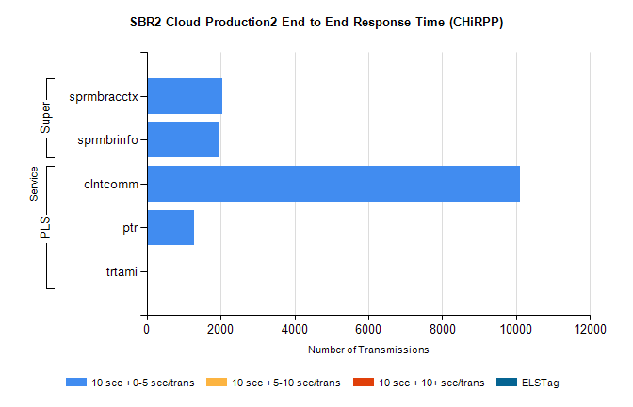
Stream | Service | 10 sec + 0-5 sec /trans | 10 sec + 5-10 sec /trans | 10 sec + >10 sec /trans | Total | % within 5 sec timing target
PLS | clntcomm | 10114 | 0 | 0 | 10114 | 100.0%
PLS | ptr | 1291 | 0 | 0 | 1291 | 100.0%
PLS | trtami | 12 | 0 | 0 | 12 | 100.0%
Super | sprmbracctx | 2046 | 0 | 0 | 2046 | 100.0%
Super | sprmbrinfo | 1976 | 0 | 0 | 1976 | 100.0%

SBR1 Production Transactions

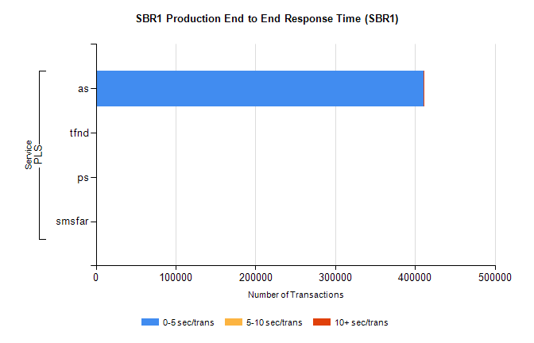
Stream | Service | 0-5 sec/trans | 5-10 sec/trans | 10+ sec/trans | Total | % within 5 sec timing target
PLS | as | 410533 | 223 | 271 | 411027 | 99.9%
PLS | tfnd | 270 | 50 | 6 | 326 | 82.8%
PLS | ps | 75 | 60 | 176 | 311 | 24.1%
PLS | smsfar | 4 | 24 |  | 28 | 14.3%

