Transmission Timings Report Week - 43
20/10/2025 - 26/10/2025

SBR2 External Vendor Testing Environment (EVTE3)

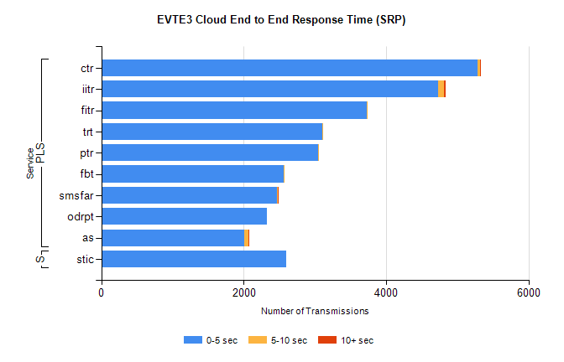
Stream | Service | 0-5 sec | 5-10 sec | >10 sec | Total | % within 5 sec timing target
PLS | ctr | 5290 | 33 | 1 | 5325 | 99.3%
PLS | iitr | 4728 | 84 | 27 | 4839 | 97.7%
PLS | fitr | 3727 | 9 | 0 | 3737 | 99.7%
PLS | trt | 3101 | 4 | 0 | 3108 | 99.8%
PLS | ptr | 3040 | 4 | 0 | 3047 | 99.8%
PLS | fbt | 2563 | 13 | 0 | 2579 | 99.4%
PLS | smsfar | 2473 | 2 | 1 | 2476 | 99.9%
PLS | odrpt | 2327 | 0 | 0 | 2328 | 100.0%
PLS | as | 2010 | 57 | 11 | 2097 | 95.9%
Super | stic | 2599 | 0 | 0 | 2599 | 100.0%

SBR2 External Vendor Testing Environment (EVTE3)

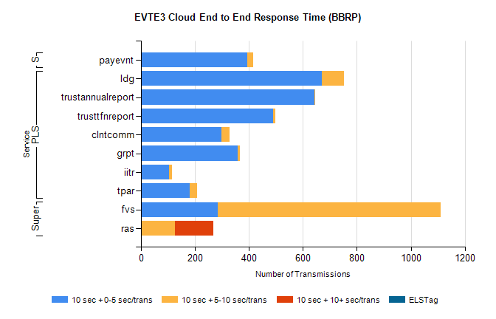
Stream | Service | 10 sec + 0-5 sec /trans | 10 sec + 5-10 sec /trans | 10 sec + >10 sec /trans | Processing Incomplete | ELStag | Total
PLS | ldg | 670 | 83 | 0 | 92 | 0 | 854
PLS | trustannualreport | 642 | 4 | 0 | 0 | 0 | 646
PLS | trusttfnreport | 490 | 7 | 0 | 0 | 0 | 498
PLS | clntcomm | 297 | 30 | 0 | 84 | 0 | 411
PLS | grpt | 358 | 8 | 0 | 0 | 0 | 366
PLS | iitr | 105 | 11 | 0 | 129 | 0 | 248
PLS | tpar | 181 | 28 | 0 | 0 | 0 | 217
Super | fvs | 285 | 826 | 0 | 5 | 0 | 1150
Super | ras | 0 | 126 | 142 | 0 | 0 | 289
STP | payevnt | 395 | 21 | 0 | 23 | 0 | 440

SBR2 External Vendor Testing Environment (EVTE3)

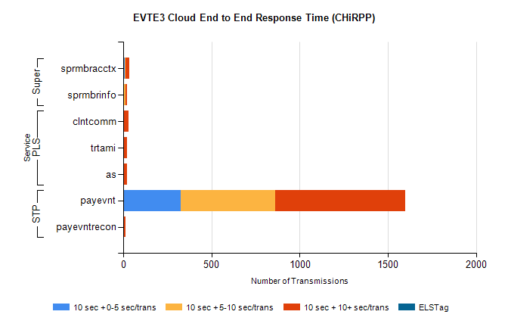
Stream | Service | 10 sec + 0-5 sec /trans | 10 sec + 5-10 sec /trans | 10 sec + >10 sec /trans | Total | % within 5 sec timing target
STP | payevnt | 328 | 533 | 736 | 2241 | 14.6%
STP | payevntrecon | 0 | 0 | 15 | 21 | 0.0%
PLS | clntcomm | 0 | 0 | 29 | 32 | 0.0%
PLS | as | 0 | 0 | 21 | 22 | 0.0%
PLS | trtami | 0 | 0 | 22 | 22 | 0.0%
Super | sprmbracctx | 9 | 5 | 20 | 39 | 23.1%
Super | sprmbrinfo | 6 | 6 | 9 | 24 | 25.0%

