Transmission Timings Report Week - 43
20/10/2025 - 26/10/2025

SBR2 Cloud Production2 - Single | Bulk or Batch Requests | (SRP, BBRP & CHiRPP)

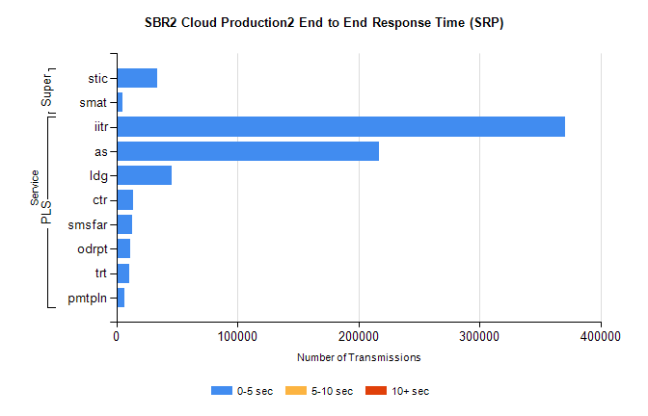
Stream | Service | 0-5 sec | 5-10 sec | >10 sec | Total | % within 5 sec timing target
PLS | iitr | 371085 | 0 | 0 | 371085 | 100.0%
PLS | as | 216833 | 0 | 0 | 216833 | 100.0%
PLS | ldg | 46047 | 0 | 0 | 46047 | 100.0%
PLS | ctr | 13562 | 0 | 0 | 13562 | 100.0%
PLS | smsfar | 13198 | 0 | 0 | 13198 | 100.0%
PLS | odrpt | 11497 | 0 | 0 | 11497 | 100.0%
PLS | trt | 10697 | 0 | 0 | 10697 | 100.0%
PLS | pmtpln | 6477 | 0 | 0 | 6477 | 100.0%
Super | stic | 33989 | 0 | 0 | 33989 | 100.0%
Super | smat | 4934 | 0 | 0 | 4934 | 100.0%

SBR2 Cloud Production2 - Single | Bulk or Batch Requests | (SRP, BBRP & CHiRPP)

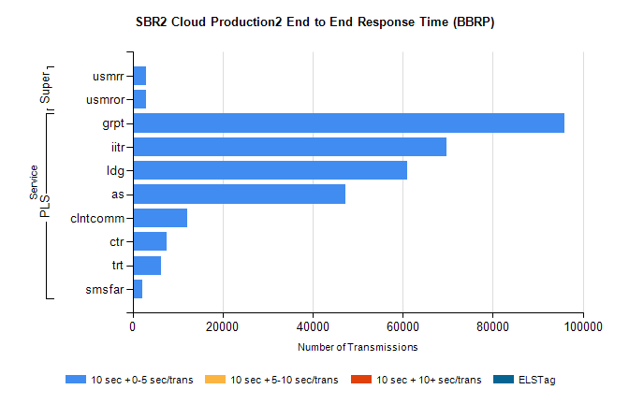
Stream | Service | 10 sec + 0-5 sec /trans | 10 sec + 5-10 sec /trans | 10 sec + >10 sec /trans | Processing Incomplete | ELStag | Total
PLS | grpt | 95813 | 0 | 0 | 0 | 0 | 95813
PLS | iitr | 69654 | 0 | 0 | 0 | 0 | 69654
PLS | ldg | 60930 | 0 | 0 | 0 | 0 | 60930
PLS | as | 47170 | 0 | 0 | 0 | 0 | 47170
PLS | clntcomm | 12168 | 0 | 0 | 0 | 0 | 12168
PLS | ctr | 7629 | 0 | 0 | 0 | 0 | 7629
PLS | trt | 6310 | 0 | 0 | 0 | 0 | 6310
PLS | smsfar | 2219 | 0 | 0 | 0 | 0 | 2219
Super | usmrr | 3066 | 0 | 0 | 0 | 0 | 3066
Super | usmror | 3049 | 0 | 0 | 0 | 0 | 3049

SBR2 Cloud Production2 - Single | Bulk or Batch Requests | (SRP, BBRP & CHiRPP)

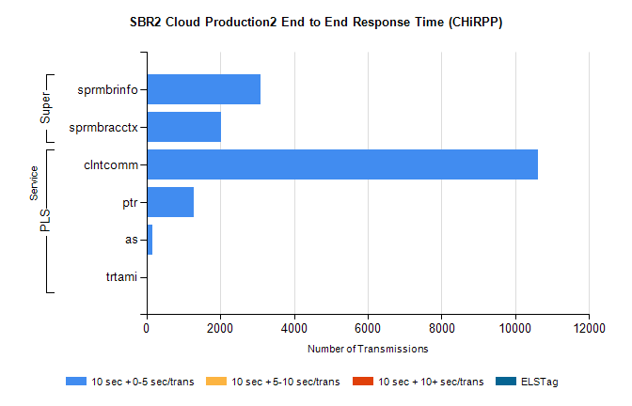
Stream | Service | 10 sec + 0-5 sec /trans | 10 sec + 5-10 sec /trans | 10 sec + >10 sec /trans | Total | % within 5 sec timing target
PLS | clntcomm | 10624 | 0 | 0 | 10624 | 100.0%
PLS | ptr | 1287 | 0 | 0 | 1287 | 100.0%
PLS | as | 146 | 0 | 0 | 146 | 100.0%
PLS | trtami | 8 | 0 | 0 | 8 | 100.0%
Super | sprmbrinfo | 3089 | 0 | 0 | 3089 | 100.0%
Super | sprmbracctx | 2014 | 0 | 0 | 2014 | 100.0%

SBR1 Production Transactions

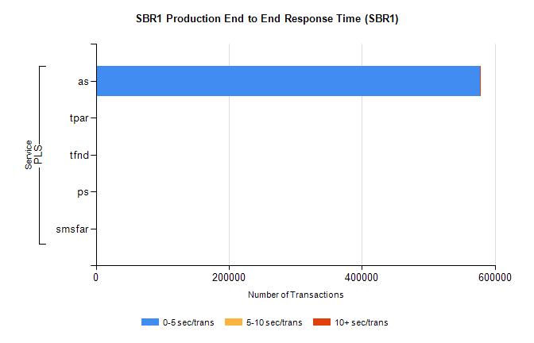
Stream | Service | 0-5 sec/trans | 5-10 sec/trans | 10+ sec/trans | Total | % within 5 sec timing target
PLS | as | 577587 | 210 | 225 | 578022 | 99.9%
PLS | tpar | 863 |  |  | 863 | 100.0%
PLS | tfnd | 235 | 59 | 5 | 299 | 78.6%
PLS | ps | 34 | 55 | 150 | 239 | 14.2%
PLS | smsfar | 5 | 23 | 3 | 31 | 16.1%

