Transmission Timings Report Week - 44
27/10/2025 - 2/11/2025

SBR2 External Vendor Testing Environment (EVTE3)

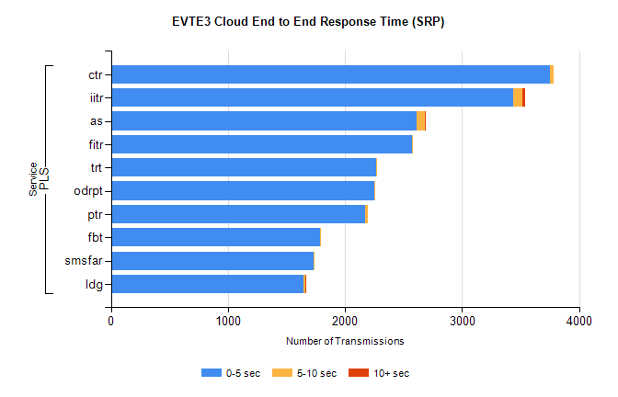
Stream | Service | 0-5 sec | 5-10 sec | >10 sec | Total | % within 5 sec timing target
PLS | ctr | 3751 | 28 | 0 | 3787 | 99.0%
PLS | iitr | 3434 | 84 | 17 | 3543 | 96.9%
PLS | as | 2612 | 73 | 6 | 2758 | 94.7%
PLS | fitr | 2574 | 1 | 0 | 2576 | 99.9%
PLS | trt | 2269 | 2 | 0 | 2275 | 99.7%
PLS | odrpt | 2252 | 4 | 0 | 2266 | 99.4%
PLS | ptr | 2173 | 21 | 0 | 2197 | 98.9%
PLS | fbt | 1783 | 14 | 0 | 1798 | 99.2%
PLS | smsfar | 1735 | 4 | 0 | 1743 | 99.5%
PLS | ldg | 1648 | 16 | 4 | 1698 | 97.1%

SBR2 External Vendor Testing Environment (EVTE3)

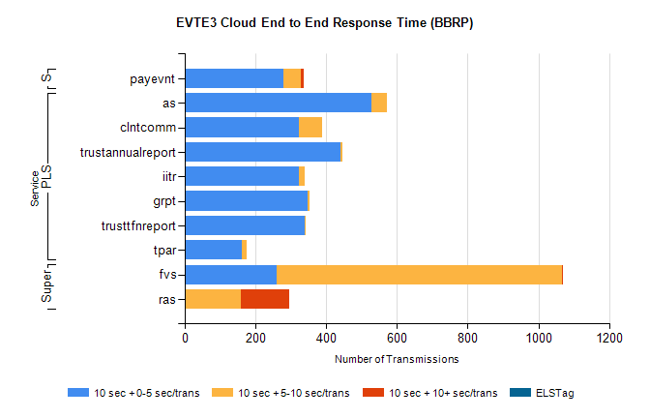
Stream | Service | 10 sec + 0-5 sec /trans | 10 sec + 5-10 sec /trans | 10 sec + >10 sec /trans | Processing Incomplete | ELStag | Total
PLS | as | 528 | 44 | 0 | 1 | 0 | 574
PLS | clntcomm | 322 | 65 | 0 | 84 | 0 | 471
PLS | trustannualreport | 441 | 5 | 0 | 0 | 0 | 446
PLS | iitr | 324 | 16 | 0 | 11 | 0 | 361
PLS | grpt | 348 | 5 | 0 | 0 | 0 | 354
PLS | trusttfnreport | 338 | 3 | 0 | 0 | 0 | 341
PLS | tpar | 162 | 13 | 0 | 0 | 0 | 183
Super | fvs | 261 | 806 | 1 | 6 | 0 | 1135
Super | ras | 0 | 158 | 138 | 21 | 0 | 322
STP | payevnt | 280 | 48 | 8 | 54 | 0 | 397

SBR2 External Vendor Testing Environment (EVTE3)

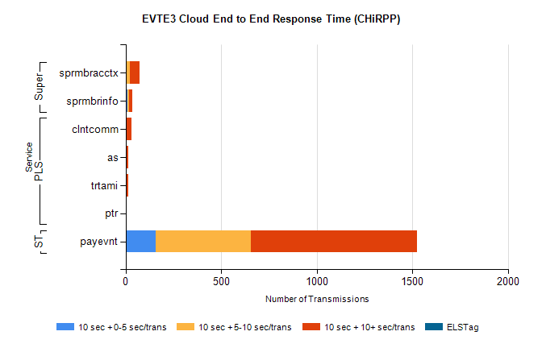
Stream | Service | 10 sec + 0-5 sec /trans | 10 sec + 5-10 sec /trans | 10 sec + >10 sec /trans | Total | % within 5 sec timing target
STP | payevnt | 159 | 497 | 870 | 2062 | 7.7%
Super | sprmbracctx | 5 | 18 | 50 | 87 | 5.7%
Super | sprmbrinfo | 9 | 8 | 18 | 38 | 23.7%
PLS | clntcomm | 0 | 0 | 32 | 33 | 0.0%
PLS | as | 0 | 0 | 13 | 14 | 0.0%
PLS | trtami | 0 | 0 | 13 | 13 | 0.0%
PLS | ptr | 0 | 1 | 4 | 5 | 0.0%

