Transmission Timings Report Week - 44
27/10/2025 - 2/11/2025

SBR2 Cloud Production2 - Single | Bulk or Batch Requests | (SRP, BBRP & CHiRPP)

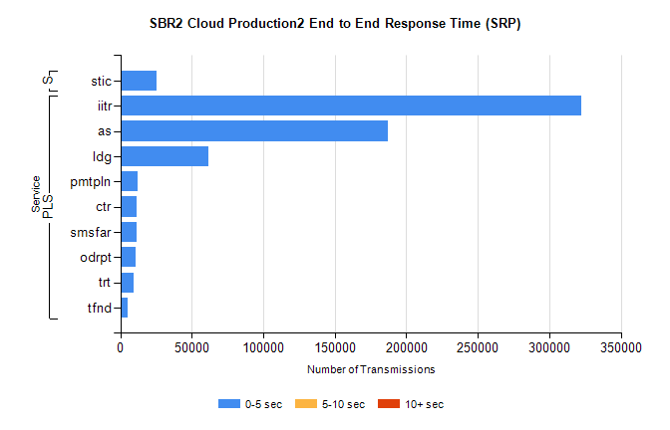
Stream | Service | 0-5 sec | 5-10 sec | >10 sec | Total | % within 5 sec timing target
PLS | iitr | 322358 | 0 | 0 | 322358 | 100.0%
PLS | as | 186864 | 0 | 0 | 186864 | 100.0%
PLS | ldg | 61776 | 0 | 0 | 61776 | 100.0%
PLS | pmtpln | 12355 | 0 | 0 | 12355 | 100.0%
PLS | ctr | 11273 | 0 | 0 | 11273 | 100.0%
PLS | smsfar | 11228 | 0 | 0 | 11228 | 100.0%
PLS | odrpt | 11008 | 0 | 0 | 11008 | 100.0%
PLS | trt | 9133 | 0 | 0 | 9133 | 100.0%
PLS | tfnd | 5500 | 0 | 0 | 5500 | 100.0%
Super | stic | 25711 | 0 | 0 | 25711 | 100.0%

SBR2 Cloud Production2 - Single | Bulk or Batch Requests | (SRP, BBRP & CHiRPP)

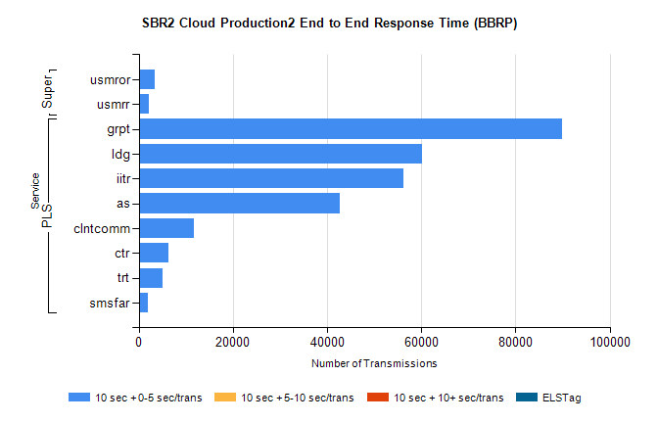
Stream | Service | 10 sec + 0-5 sec /trans | 10 sec + 5-10 sec /trans | 10 sec + >10 sec /trans | Processing Incomplete | ELStag | Total
PLS | grpt | 89890 | 0 | 0 | 0 | 0 | 89890
PLS | ldg | 60192 | 0 | 0 | 0 | 0 | 60192
PLS | iitr | 56272 | 0 | 0 | 0 | 0 | 56272
PLS | as | 42677 | 0 | 0 | 0 | 0 | 42677
PLS | clntcomm | 11784 | 0 | 0 | 0 | 0 | 11784
PLS | ctr | 6317 | 0 | 0 | 0 | 0 | 6317
PLS | trt | 4969 | 0 | 0 | 0 | 0 | 4969
PLS | smsfar | 1870 | 0 | 0 | 0 | 0 | 1870
Super | usmror | 3317 | 0 | 0 | 0 | 0 | 3317
Super | usmrr | 2169 | 0 | 0 | 0 | 0 | 2169

SBR2 Cloud Production2 - Single | Bulk or Batch Requests | (SRP, BBRP & CHiRPP)

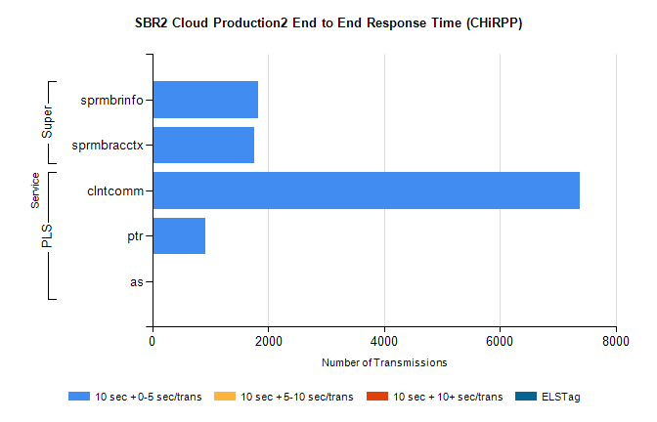
Stream | Service | 10 sec + 0-5 sec /trans | 10 sec + 5-10 sec /trans | 10 sec + >10 sec /trans | Total | % within 5 sec timing target
PLS | clntcomm | 7375 | 0 | 0 | 7375 | 100.0%
PLS | ptr | 923 | 0 | 0 | 923 | 100.0%
PLS | as | 1 | 0 | 0 | 1 | 100.0%
Super | sprmbrinfo | 1832 | 0 | 0 | 1832 | 100.0%
Super | sprmbracctx | 1755 | 0 | 0 | 1755 | 100.0%

SBR1 Production Transactions

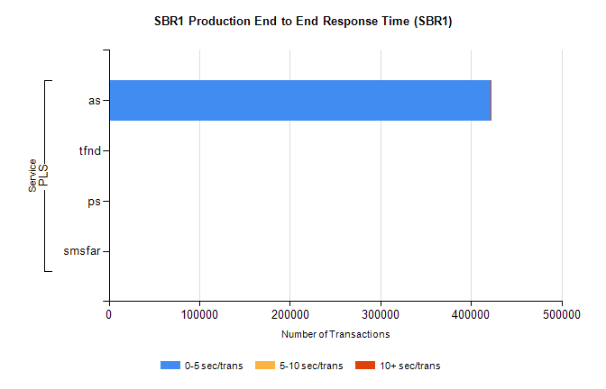
Stream | Service | 0-5 sec/trans | 5-10 sec/trans | 10+ sec/trans | Total | % within 5 sec timing target
PLS | as | 421542 | 215 | 136 | 421893 | 99.9%
PLS | tfnd | 180 | 43 | 10 | 233 | 77.3%
PLS | ps | 26 | 41 | 164 | 231 | 11.3%
PLS | smsfar | 3 | 20 | 1 | 24 | 12.5%

