Transmission Timings Report Week - 45
3/11/2025 - 9/11/2025

SBR2 External Vendor Testing Environment (EVTE3)

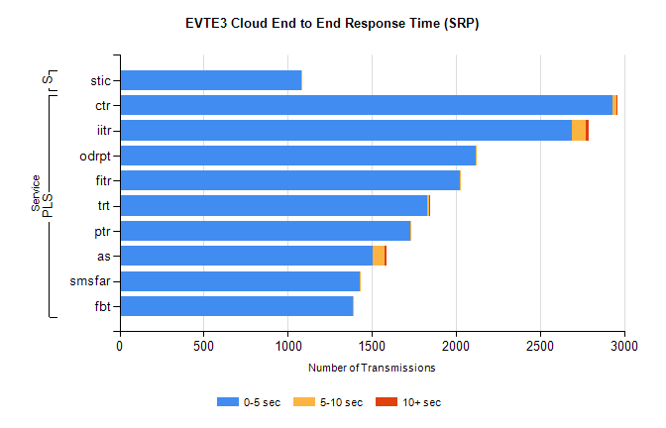
Stream | Service | 0-5 sec | 5-10 sec | >10 sec | Total | % within 5 sec timing target
PLS | ctr | 2932 | 23 | 1 | 2974 | 98.6%
PLS | iitr | 2688 | 83 | 20 | 2791 | 96.3%
PLS | odrpt | 2116 | 4 | 0 | 2120 | 99.8%
PLS | fitr | 2023 | 2 | 0 | 2025 | 99.9%
PLS | trt | 1831 | 11 | 1 | 1847 | 99.1%
PLS | ptr | 1726 | 4 | 0 | 1735 | 99.5%
PLS | as | 1503 | 73 | 12 | 1686 | 89.1%
PLS | smsfar | 1431 | 2 | 0 | 1433 | 99.9%
PLS | fbt | 1386 | 6 | 0 | 1394 | 99.4%
Super | stic | 1082 | 2 | 0 | 1084 | 99.8%

SBR2 External Vendor Testing Environment (EVTE3)

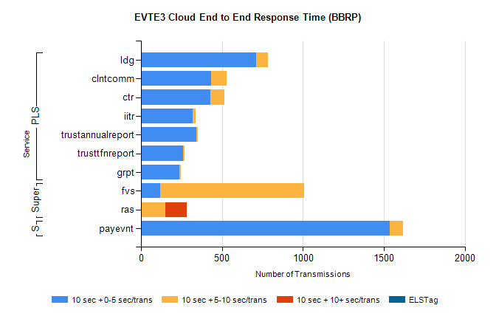
Stream | Service | 10 sec + 0-5 sec /trans | 10 sec + 5-10 sec /trans | 10 sec + >10 sec /trans | Processing Incomplete | ELStag | Total
PLS | ldg | 710 | 76 | 0 | 141 | 0 | 940
PLS | clntcomm | 432 | 98 | 0 | 84 | 0 | 614
PLS | ctr | 428 | 88 | 0 | 30 | 0 | 546
PLS | iitr | 317 | 18 | 0 | 18 | 0 | 364
PLS | trustannualreport | 340 | 12 | 0 | 0 | 0 | 352
PLS | trusttfnreport | 259 | 8 | 0 | 0 | 0 | 267
PLS | grpt | 238 | 10 | 0 | 0 | 0 | 248
STP | payevnt | 1534 | 86 | 0 | 44 | 0 | 1666
Super | fvs | 120 | 888 | 0 | 8 | 0 | 1160
Super | ras | 0 | 151 | 133 | 30 | 0 | 320

SBR2 External Vendor Testing Environment (EVTE3)

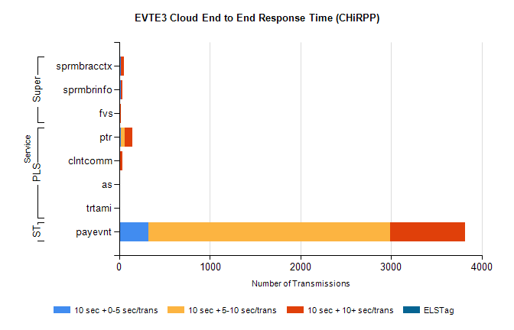
Stream | Service | 10 sec + 0-5 sec /trans | 10 sec + 5-10 sec /trans | 10 sec + >10 sec /trans | Total | % within 5 sec timing target
STP | payevnt | 323 | 2665 | 826 | 4824 | 6.7%
PLS | ptr | 20 | 40 | 85 | 230 | 8.7%
PLS | clntcomm | 0 | 1 | 32 | 34 | 0.0%
PLS | as | 0 | 0 | 12 | 13 | 0.0%
PLS | trtami | 0 | 0 | 7 | 7 | 0.0%
Super | sprmbracctx | 15 | 7 | 27 | 55 | 27.3%
Super | sprmbrinfo | 17 | 4 | 16 | 42 | 40.5%
Super | fvs | 1 | 5 | 2 | 8 | 12.5%

