Transmission Timings Report Week - 45
3/11/2025 - 9/11/2025

SBR2 Cloud Production2 - Single | Bulk or Batch Requests | (SRP, BBRP & CHiRPP)

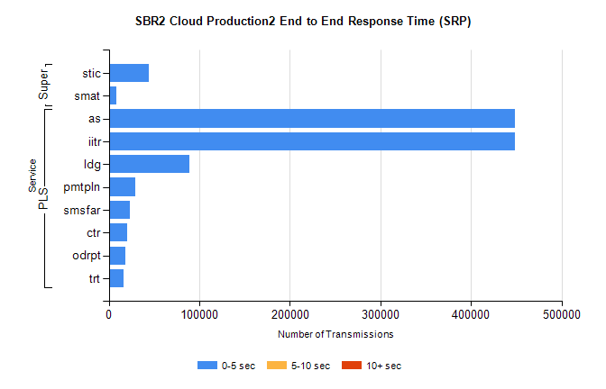
Stream | Service | 0-5 sec | 5-10 sec | >10 sec | Total | % within 5 sec timing target
PLS | as | 448881 | 0 | 0 | 448881 | 100.0%
PLS | iitr | 448771 | 0 | 0 | 448771 | 100.0%
PLS | ldg | 89065 | 0 | 0 | 89065 | 100.0%
PLS | pmtpln | 29621 | 0 | 0 | 29621 | 100.0%
PLS | smsfar | 22907 | 0 | 0 | 22907 | 100.0%
PLS | ctr | 20719 | 0 | 0 | 20719 | 100.0%
PLS | odrpt | 18794 | 0 | 0 | 18794 | 100.0%
PLS | trt | 16623 | 0 | 0 | 16623 | 100.0%
Super | stic | 44276 | 0 | 0 | 44276 | 100.0%
Super | smat | 8454 | 0 | 0 | 8454 | 100.0%

SBR2 Cloud Production2 - Single | Bulk or Batch Requests | (SRP, BBRP & CHiRPP)

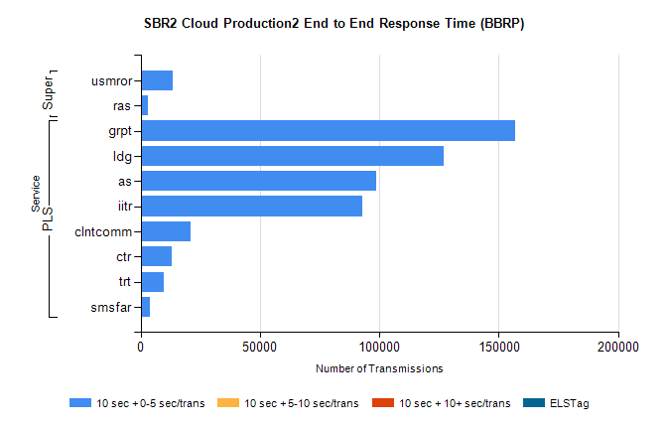
Stream | Service | 10 sec + 0-5 sec /trans | 10 sec + 5-10 sec /trans | 10 sec + >10 sec /trans | Processing Incomplete | ELStag | Total
PLS | grpt | 156877 | 0 | 0 | 0 | 0 | 156877
PLS | ldg | 126911 | 0 | 0 | 0 | 0 | 126911
PLS | as | 98784 | 0 | 0 | 0 | 0 | 98784
PLS | iitr | 92981 | 0 | 0 | 0 | 0 | 92981
PLS | clntcomm | 20836 | 0 | 0 | 0 | 0 | 20836
PLS | ctr | 13058 | 0 | 0 | 0 | 0 | 13058
PLS | trt | 9479 | 0 | 0 | 0 | 0 | 9479
PLS | smsfar | 3872 | 0 | 0 | 0 | 0 | 3872
Super | usmror | 13345 | 0 | 0 | 0 | 0 | 13345
Super | ras | 3112 | 0 | 0 | 0 | 0 | 3112

SBR2 Cloud Production2 - Single | Bulk or Batch Requests | (SRP, BBRP & CHiRPP)

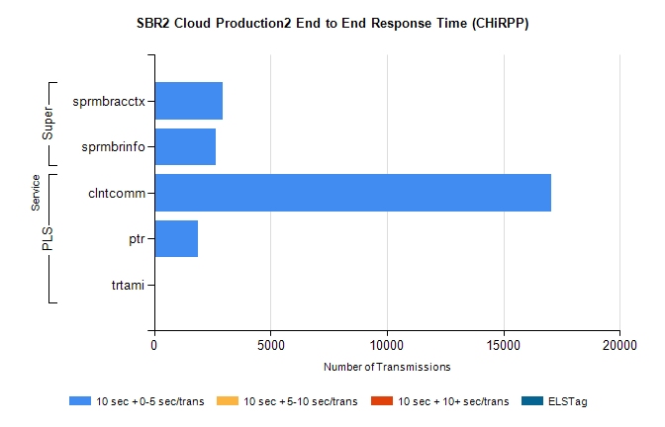
Stream | Service | 10 sec + 0-5 sec /trans | 10 sec + 5-10 sec /trans | 10 sec + >10 sec /trans | Total | % within 5 sec timing target
PLS | clntcomm | 17046 | 0 | 0 | 17046 | 100.0%
PLS | ptr | 1883 | 0 | 0 | 1883 | 100.0%
PLS | trtami | 54 | 0 | 0 | 54 | 100.0%
Super | sprmbracctx | 2929 | 0 | 0 | 2929 | 100.0%
Super | sprmbrinfo | 2660 | 0 | 0 | 2660 | 100.0%

SBR1 Production Transactions

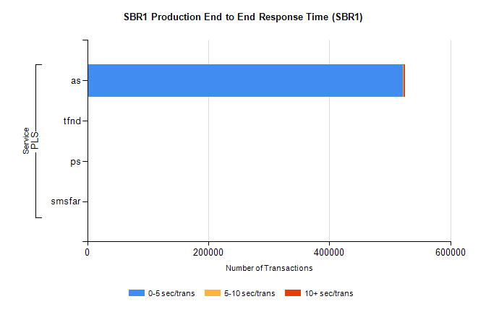
Stream | Service | 0-5 sec/trans | 5-10 sec/trans | 10+ sec/trans | Total | % within 5 sec timing target
PLS | as | 522084 | 301 | 2337 | 524722 | 99.5%
PLS | tfnd | 364 | 62 | 6 | 432 | 84.3%
PLS | ps | 40 | 38 | 98 | 176 | 22.7%
PLS | smsfar | 2 | 11 | 2 | 15 | 13.3%

