Transmission Timings Report Week - 46
10/11/2025 - 16/11/2025

SBR2 External Vendor Testing Environment (EVTE3)

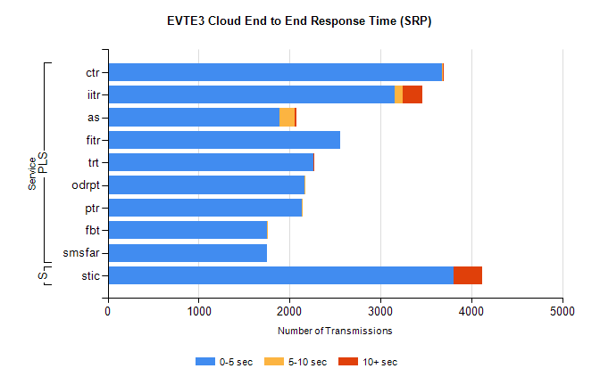
Stream | Service | 0-5 sec | 5-10 sec | >10 sec | Total | % within 5 sec timing target
PLS | ctr | 3674 | 17 | 2 | 3694 | 99.5%
PLS | iitr | 3153 | 93 | 217 | 3470 | 90.9%
PLS | as | 1888 | 170 | 16 | 2836 | 66.6%
PLS | fitr | 2557 | 0 | 0 | 2557 | 100.0%
PLS | trt | 2260 | 7 | 4 | 2271 | 99.5%
PLS | odrpt | 2163 | 10 | 0 | 2173 | 99.5%
PLS | ptr | 2133 | 15 | 0 | 2148 | 99.3%
PLS | fbt | 1750 | 9 | 0 | 1759 | 99.5%
PLS | smsfar | 1755 | 0 | 0 | 1755 | 100.0%
Super | stic | 3804 | 4 | 314 | 4122 | 92.3%

SBR2 External Vendor Testing Environment (EVTE3)

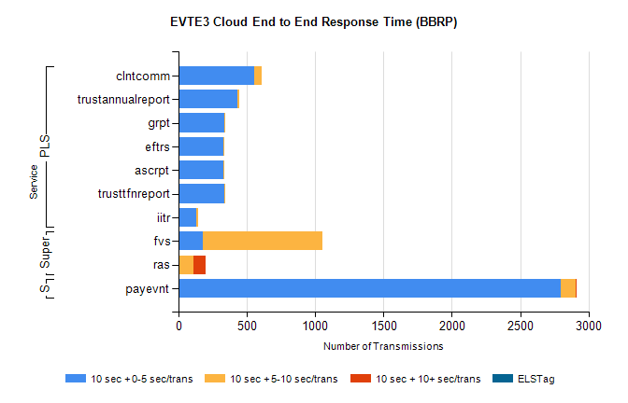
Stream | Service | 10 sec + 0-5 sec /trans | 10 sec + 5-10 sec /trans | 10 sec + >10 sec /trans | Processing Incomplete | ELStag | Total
STP | payevnt | 2796 | 111 | 1 | 47 | 0 | 2956
PLS | clntcomm | 556 | 50 | 0 | 156 | 0 | 764
PLS | trustannualreport | 433 | 13 | 0 | 0 | 0 | 446
PLS | grpt | 333 | 11 | 0 | 1 | 0 | 345
PLS | ascrpt | 326 | 12 | 0 | 0 | 0 | 338
PLS | eftrs | 326 | 12 | 0 | 0 | 0 | 338
PLS | trusttfnreport | 336 | 1 | 0 | 0 | 0 | 337
PLS | iitr | 129 | 16 | 0 | 39 | 0 | 193
Super | fvs | 180 | 876 | 0 | 6 | 0 | 1137
Super | ras | 0 | 110 | 90 | 122 | 0 | 340

SBR2 External Vendor Testing Environment (EVTE3)

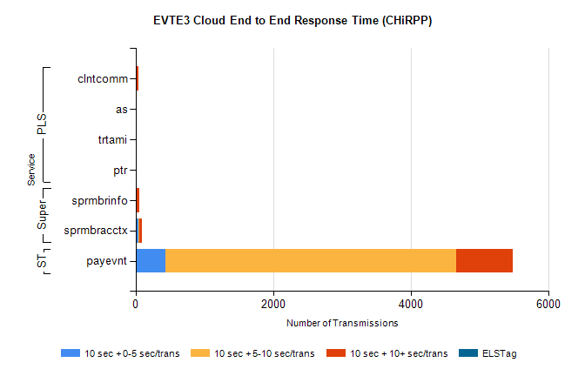
Stream | Service | 10 sec + 0-5 sec /trans | 10 sec + 5-10 sec /trans | 10 sec + >10 sec /trans | Total | % within 5 sec timing target
STP | payevnt | 439 | 4217 | 824 | 6887 | 6.4%
Super | sprmbrinfo | 8 | 7 | 41 | 503 | 11.4%
Super | sprmbracctx | 43 | 12 | 38 | 155 | 38.4%
PLS | clntcomm | 2 | 1 | 39 | 48 | 4.2%
PLS | as | 0 | 0 | 13 | 14 | 0.0%
PLS | trtami | 0 | 0 | 9 | 9 | 0.0%
PLS | ptr | 1 | 1 | 4 | 7 | 14.3%

