Transmission Timings Report Week - 46
10/11/2025 - 16/11/2025

SBR2 Cloud Production2 - Single | Bulk or Batch Requests | (SRP, BBRP & CHiRPP)

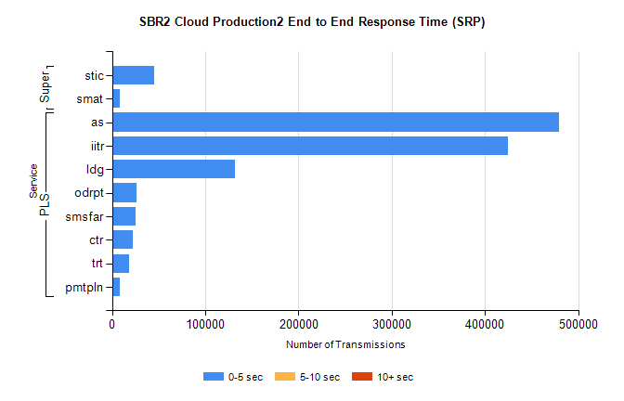
Stream | Service | 0-5 sec | 5-10 sec | >10 sec | Total | % within 5 sec timing target
PLS | as | 479009 | 0 | 0 | 479009 | 100.0%
PLS | iitr | 424773 | 0 | 0 | 424773 | 100.0%
PLS | ldg | 131612 | 0 | 0 | 131612 | 100.0%
PLS | odrpt | 26334 | 0 | 0 | 26334 | 100.0%
PLS | smsfar | 25397 | 0 | 0 | 25397 | 100.0%
PLS | ctr | 22680 | 0 | 0 | 22680 | 100.0%
PLS | trt | 18530 | 0 | 0 | 18530 | 100.0%
PLS | pmtpln | 8674 | 0 | 0 | 8674 | 100.0%
Super | stic | 45332 | 0 | 0 | 45332 | 100.0%
Super | smat | 8388 | 0 | 0 | 8388 | 100.0%

SBR2 Cloud Production2 - Single | Bulk or Batch Requests | (SRP, BBRP & CHiRPP)

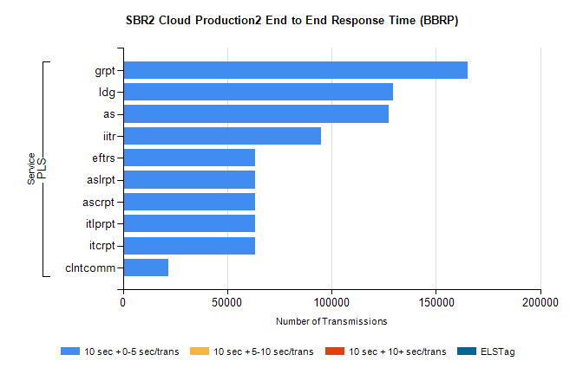
Stream | Service | 10 sec + 0-5 sec /trans | 10 sec + 5-10 sec /trans | 10 sec + >10 sec /trans | Processing Incomplete | ELStag | Total
PLS | grpt | 165306 | 0 | 0 | 0 | 0 | 165306
PLS | ldg | 129345 | 0 | 0 | 0 | 0 | 129345
PLS | as | 127510 | 0 | 0 | 0 | 0 | 127510
PLS | iitr | 95096 | 0 | 0 | 0 | 0 | 95096
PLS | itcrpt | 63185 | 0 | 0 | 0 | 0 | 63185
PLS | itlprpt | 63185 | 0 | 0 | 0 | 0 | 63185
PLS | ascrpt | 63185 | 0 | 0 | 0 | 0 | 63185
PLS | aslrpt | 63185 | 0 | 0 | 0 | 0 | 63185
PLS | eftrs | 63185 | 0 | 0 | 0 | 0 | 63185
PLS | clntcomm | 21592 | 0 | 0 | 0 | 0 | 21592

SBR2 Cloud Production2 - Single | Bulk or Batch Requests | (SRP, BBRP & CHiRPP)

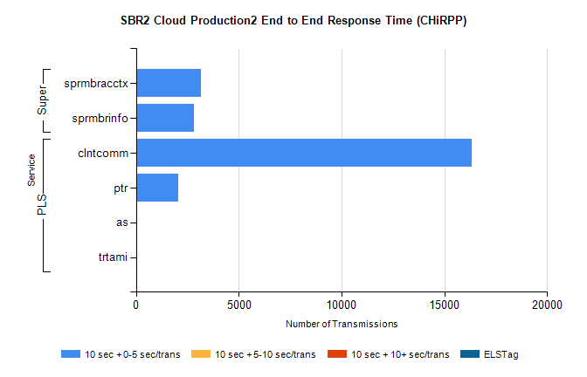
Stream | Service | 10 sec + 0-5 sec /trans | 10 sec + 5-10 sec /trans | 10 sec + >10 sec /trans | Total | % within 5 sec timing target
PLS | clntcomm | 16344 | 0 | 0 | 16344 | 100.0%
PLS | ptr | 2040 | 0 | 0 | 2040 | 100.0%
PLS | as | 27 | 0 | 0 | 27 | 100.0%
PLS | trtami | 20 | 0 | 0 | 20 | 100.0%
Super | sprmbracctx | 3173 | 0 | 0 | 3173 | 100.0%
Super | sprmbrinfo | 2817 | 0 | 0 | 2817 | 100.0%

SBR1 Production Transactions

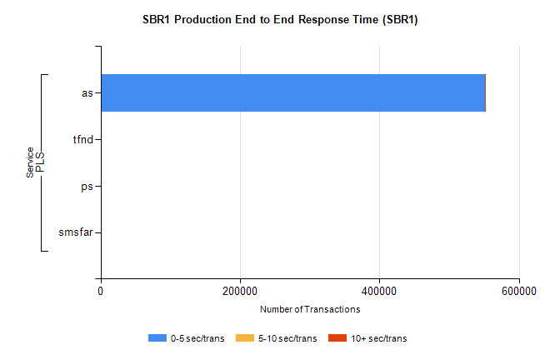
Stream | Service | 0-5 sec/trans | 5-10 sec/trans | 10+ sec/trans | Total | % within 5 sec timing target
PLS | as | 551198 | 160 | 1185 | 552543 | 99.8%
PLS | tfnd | 247 | 37 | 5 | 289 | 85.5%
PLS | ps | 46 | 62 | 131 | 239 | 19.2%
PLS | smsfar | 4 | 21 | 5 | 30 | 13.3%

