Transmission Timings Report Week - 47
17/11/2025 - 23/11/2025

SBR2 External Vendor Testing Environment (EVTE3)

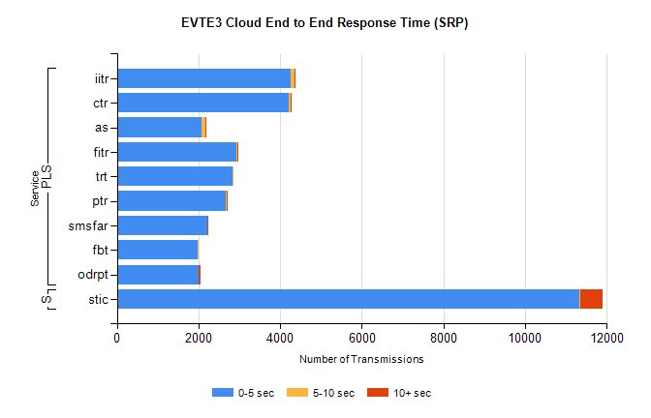
Stream | Service | 0-5 sec | 5-10 sec | >10 sec | Total | % within 5 sec timing target
PLS | iitr | 4258 | 98 | 21 | 4449 | 95.7%
PLS | ctr | 4215 | 35 | 7 | 4332 | 97.3%
PLS | as | 2066 | 105 | 5 | 3472 | 59.5%
PLS | fitr | 2941 | 2 | 1 | 2999 | 98.1%
PLS | trt | 2842 | 16 | 0 | 2901 | 98.0%
PLS | ptr | 2679 | 8 | 1 | 2736 | 97.9%
PLS | smsfar | 2221 | 2 | 1 | 2224 | 99.9%
PLS | fbt | 1969 | 12 | 0 | 2073 | 95.0%
PLS | odrpt | 2004 | 3 | 40 | 2047 | 97.9%
Super | stic | 11330 | 22 | 545 | 12030 | 94.2%

SBR2 External Vendor Testing Environment (EVTE3)

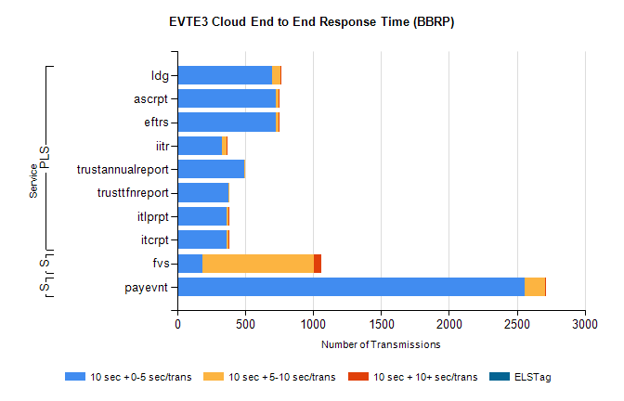
Stream | Service | 10 sec + 0-5 sec /trans | 10 sec + 5-10 sec /trans | 10 sec + >10 sec /trans | Processing Incomplete | ELStag | Total
PLS | ldg | 694 | 68 | 4 | 50 | 0 | 833
PLS | eftrs | 724 | 22 | 4 | 0 | 0 | 750
PLS | ascrpt | 724 | 22 | 4 | 0 | 0 | 750
PLS | iitr | 328 | 35 | 5 | 343 | 0 | 715
PLS | trustannualreport | 492 | 9 | 0 | 0 | 0 | 501
PLS | trusttfnreport | 375 | 5 | 0 | 0 | 0 | 381
PLS | itcrpt | 362 | 11 | 2 | 0 | 0 | 375
PLS | itlprpt | 362 | 11 | 2 | 0 | 0 | 375
STP | payevnt | 2554 | 155 | 5 | 35 | 0 | 2754
Super | fvs | 185 | 820 | 57 | 49 | 0 | 1190

SBR2 External Vendor Testing Environment (EVTE3)

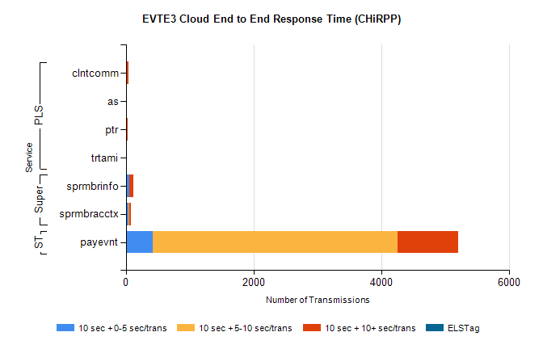
Stream | Service | 10 sec + 0-5 sec /trans | 10 sec + 5-10 sec /trans | 10 sec + >10 sec /trans | Total | % within 5 sec timing target
STP | payevnt | 421 | 3831 | 948 | 6631 | 6.4%
Super | sprmbrinfo | 53 | 5 | 55 | 208 | 40.8%
Super | sprmbracctx | 38 | 13 | 25 | 105 | 40.0%
PLS | clntcomm | 0 | 0 | 37 | 41 | 0.0%
PLS | as | 2 | 2 | 15 | 29 | 6.9%
PLS | ptr | 0 | 0 | 23 | 25 | 0.0%
PLS | trtami | 0 | 0 | 5 | 5 | 0.0%

