Transmission Timings Report Week - 47
17/11/2025 - 23/11/2025

SBR2 Cloud Production2 - Single | Bulk or Batch Requests | (SRP, BBRP & CHiRPP)

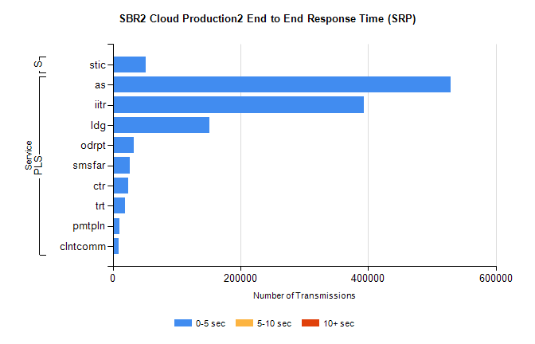
Stream | Service | 0-5 sec | 5-10 sec | >10 sec | Total | % within 5 sec timing target
PLS | as | 528688 | 0 | 0 | 528688 | 100.0%
PLS | iitr | 392829 | 0 | 0 | 392829 | 100.0%
PLS | ldg | 151449 | 0 | 0 | 151449 | 100.0%
PLS | odrpt | 32637 | 0 | 0 | 32637 | 100.0%
PLS | smsfar | 26162 | 0 | 0 | 26162 | 100.0%
PLS | ctr | 23860 | 0 | 0 | 23860 | 100.0%
PLS | trt | 19590 | 0 | 0 | 19590 | 100.0%
PLS | pmtpln | 10636 | 0 | 0 | 10636 | 100.0%
PLS | clntcomm | 9101 | 0 | 0 | 9101 | 100.0%
Super | stic | 52043 | 0 | 0 | 52043 | 100.0%

SBR2 Cloud Production2 - Single | Bulk or Batch Requests | (SRP, BBRP & CHiRPP)

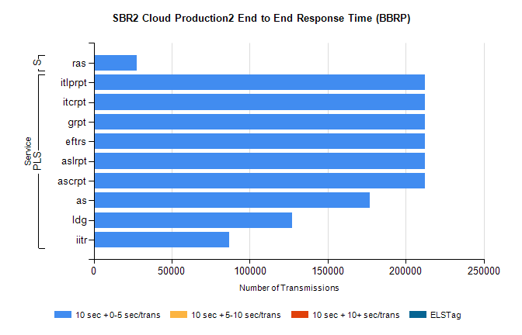
Stream | Service | 10 sec + 0-5 sec /trans | 10 sec + 5-10 sec /trans | 10 sec + >10 sec /trans | Processing Incomplete | ELStag | Total
PLS | ascrpt | 212340 | 0 | 0 | 0 | 0 | 212340
PLS | aslrpt | 212340 | 0 | 0 | 0 | 0 | 212340
PLS | eftrs | 212340 | 0 | 0 | 0 | 0 | 212340
PLS | grpt | 212340 | 0 | 0 | 0 | 0 | 212340
PLS | itcrpt | 212340 | 0 | 0 | 0 | 0 | 212340
PLS | itlprpt | 212340 | 0 | 0 | 0 | 0 | 212340
PLS | as | 176760 | 0 | 0 | 0 | 0 | 176760
PLS | ldg | 127190 | 0 | 0 | 0 | 0 | 127190
PLS | iitr | 86994 | 0 | 0 | 0 | 0 | 86994
Super | ras | 27353 | 0 | 0 | 0 | 0 | 27353

SBR2 Cloud Production2 - Single | Bulk or Batch Requests | (SRP, BBRP & CHiRPP)

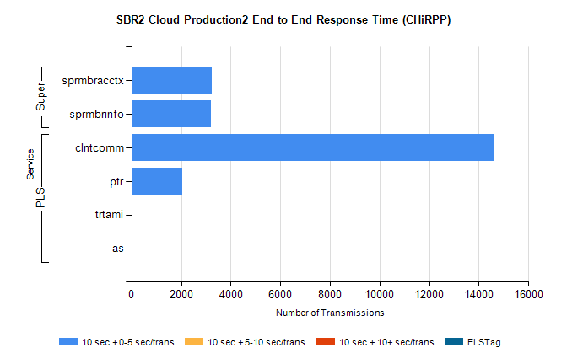
Stream | Service | 10 sec + 0-5 sec /trans | 10 sec + 5-10 sec /trans | 10 sec + >10 sec /trans | Total | % within 5 sec timing target
PLS | clntcomm | 14627 | 0 | 0 | 14627 | 100.0%
PLS | ptr | 2036 | 0 | 0 | 2036 | 100.0%
PLS | trtami | 43 | 0 | 0 | 43 | 100.0%
PLS | as | 16 | 0 | 0 | 16 | 100.0%
Super | sprmbracctx | 3243 | 0 | 0 | 3243 | 100.0%
Super | sprmbrinfo | 3192 | 0 | 0 | 3192 | 100.0%

SBR1 Production Transactions

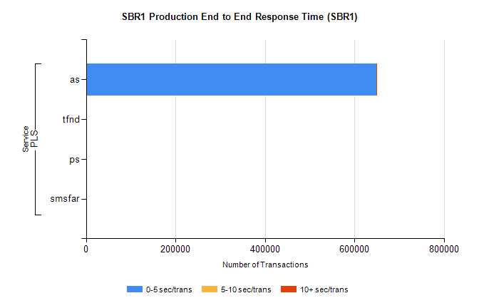
Stream | Service | 0-5 sec/trans | 5-10 sec/trans | 10+ sec/trans | Total | % within 5 sec timing target
PLS | as | 649404 | 194 | 839 | 650437 | 99.8%
PLS | tfnd | 319 | 52 | 11 | 382 | 83.5%
PLS | ps | 26 | 53 | 106 | 185 | 14.1%
PLS | smsfar | 6 | 19 | 3 | 28 | 21.4%

