Transmission Timings Report Week - 48
24/11/2025 - 30/11/2025

SBR2 External Vendor Testing Environment (EVTE3)

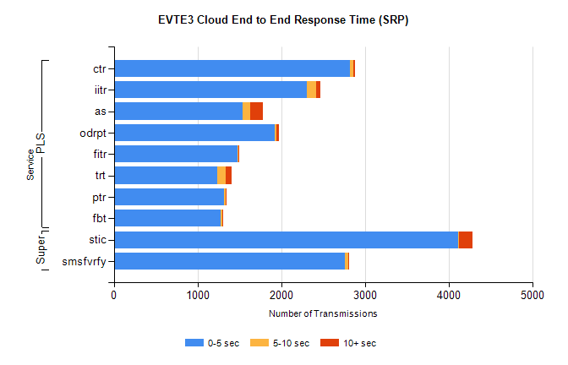
Stream | Service | 0-5 sec | 5-10 sec | >10 sec | Total | % within 5 sec timing target
PLS | ctr | 2822 | 44 | 19 | 2979 | 94.7%
PLS | iitr | 2311 | 106 | 54 | 2609 | 88.6%
PLS | as | 1539 | 92 | 153 | 2018 | 76.3%
PLS | odrpt | 1921 | 20 | 36 | 1977 | 97.2%
PLS | fitr | 1483 | 6 | 5 | 1526 | 97.2%
PLS | trt | 1232 | 106 | 74 | 1466 | 84.0%
PLS | ptr | 1314 | 23 | 7 | 1344 | 97.8%
PLS | fbt | 1278 | 17 | 3 | 1319 | 96.9%
Super | stic | 4115 | 5 | 162 | 4282 | 96.1%
Super | smsfvrfy | 2765 | 39 | 9 | 2813 | 98.3%

SBR2 External Vendor Testing Environment (EVTE3)

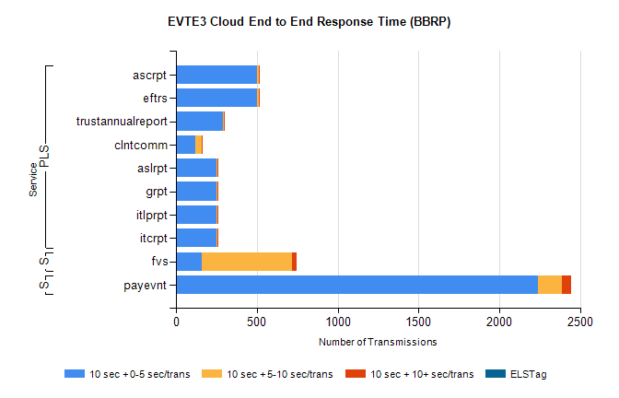
Stream | Service | 10 sec + 0-5 sec /trans | 10 sec + 5-10 sec /trans | 10 sec + >10 sec /trans | Processing Incomplete | ELStag | Total
PLS | eftrs | 500 | 10 | 10 | 0 | 0 | 520
PLS | ascrpt | 500 | 10 | 10 | 0 | 0 | 520
PLS | trustannualreport | 289 | 6 | 5 | 0 | 0 | 300
PLS | clntcomm | 121 | 39 | 2 | 102 | 0 | 264
PLS | itcrpt | 250 | 5 | 5 | 0 | 0 | 260
PLS | itlprpt | 250 | 5 | 5 | 0 | 0 | 260
PLS | grpt | 250 | 5 | 5 | 0 | 0 | 260
PLS | aslrpt | 250 | 5 | 5 | 0 | 0 | 260
STP | payevnt | 2241 | 149 | 54 | 33 | 0 | 2484
Super | fvs | 161 | 555 | 29 | 23 | 0 | 805

SBR2 External Vendor Testing Environment (EVTE3)

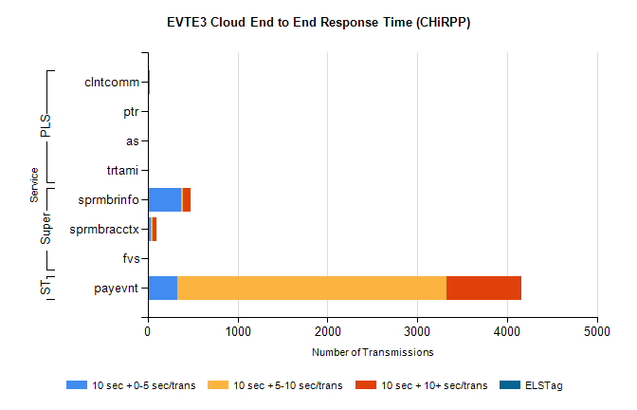
Stream | Service | 10 sec + 0-5 sec /trans | 10 sec + 5-10 sec /trans | 10 sec + >10 sec /trans | Total | % within 5 sec timing target
STP | payevnt | 330 | 2998 | 833 | 5491 | 6.0%
Super | sprmbrinfo | 374 | 21 | 82 | 529 | 70.7%
Super | sprmbracctx | 29 | 23 | 49 | 120 | 24.2%
Super | fvs | 3 | 4 | 1 | 17 | 21.4%
PLS | clntcomm | 0 | 0 | 28 | 31 | 0.0%
PLS | ptr | 0 | 2 | 8 | 10 | 0.0%
PLS | trtami | 0 | 0 | 2 | 2 | 0.0%
PLS | as | 0 | 0 | 2 | 2 | 0.0%

