Transmission Timings Report Week - 48
24/11/2025 - 30/11/2025

SBR2 Cloud Production2 - Single | Bulk or Batch Requests | (SRP, BBRP & CHiRPP)

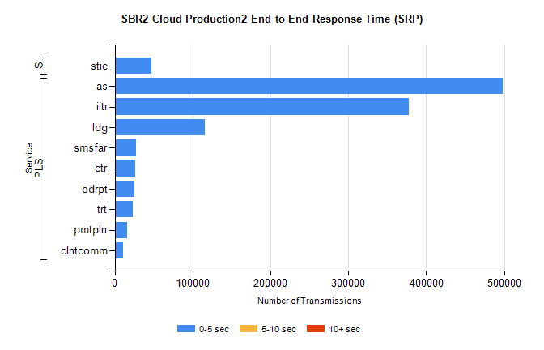
Stream | Service | 0-5 sec | 5-10 sec | >10 sec | Total | % within 5 sec timing target
PLS | as | 498157 | 0 | 0 | 498157 | 100.0%
PLS | iitr | 377669 | 0 | 0 | 377669 | 100.0%
PLS | ldg | 115365 | 0 | 0 | 115365 | 100.0%
PLS | smsfar | 26817 | 0 | 0 | 26817 | 100.0%
PLS | ctr | 26308 | 0 | 0 | 26308 | 100.0%
PLS | odrpt | 25603 | 0 | 0 | 25603 | 100.0%
PLS | trt | 22991 | 0 | 0 | 22991 | 100.0%
PLS | pmtpln | 16115 | 0 | 0 | 16115 | 100.0%
PLS | clntcomm | 10224 | 0 | 0 | 10224 | 100.0%
Super | stic | 47136 | 0 | 0 | 47136 | 100.0%

SBR2 Cloud Production2 - Single | Bulk or Batch Requests | (SRP, BBRP & CHiRPP)

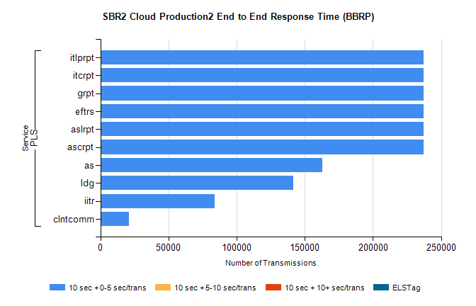
Stream | Service | 10 sec + 0-5 sec /trans | 10 sec + 5-10 sec /trans | 10 sec + >10 sec /trans | Processing Incomplete | ELStag | Total
PLS | ascrpt | 237305 | 0 | 0 | 0 | 0 | 237305
PLS | aslrpt | 237305 | 0 | 0 | 0 | 0 | 237305
PLS | eftrs | 237305 | 0 | 0 | 0 | 0 | 237305
PLS | grpt | 237305 | 0 | 0 | 0 | 0 | 237305
PLS | itcrpt | 237305 | 0 | 0 | 0 | 0 | 237305
PLS | itlprpt | 237305 | 0 | 0 | 0 | 0 | 237305
PLS | as | 162698 | 0 | 0 | 0 | 0 | 162698
PLS | ldg | 141585 | 0 | 0 | 0 | 0 | 141585
PLS | iitr | 83792 | 0 | 0 | 0 | 0 | 83792
PLS | clntcomm | 20792 | 0 | 0 | 0 | 0 | 20792

SBR2 Cloud Production2 - Single | Bulk or Batch Requests | (SRP, BBRP & CHiRPP)

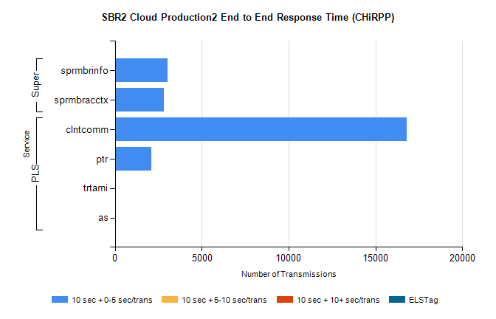
Stream | Service | 10 sec + 0-5 sec /trans | 10 sec + 5-10 sec /trans | 10 sec + >10 sec /trans | Total | % within 5 sec timing target
PLS | clntcomm | 16792 | 0 | 0 | 16792 | 100.0%
PLS | ptr | 2104 | 0 | 0 | 2104 | 100.0%
PLS | trtami | 30 | 0 | 0 | 30 | 100.0%
PLS | as | 18 | 0 | 0 | 18 | 100.0%
Super | sprmbrinfo | 3044 | 0 | 0 | 3044 | 100.0%
Super | sprmbracctx | 2816 | 0 | 0 | 2816 | 100.0%

SBR1 Production Transactions

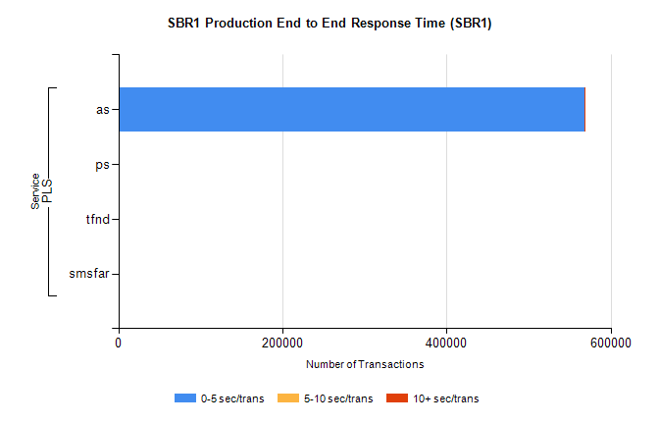
Stream | Service | 0-5 sec/trans | 5-10 sec/trans | 10+ sec/trans | Total | % within 5 sec timing target
PLS | as | 568027 | 232 | 273 | 568532 | 99.9%
PLS | ps | 90 | 55 | 138 | 283 | 31.8%
PLS | tfnd | 209 | 48 | 8 | 265 | 78.9%
PLS | smsfar | 1 | 8 |  | 9 | 11.1%

