Transmission Timings Report Week - 49
1/12/2025 - 7/12/2025

SBR2 External Vendor Testing Environment (EVTE3)

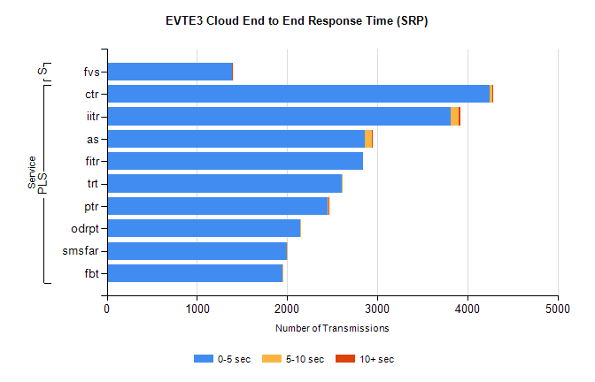
Stream | Service | 0-5 sec | 5-10 sec | >10 sec | Total | % within 5 sec timing target
PLS | ctr | 4242 | 37 | 2 | 4324 | 98.1%
PLS | iitr | 3810 | 96 | 14 | 4018 | 94.8%
PLS | as | 2860 | 78 | 5 | 3244 | 88.2%
PLS | fitr | 2844 | 0 | 0 | 2852 | 99.7%
PLS | trt | 2605 | 9 | 0 | 2619 | 99.5%
PLS | ptr | 2445 | 13 | 2 | 2474 | 98.8%
PLS | odrpt | 2144 | 14 | 0 | 2158 | 99.4%
PLS | smsfar | 1997 | 1 | 0 | 1998 | 99.9%
PLS | fbt | 1950 | 10 | 0 | 1960 | 99.5%
Super | fvs | 1385 | 1 | 4 | 1391 | 99.6%

SBR2 External Vendor Testing Environment (EVTE3)

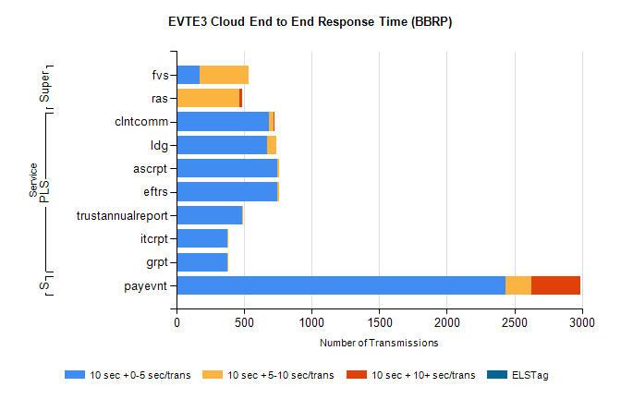
Stream | Service | 10 sec + 0-5 sec /trans | 10 sec + 5-10 sec /trans | 10 sec + >10 sec /trans | Processing Incomplete | ELStag | Total
PLS | clntcomm | 681 | 40 | 1 | 73 | 0 | 795
PLS | ldg | 672 | 66 | 0 | 46 | 0 | 784
PLS | eftrs | 748 | 12 | 0 | 0 | 0 | 760
PLS | ascrpt | 748 | 12 | 0 | 0 | 0 | 760
PLS | trustannualreport | 484 | 10 | 0 | 0 | 0 | 494
PLS | grpt | 374 | 6 | 0 | 0 | 0 | 380
PLS | itcrpt | 374 | 6 | 0 | 0 | 0 | 380
STP | payevnt | 2434 | 190 | 366 | 39 | 0 | 3089
Super | fvs | 172 | 361 | 0 | 8 | 0 | 559
Super | ras | 0 | 467 | 17 | 1 | 0 | 494

SBR2 External Vendor Testing Environment (EVTE3)

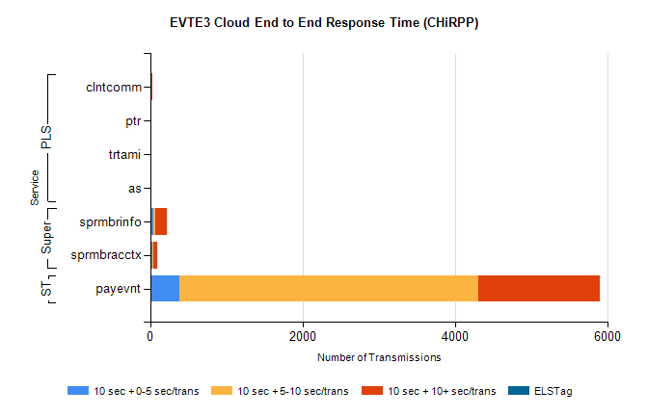
Stream | Service | 10 sec + 0-5 sec /trans | 10 sec + 5-10 sec /trans | 10 sec + >10 sec /trans | Total | % within 5 sec timing target
STP | payevnt | 380 | 3921 | 1601 | 7547 | 5.0%
Super | sprmbrinfo | 40 | 32 | 140 | 252 | 15.9%
Super | sprmbracctx | 23 | 13 | 54 | 105 | 21.9%
PLS | clntcomm | 0 | 0 | 22 | 22 | 0.0%
PLS | ptr | 0 | 0 | 11 | 11 | 0.0%
PLS | trtami | 0 | 0 | 6 | 6 | 0.0%
PLS | as | 0 | 0 | 5 | 5 | 0.0%

