Transmission Timings Report Week - 49
1/12/2025 - 7/12/2025

SBR2 Cloud Production2 - Single | Bulk or Batch Requests | (SRP, BBRP & CHiRPP)

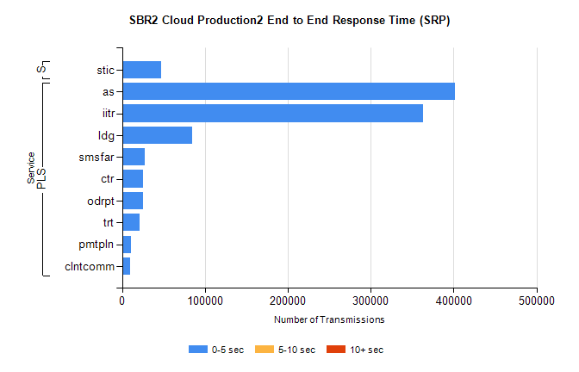
Stream | Service | 0-5 sec | 5-10 sec | >10 sec | Total | % within 5 sec timing target
PLS | as | 401986 | 0 | 0 | 401986 | 100.0%
PLS | iitr | 363242 | 0 | 0 | 363242 | 100.0%
PLS | ldg | 84501 | 0 | 0 | 84501 | 100.0%
PLS | smsfar | 26834 | 0 | 0 | 26834 | 100.0%
PLS | ctr | 25753 | 0 | 0 | 25753 | 100.0%
PLS | odrpt | 25536 | 0 | 0 | 25536 | 100.0%
PLS | trt | 21341 | 0 | 0 | 21341 | 100.0%
PLS | pmtpln | 10911 | 0 | 0 | 10911 | 100.0%
PLS | clntcomm | 9777 | 0 | 0 | 9777 | 100.0%
Super | stic | 47424 | 0 | 0 | 47424 | 100.0%

SBR2 Cloud Production2 - Single | Bulk or Batch Requests | (SRP, BBRP & CHiRPP)

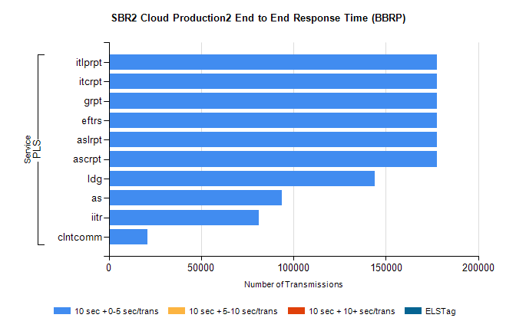
Stream | Service | 10 sec + 0-5 sec /trans | 10 sec + 5-10 sec /trans | 10 sec + >10 sec /trans | Processing Incomplete | ELStag | Total
PLS | ascrpt | 177501 | 0 | 0 | 0 | 0 | 177501
PLS | aslrpt | 177501 | 0 | 0 | 0 | 0 | 177501
PLS | eftrs | 177501 | 0 | 0 | 0 | 0 | 177501
PLS | grpt | 177501 | 0 | 0 | 0 | 0 | 177501
PLS | itcrpt | 177501 | 0 | 0 | 0 | 0 | 177501
PLS | itlprpt | 177501 | 0 | 0 | 0 | 0 | 177501
PLS | ldg | 143840 | 0 | 0 | 0 | 0 | 143840
PLS | as | 93598 | 0 | 0 | 0 | 0 | 93598
PLS | iitr | 81229 | 0 | 0 | 0 | 0 | 81229
PLS | clntcomm | 20993 | 0 | 0 | 0 | 0 | 20993

SBR2 Cloud Production2 - Single | Bulk or Batch Requests | (SRP, BBRP & CHiRPP)

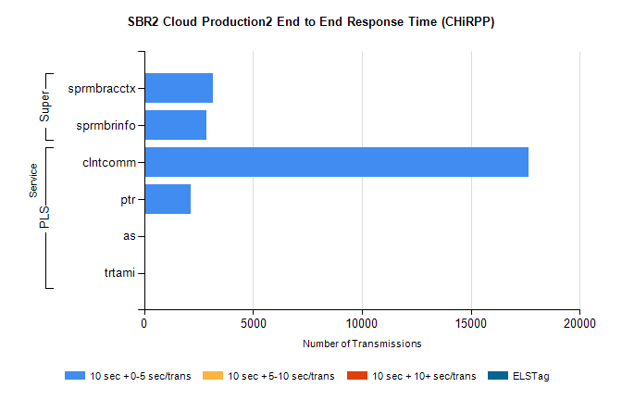
Stream | Service | 10 sec + 0-5 sec /trans | 10 sec + 5-10 sec /trans | 10 sec + >10 sec /trans | Total | % within 5 sec timing target
PLS | clntcomm | 17665 | 0 | 0 | 17665 | 100.0%
PLS | ptr | 2142 | 0 | 0 | 2142 | 100.0%
PLS | as | 19 | 0 | 0 | 19 | 100.0%
PLS | trtami | 18 | 0 | 0 | 18 | 100.0%
Super | sprmbracctx | 3174 | 0 | 0 | 3174 | 100.0%
Super | sprmbrinfo | 2855 | 0 | 0 | 2855 | 100.0%

SBR1 Production Transactions

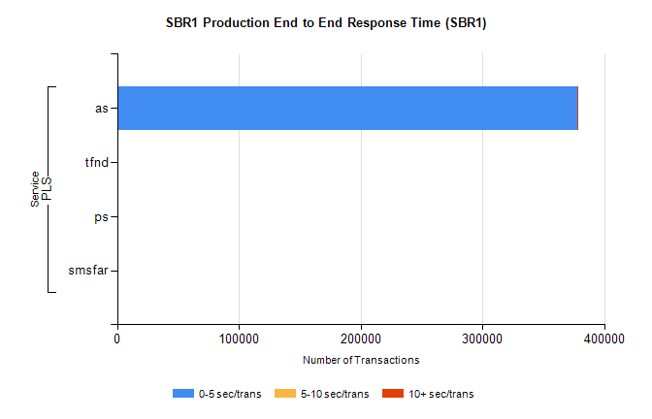
Stream | Service | 0-5 sec/trans | 5-10 sec/trans | 10+ sec/trans | Total | % within 5 sec timing target
PLS | as | 377770 | 245 | 946 | 378961 | 99.7%
PLS | tfnd | 243 | 48 | 8 | 299 | 81.3%
PLS | ps | 10 | 33 | 94 | 137 | 7.3%
PLS | smsfar | 4 | 16 | 2 | 22 | 18.2%

