Transmission Timings Report Week - 50
8/12/2025 - 14/12/2025

SBR2 External Vendor Testing Environment (EVTE3)

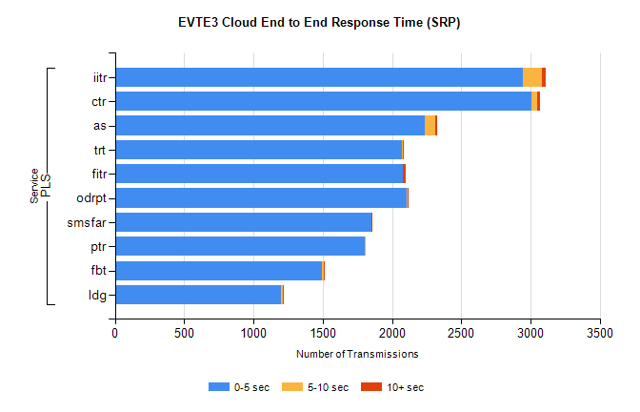
Stream | Service | 0-5 sec | 5-10 sec | >10 sec | Total | % within 5 sec timing target
PLS | iitr | 2946 | 137 | 29 | 3116 | 94.5%
PLS | ctr | 3005 | 41 | 23 | 3098 | 97.0%
PLS | as | 2240 | 73 | 10 | 2417 | 92.7%
PLS | trt | 2072 | 5 | 4 | 2181 | 95.0%
PLS | fitr | 2080 | 0 | 20 | 2126 | 97.8%
PLS | odrpt | 2105 | 5 | 1 | 2111 | 99.7%
PLS | smsfar | 1849 | 6 | 2 | 1858 | 99.5%
PLS | ptr | 1805 | 5 | 0 | 1831 | 98.6%
PLS | fbt | 1496 | 11 | 6 | 1570 | 95.3%
PLS | ldg | 1200 | 13 | 1 | 1215 | 98.8%

SBR2 External Vendor Testing Environment (EVTE3)

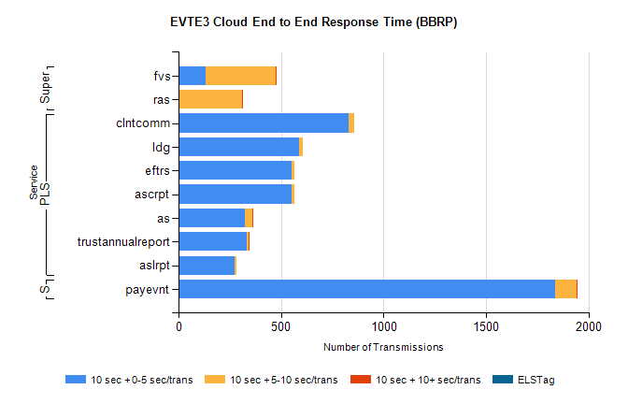
Stream | Service | 10 sec + 0-5 sec /trans | 10 sec + 5-10 sec /trans | 10 sec + >10 sec /trans | Processing Incomplete | ELStag | Total
PLS | clntcomm | 830 | 27 | 0 | 49 | 0 | 906
PLS | ldg | 588 | 16 | 0 | 123 | 0 | 727
PLS | ascrpt | 550 | 16 | 0 | 4 | 0 | 578
PLS | eftrs | 550 | 16 | 0 | 4 | 0 | 578
PLS | as | 323 | 37 | 1 | 17 | 0 | 381
PLS | trustannualreport | 334 | 10 | 1 | 0 | 0 | 354
PLS | aslrpt | 275 | 8 | 0 | 2 | 0 | 289
STP | payevnt | 1835 | 107 | 3 | 52 | 0 | 2004
Super | fvs | 134 | 339 | 1 | 7 | 0 | 497
Super | ras | 0 | 312 | 4 | 0 | 0 | 329

SBR2 External Vendor Testing Environment (EVTE3)

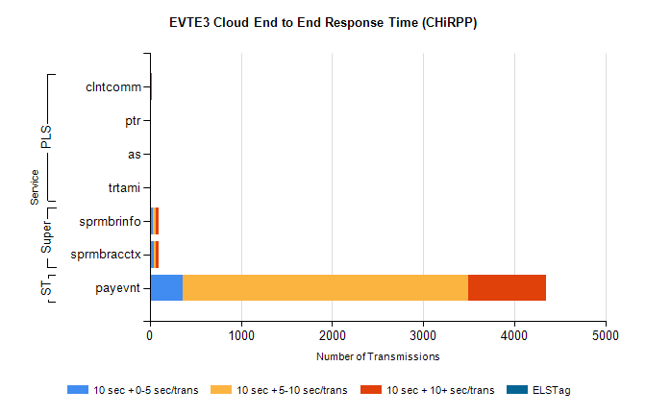
Stream | Service | 10 sec + 0-5 sec /trans | 10 sec + 5-10 sec /trans | 10 sec + >10 sec /trans | Total | % within 5 sec timing target
STP | payevnt | 357 | 3134 | 859 | 5731 | 6.2%
Super | sprmbrinfo | 36 | 25 | 41 | 139 | 25.9%
Super | sprmbracctx | 45 | 18 | 39 | 119 | 37.8%
PLS | clntcomm | 0 | 0 | 27 | 27 | 0.0%
PLS | ptr | 0 | 0 | 7 | 8 | 0.0%
PLS | as | 0 | 0 | 5 | 7 | 0.0%
PLS | trtami | 0 | 0 | 2 | 2 | 0.0%

