Transmission Timings Report Week - 50
8/12/2025 - 14/12/2025

SBR2 Cloud Production2 - Single | Bulk or Batch Requests | (SRP, BBRP & CHiRPP)

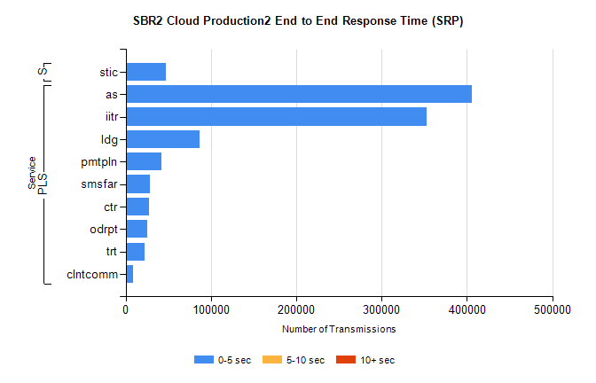
Stream | Service | 0-5 sec | 5-10 sec | >10 sec | Total | % within 5 sec timing target
PLS | as | 405895 | 0 | 0 | 405895 | 100.0%
PLS | iitr | 353099 | 0 | 0 | 353099 | 100.0%
PLS | ldg | 86949 | 0 | 0 | 86949 | 100.0%
PLS | pmtpln | 42211 | 0 | 0 | 42211 | 100.0%
PLS | smsfar | 28011 | 0 | 0 | 28011 | 100.0%
PLS | ctr | 27574 | 0 | 0 | 27574 | 100.0%
PLS | odrpt | 25607 | 0 | 0 | 25607 | 100.0%
PLS | trt | 22114 | 0 | 0 | 22114 | 100.0%
PLS | clntcomm | 8998 | 0 | 0 | 8998 | 100.0%
Super | stic | 47474 | 0 | 0 | 47474 | 100.0%

SBR2 Cloud Production2 - Single | Bulk or Batch Requests | (SRP, BBRP & CHiRPP)

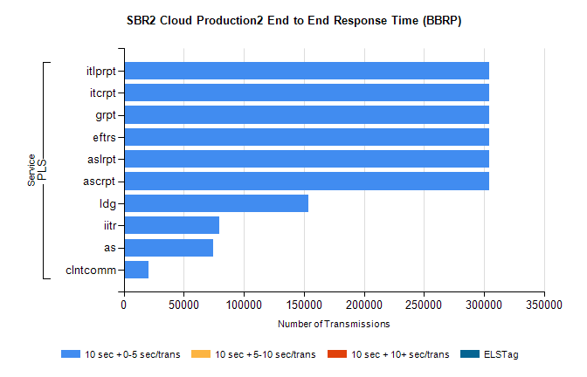
Stream | Service | 10 sec + 0-5 sec /trans | 10 sec + 5-10 sec /trans | 10 sec + >10 sec /trans | Processing Incomplete | ELStag | Total
PLS | ascrpt | 304578 | 0 | 0 | 0 | 0 | 304578
PLS | aslrpt | 304578 | 0 | 0 | 0 | 0 | 304578
PLS | eftrs | 304578 | 0 | 0 | 0 | 0 | 304578
PLS | grpt | 304578 | 0 | 0 | 0 | 0 | 304578
PLS | itcrpt | 304578 | 0 | 0 | 0 | 0 | 304578
PLS | itlprpt | 304578 | 0 | 0 | 0 | 0 | 304578
PLS | ldg | 153822 | 0 | 0 | 0 | 0 | 153822
PLS | iitr | 79591 | 0 | 0 | 0 | 0 | 79591
PLS | as | 74314 | 0 | 0 | 0 | 0 | 74314
PLS | clntcomm | 20496 | 0 | 0 | 0 | 0 | 20496

SBR2 Cloud Production2 - Single | Bulk or Batch Requests | (SRP, BBRP & CHiRPP)

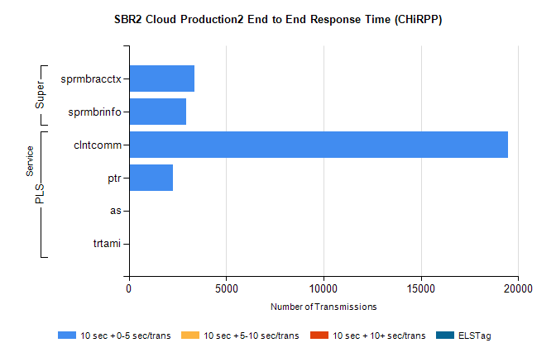
Stream | Service | 10 sec + 0-5 sec /trans | 10 sec + 5-10 sec /trans | 10 sec + >10 sec /trans | Total | % within 5 sec timing target
PLS | clntcomm | 19502 | 0 | 0 | 19502 | 100.0%
PLS | ptr | 2271 | 0 | 0 | 2271 | 100.0%
PLS | as | 23 | 0 | 0 | 23 | 100.0%
PLS | trtami | 11 | 0 | 0 | 11 | 100.0%
Super | sprmbracctx | 3353 | 0 | 0 | 3353 | 100.0%
Super | sprmbrinfo | 2962 | 0 | 0 | 2962 | 100.0%

SBR1 Production Transactions

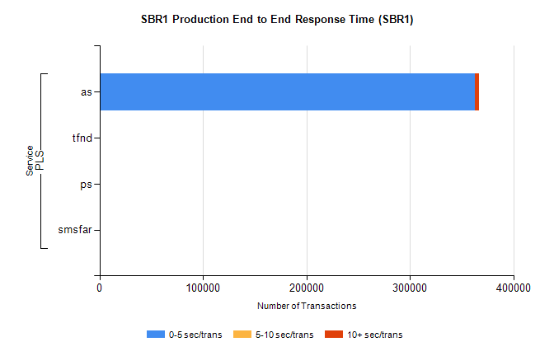
Stream | Service | 0-5 sec/trans | 5-10 sec/trans | 10+ sec/trans | Total | % within 5 sec timing target
PLS | as | 362650 | 278 | 3470 | 366398 | 99.0%
PLS | tfnd | 209 | 41 | 9 | 259 | 80.7%
PLS | ps | 24 | 38 | 124 | 186 | 12.9%
PLS | smsfar |  | 5 |  | 5 | 0.0%

