Transmission Timings Report Week - 1
29/12/2025 - 4/01/2026

SBR2 External Vendor Testing Environment (EVTE3)

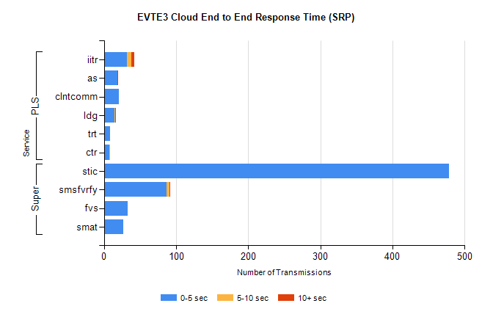
Stream | Service | 0-5 sec | 5-10 sec | >10 sec | Total | % within 5 sec timing target
Super | stic | 478 | 0 | 0 | 478 | 100.0%
Super | smsfvrfy | 87 | 4 | 1 | 92 | 94.6%
Super | fvs | 33 | 0 | 0 | 33 | 100.0%
Super | smat | 27 | 0 | 0 | 27 | 100.0%
PLS | iitr | 32 | 6 | 4 | 42 | 76.2%
PLS | as | 19 | 0 | 1 | 29 | 65.5%
PLS | clntcomm | 21 | 0 | 0 | 21 | 100.0%
PLS | ldg | 15 | 1 | 1 | 17 | 88.2%
PLS | ctr | 7 | 1 | 0 | 8 | 87.5%
PLS | trt | 8 | 0 | 0 | 8 | 100.0%

SBR2 External Vendor Testing Environment (EVTE3)

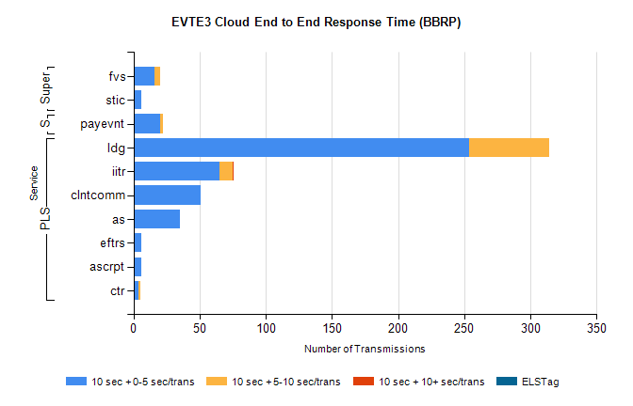
Stream | Service | 10 sec + 0-5 sec /trans | 10 sec + 5-10 sec /trans | 10 sec + >10 sec /trans | Processing Incomplete | ELStag | Total
PLS | ldg | 254 | 60 | 0 | 1 | 0 | 337
PLS | iitr | 65 | 10 | 1 | 0 | 0 | 79
PLS | clntcomm | 51 | 0 | 0 | 8 | 0 | 59
PLS | as | 35 | 0 | 0 | 0 | 0 | 35
PLS | ascrpt | 6 | 0 | 0 | 0 | 0 | 6
PLS | eftrs | 6 | 0 | 0 | 0 | 0 | 6
PLS | ctr | 4 | 1 | 0 | 0 | 0 | 5
STP | payevnt | 20 | 2 | 0 | 17 | 0 | 39
Super | fvs | 16 | 4 | 0 | 0 | 0 | 20
Super | stic | 6 | 0 | 0 | 3 | 0 | 9

SBR2 External Vendor Testing Environment (EVTE3)

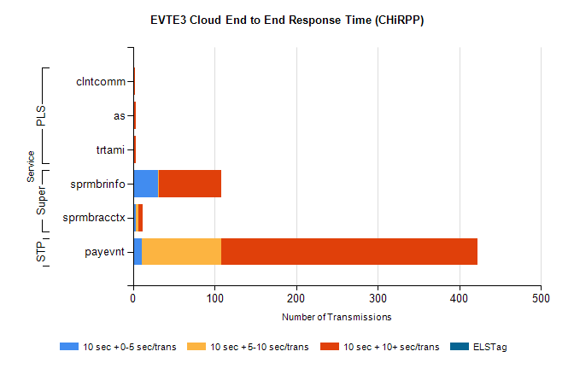
Stream | Service | 10 sec + 0-5 sec /trans | 10 sec + 5-10 sec /trans | 10 sec + >10 sec /trans | Total | % within 5 sec timing target
STP | payevnt | 11 | 97 | 314 | 560 | 2.0%
Super | sprmbrinfo | 31 | 1 | 76 | 120 | 25.8%
Super | sprmbracctx | 3 | 3 | 6 | 17 | 17.6%
PLS | trtami | 0 | 0 | 3 | 3 | 0.0%
PLS | as | 0 | 0 | 3 | 3 | 0.0%
PLS | clntcomm | 0 | 0 | 2 | 3 | 0.0%

