Transmission Timings Report Week - 1
29/12/2025 - 4/01/2026

SBR2 Cloud Production2 - Single | Bulk or Batch Requests | (SRP, BBRP & CHiRPP)

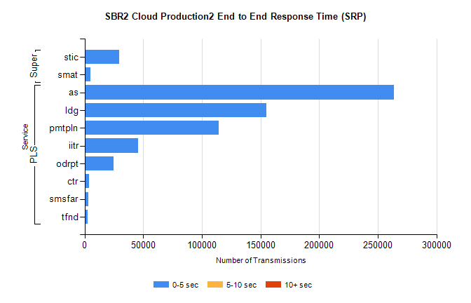
Stream | Service | 0-5 sec | 5-10 sec | >10 sec | Total | % within 5 sec timing target
PLS | as | 263880 | 0 | 0 | 263880 | 100.0%
PLS | ldg | 154801 | 0 | 0 | 154801 | 100.0%
PLS | pmtpln | 114141 | 0 | 0 | 114141 | 100.0%
PLS | iitr | 45745 | 0 | 0 | 45745 | 100.0%
PLS | odrpt | 24694 | 0 | 0 | 24694 | 100.0%
PLS | ctr | 3744 | 0 | 0 | 3744 | 100.0%
PLS | smsfar | 3275 | 0 | 0 | 3275 | 100.0%
PLS | tfnd | 2900 | 0 | 0 | 2900 | 100.0%
Super | stic | 29677 | 0 | 0 | 29677 | 100.0%
Super | smat | 4899 | 0 | 0 | 4899 | 100.0%

SBR2 Cloud Production2 - Single | Bulk or Batch Requests | (SRP, BBRP & CHiRPP)

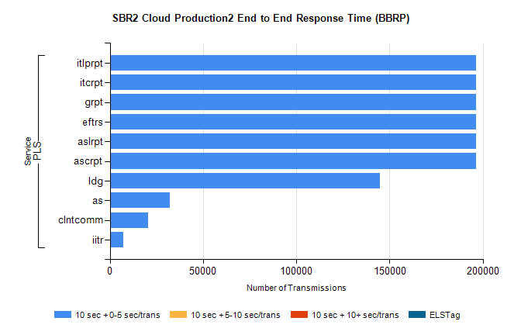
Stream | Service | 10 sec + 0-5 sec /trans | 10 sec + 5-10 sec /trans | 10 sec + >10 sec /trans | Processing Incomplete | ELStag | Total
PLS | ascrpt | 196426 | 0 | 0 | 0 | 0 | 196426
PLS | aslrpt | 196426 | 0 | 0 | 0 | 0 | 196426
PLS | eftrs | 196426 | 0 | 0 | 0 | 0 | 196426
PLS | grpt | 196426 | 0 | 0 | 0 | 0 | 196426
PLS | itcrpt | 196426 | 0 | 0 | 0 | 0 | 196426
PLS | itlprpt | 196426 | 0 | 0 | 0 | 0 | 196426
PLS | ldg | 144975 | 0 | 0 | 0 | 0 | 144975
PLS | as | 32348 | 0 | 0 | 0 | 0 | 32348
PLS | clntcomm | 20573 | 0 | 0 | 0 | 0 | 20573
PLS | iitr | 7019 | 0 | 0 | 0 | 0 | 7019

SBR2 Cloud Production2 - Single | Bulk or Batch Requests | (SRP, BBRP & CHiRPP)

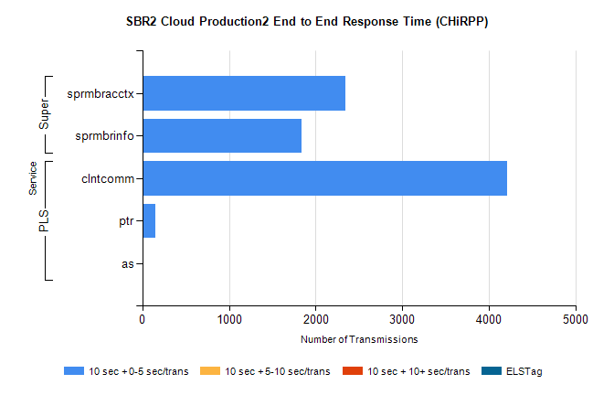
Stream | Service | 10 sec + 0-5 sec /trans | 10 sec + 5-10 sec /trans | 10 sec + >10 sec /trans | Total | % within 5 sec timing target
PLS | clntcomm | 4212 | 0 | 0 | 4212 | 100.0%
PLS | ptr | 145 | 0 | 0 | 145 | 100.0%
PLS | as | 4 | 0 | 0 | 4 | 100.0%
Super | sprmbracctx | 2346 | 0 | 0 | 2346 | 100.0%
Super | sprmbrinfo | 1833 | 0 | 0 | 1833 | 100.0%

SBR1 Production Transactions

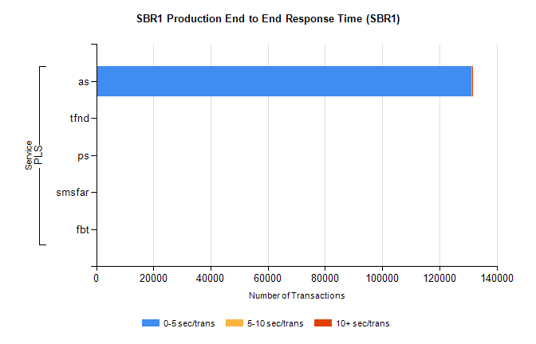
Stream | Service | 0-5 sec/trans | 5-10 sec/trans | 10+ sec/trans | Total | % within 5 sec timing target
PLS | as | 131284 | 119 | 27 | 131430 | 99.9%
PLS | tfnd | 128 | 51 | 9 | 188 | 68.1%
PLS | ps | 1 | 2 | 27 | 30 | 3.3%
PLS | smsfar |  | 5 |  | 5 | 0.0%
PLS | fbt |  | 1 |  | 1 | 0.0%

