Transmission Timings Report Week - 2
5/01/2026 - 11/01/2026

SBR2 External Vendor Testing Environment (EVTE3)

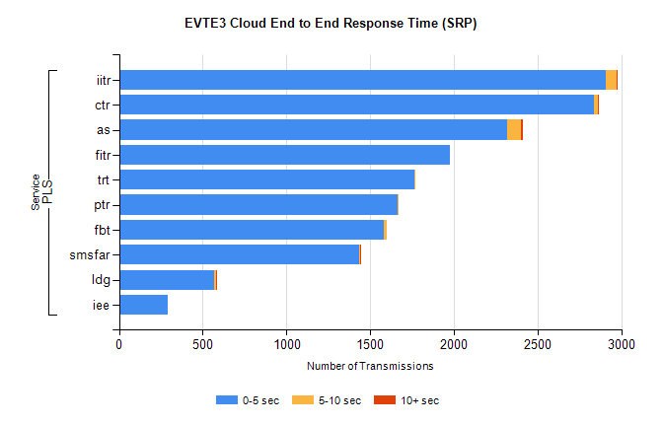
Stream | Service | 0-5 sec | 5-10 sec | >10 sec | Total | % within 5 sec timing target
PLS | iitr | 2906 | 64 | 7 | 2979 | 97.5%
PLS | ctr | 2834 | 27 | 1 | 2862 | 99.0%
PLS | as | 2318 | 84 | 8 | 2461 | 94.2%
PLS | fitr | 1974 | 0 | 0 | 1974 | 100.0%
PLS | trt | 1766 | 3 | 0 | 1772 | 99.7%
PLS | ptr | 1666 | 3 | 0 | 1669 | 99.8%
PLS | fbt | 1583 | 18 | 0 | 1603 | 98.8%
PLS | smsfar | 1436 | 5 | 1 | 1442 | 99.6%
PLS | ldg | 568 | 10 | 2 | 654 | 86.9%
PLS | iee | 294 | 0 | 0 | 294 | 100.0%

SBR2 External Vendor Testing Environment (EVTE3)

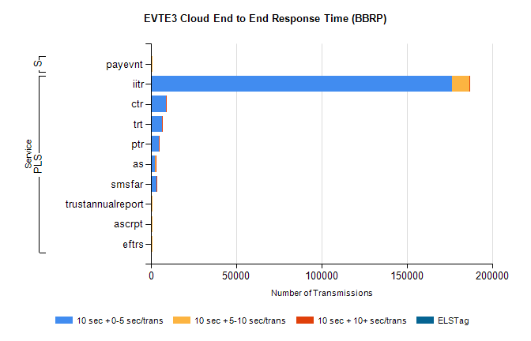
Stream | Service | 10 sec + 0-5 sec /trans | 10 sec + 5-10 sec /trans | 10 sec + >10 sec /trans | Processing Incomplete | ELStag | Total
PLS | iitr | 176520 | 10173 | 334 | 0 | 0 | 187257
PLS | ctr | 8722 | 180 | 19 | 0 | 0 | 8925
PLS | trt | 6301 | 136 | 11 | 0 | 0 | 6454
PLS | ptr | 4617 | 77 | 10 | 0 | 0 | 4705
PLS | as | 2447 | 479 | 14 | 439 | 0 | 3386
PLS | smsfar | 3118 | 72 | 6 | 0 | 0 | 3205
PLS | trustannualreport | 347 | 22 | 0 | 0 | 0 | 375
PLS | eftrs | 340 | 30 | 0 | 0 | 0 | 370
PLS | ascrpt | 340 | 30 | 0 | 0 | 0 | 370
STP | payevnt | 243 | 54 | 0 | 53 | 0 | 350

SBR2 External Vendor Testing Environment (EVTE3)

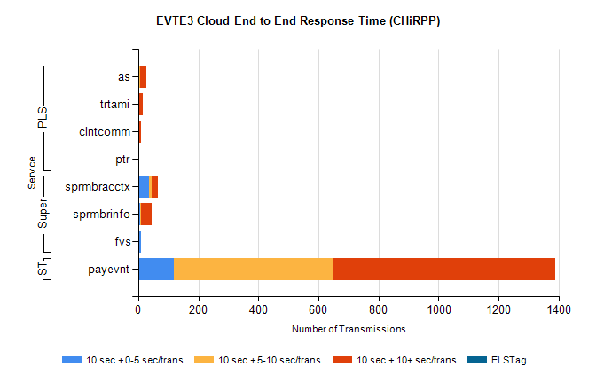
Stream | Service | 10 sec + 0-5 sec /trans | 10 sec + 5-10 sec /trans | 10 sec + >10 sec /trans | Total | % within 5 sec timing target
STP | payevnt | 118 | 532 | 739 | 2258 | 5.2%
Super | sprmbracctx | 37 | 8 | 21 | 71 | 52.1%
Super | sprmbrinfo | 6 | 3 | 37 | 53 | 11.3%
Super | fvs | 8 | 0 | 0 | 8 | 100.0%
PLS | as | 5 | 2 | 19 | 36 | 13.9%
PLS | trtami | 0 | 1 | 15 | 16 | 0.0%
PLS | clntcomm | 0 | 0 | 9 | 9 | 0.0%
PLS | ptr | 0 | 0 | 2 | 2 | 0.0%

