Transmission Timings Report Week - 2
5/01/2026 - 11/01/2026

SBR2 Cloud Production2 - Single | Bulk or Batch Requests | (SRP, BBRP & CHiRPP)

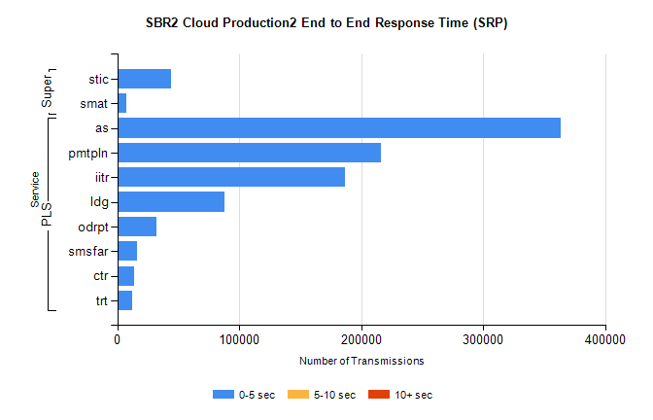
Stream | Service | 0-5 sec | 5-10 sec | >10 sec | Total | % within 5 sec timing target
PLS | as | 363651 | 0 | 0 | 363651 | 100.0%
PLS | pmtpln | 215999 | 0 | 0 | 215999 | 100.0%
PLS | iitr | 186888 | 0 | 0 | 186888 | 100.0%
PLS | ldg | 88261 | 0 | 0 | 88261 | 100.0%
PLS | odrpt | 32029 | 0 | 0 | 32029 | 100.0%
PLS | smsfar | 16279 | 0 | 0 | 16279 | 100.0%
PLS | ctr | 14093 | 0 | 0 | 14093 | 100.0%
PLS | trt | 12206 | 0 | 0 | 12206 | 100.0%
Super | stic | 44303 | 0 | 0 | 44303 | 100.0%
Super | smat | 7507 | 0 | 0 | 7507 | 100.0%

SBR2 Cloud Production2 - Single | Bulk or Batch Requests | (SRP, BBRP & CHiRPP)

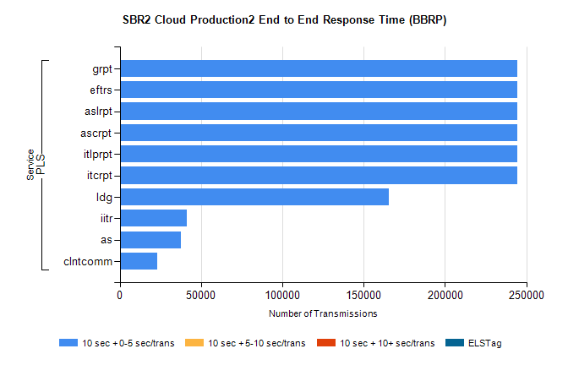
Stream | Service | 10 sec + 0-5 sec /trans | 10 sec + 5-10 sec /trans | 10 sec + >10 sec /trans | Processing Incomplete | ELStag | Total
PLS | itcrpt | 244494 | 0 | 0 | 0 | 0 | 244494
PLS | itlprpt | 244494 | 0 | 0 | 0 | 0 | 244494
PLS | ascrpt | 244494 | 0 | 0 | 0 | 0 | 244494
PLS | aslrpt | 244494 | 0 | 0 | 0 | 0 | 244494
PLS | eftrs | 244494 | 0 | 0 | 0 | 0 | 244494
PLS | grpt | 244494 | 0 | 0 | 0 | 0 | 244494
PLS | ldg | 165302 | 0 | 0 | 0 | 0 | 165302
PLS | iitr | 41249 | 0 | 0 | 0 | 0 | 41249
PLS | as | 37561 | 0 | 0 | 0 | 0 | 37561
PLS | clntcomm | 22865 | 0 | 0 | 0 | 0 | 22865

SBR2 Cloud Production2 - Single | Bulk or Batch Requests | (SRP, BBRP & CHiRPP)

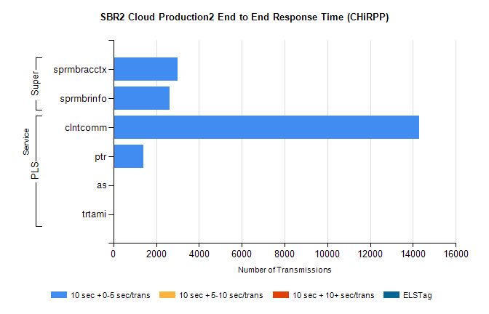
Stream | Service | 10 sec + 0-5 sec /trans | 10 sec + 5-10 sec /trans | 10 sec + >10 sec /trans | Total | % within 5 sec timing target
PLS | clntcomm | 14297 | 0 | 0 | 14297 | 100.0%
PLS | ptr | 1412 | 0 | 0 | 1412 | 100.0%
PLS | as | 33 | 0 | 0 | 33 | 100.0%
PLS | trtami | 19 | 0 | 0 | 19 | 100.0%
Super | sprmbracctx | 3004 | 0 | 0 | 3004 | 100.0%
Super | sprmbrinfo | 2624 | 0 | 0 | 2624 | 100.0%

SBR1 Production Transactions

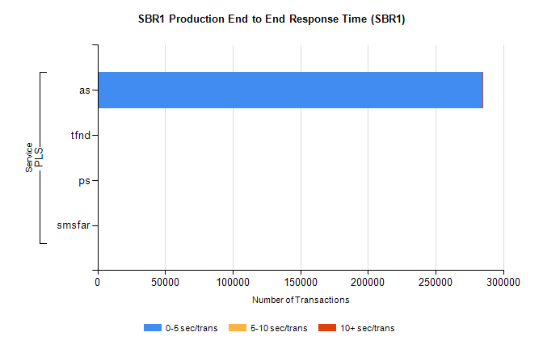
Stream | Service | 0-5 sec/trans | 5-10 sec/trans | 10+ sec/trans | Total | % within 5 sec timing target
PLS | as | 284613 | 114 | 163 | 284890 | 99.9%
PLS | tfnd | 231 | 46 | 10 | 287 | 80.5%
PLS | ps | 10 | 12 | 91 | 113 | 8.8%
PLS | smsfar |  | 5 |  | 5 | 0.0%

