Transmission Timings Report Week - 3
12/01/2026 - 18/01/2026

SBR2 Cloud Production2 - Single | Bulk or Batch Requests | (SRP, BBRP & CHiRPP)

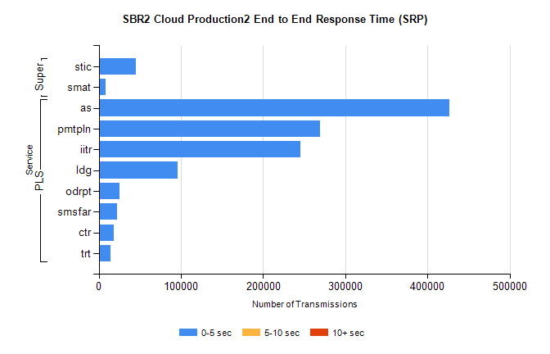
Stream | Service | 0-5 sec | 5-10 sec | >10 sec | Total | % within 5 sec timing target
PLS | as | 426223 | 0 | 0 | 426223 | 100.0%
PLS | pmtpln | 269430 | 0 | 0 | 269430 | 100.0%
PLS | iitr | 245858 | 0 | 0 | 245858 | 100.0%
PLS | ldg | 95759 | 0 | 0 | 95759 | 100.0%
PLS | odrpt | 25498 | 0 | 0 | 25498 | 100.0%
PLS | smsfar | 22032 | 0 | 0 | 22032 | 100.0%
PLS | ctr | 18186 | 0 | 0 | 18186 | 100.0%
PLS | trt | 14095 | 0 | 0 | 14095 | 100.0%
Super | stic | 44870 | 0 | 0 | 44870 | 100.0%
Super | smat | 8100 | 0 | 0 | 8100 | 100.0%

SBR2 Cloud Production2 - Single | Bulk or Batch Requests | (SRP, BBRP & CHiRPP)

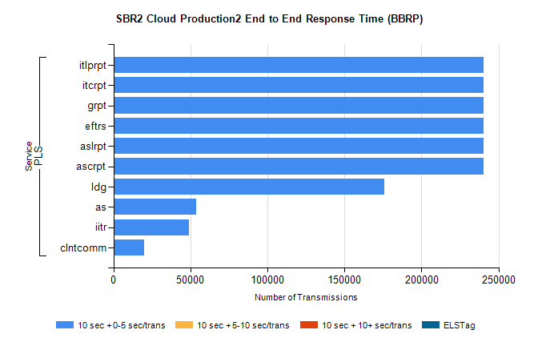
Stream | Service | 10 sec + 0-5 sec /trans | 10 sec + 5-10 sec /trans | 10 sec + >10 sec /trans | Processing Incomplete | ELStag | Total
PLS | ascrpt | 240369 | 0 | 0 | 0 | 0 | 240369
PLS | aslrpt | 240369 | 0 | 0 | 0 | 0 | 240369
PLS | eftrs | 240369 | 0 | 0 | 0 | 0 | 240369
PLS | grpt | 240369 | 0 | 0 | 0 | 0 | 240369
PLS | itcrpt | 240369 | 0 | 0 | 0 | 0 | 240369
PLS | itlprpt | 240369 | 0 | 0 | 0 | 0 | 240369
PLS | ldg | 175943 | 0 | 0 | 0 | 0 | 175943
PLS | as | 53465 | 0 | 0 | 0 | 0 | 53465
PLS | iitr | 48821 | 0 | 0 | 0 | 0 | 48821
PLS | clntcomm | 19990 | 0 | 0 | 0 | 0 | 19990

SBR2 Cloud Production2 - Single | Bulk or Batch Requests | (SRP, BBRP & CHiRPP)

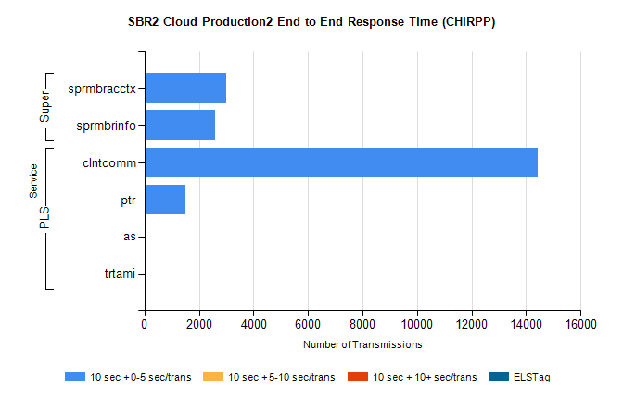
Stream | Service | 10 sec + 0-5 sec /trans | 10 sec + 5-10 sec /trans | 10 sec + >10 sec /trans | Total | % within 5 sec timing target
PLS | clntcomm | 14428 | 0 | 0 | 14428 | 100.0%
PLS | ptr | 1509 | 0 | 0 | 1509 | 100.0%
PLS | as | 52 | 0 | 0 | 52 | 100.0%
PLS | trtami | 11 | 0 | 0 | 11 | 100.0%
Super | sprmbracctx | 3003 | 0 | 0 | 3003 | 100.0%
Super | sprmbrinfo | 2604 | 0 | 0 | 2604 | 100.0%

SBR1 Production Transactions

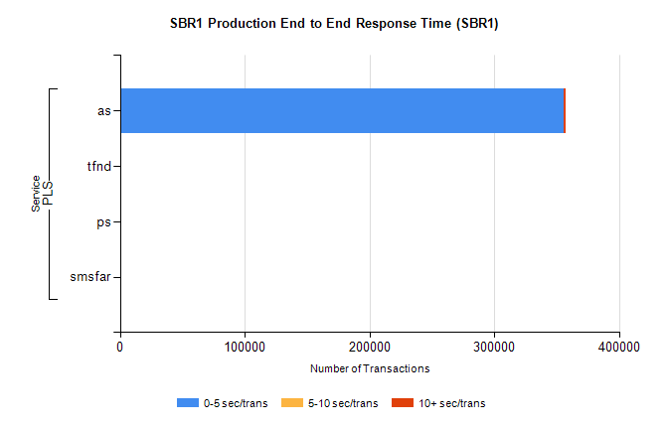
Stream | Service | 0-5 sec/trans | 5-10 sec/trans | 10+ sec/trans | Total | % within 5 sec timing target
PLS | as | 355806 | 181 | 869 | 356856 | 99.7%
PLS | tfnd | 214 | 48 | 7 | 269 | 79.6%
PLS | ps | 6 | 6 | 70 | 82 | 7.3%
PLS | smsfar | 4 | 8 |  | 12 | 33.3%

