Transmission Timings Report Week - 3
13/01/2026 - 19/01/2026

SBR2 External Vendor Testing Environment (EVTE3)

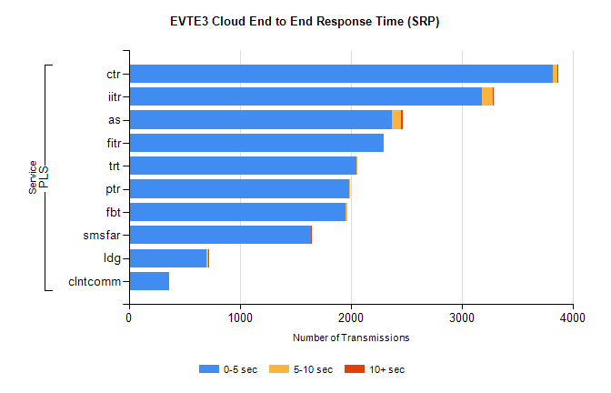
Stream | Service | 0-5 sec | 5-10 sec | >10 sec | Total | % within 5 sec timing target
PLS | ctr | 3824 | 38 | 2 | 5038 | 75.9%
PLS | iitr | 3186 | 93 | 10 | 3297 | 96.6%
PLS | as | 2373 | 80 | 14 | 2483 | 95.6%
PLS | fitr | 2298 | 0 | 0 | 2298 | 100.0%
PLS | trt | 2053 | 4 | 0 | 2057 | 99.8%
PLS | ptr | 1985 | 7 | 0 | 1995 | 99.5%
PLS | fbt | 1956 | 11 | 0 | 1972 | 99.2%
PLS | smsfar | 1641 | 2 | 1 | 1644 | 99.8%
PLS | ldg | 701 | 11 | 2 | 732 | 95.8%
PLS | clntcomm | 362 | 0 | 0 | 362 | 100.0%

SBR2 External Vendor Testing Environment (EVTE3)

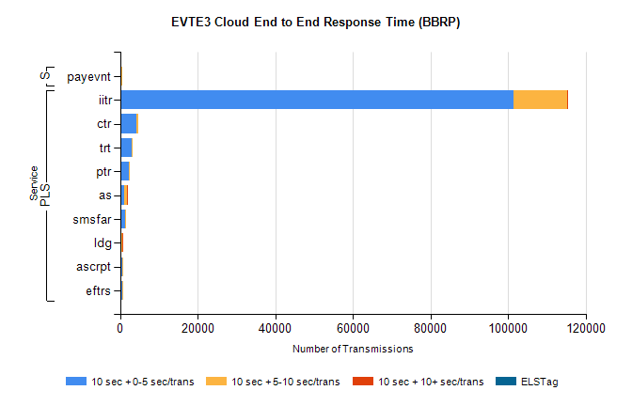
Stream | Service | 10 sec + 0-5 sec /trans | 10 sec + 5-10 sec /trans | 10 sec + >10 sec /trans | Processing Incomplete | ELStag | Total
PLS | iitr | 101363 | 13851 | 2 | 0 | 0 | 115800
PLS | ctr | 4238 | 417 | 0 | 0 | 0 | 4681
PLS | trt | 2994 | 280 | 0 | 0 | 0 | 3291
PLS | ptr | 2187 | 214 | 0 | 0 | 0 | 2410
PLS | as | 1104 | 638 | 2 | 523 | 0 | 2302
PLS | smsfar | 1364 | 145 | 0 | 0 | 0 | 1515
PLS | ldg | 373 | 136 | 1 | 72 | 0 | 583
PLS | eftrs | 508 | 24 | 0 | 0 | 0 | 532
PLS | ascrpt | 508 | 24 | 0 | 0 | 0 | 532
STP | payevnt | 381 | 60 | 0 | 104 | 0 | 547

SBR2 External Vendor Testing Environment (EVTE3)

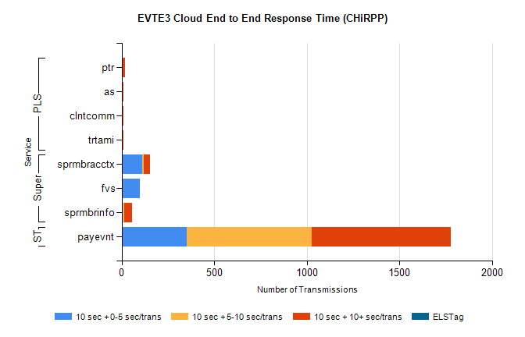
Stream | Service | 10 sec + 0-5 sec /trans | 10 sec + 5-10 sec /trans | 10 sec + >10 sec /trans | Total | % within 5 sec timing target
STP | payevnt | 351 | 675 | 750 | 2820 | 12.5%
Super | sprmbracctx | 111 | 10 | 31 | 164 | 67.7%
Super | fvs | 100 | 0 | 0 | 102 | 98.0%
Super | sprmbrinfo | 3 | 10 | 42 | 69 | 4.3%
PLS | ptr | 0 | 2 | 15 | 17 | 0.0%
PLS | as | 0 | 0 | 11 | 12 | 0.0%
PLS | trtami | 0 | 0 | 9 | 9 | 0.0%
PLS | clntcomm | 0 | 0 | 9 | 9 | 0.0%

