Transmission Timings Report Week - 4
19/01/2026 - 25/01/2026

SBR2 External Vendor Testing Environment (EVTE3)

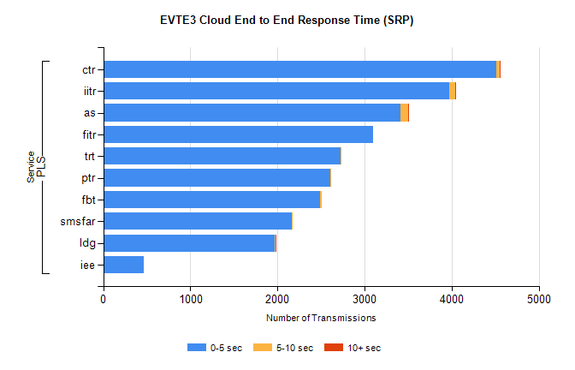
Stream | Service | 0-5 sec | 5-10 sec | >10 sec | Total | % within 5 sec timing target
PLS | ctr | 4514 | 39 | 1 | 4584 | 98.5%
PLS | iitr | 3970 | 74 | 7 | 4068 | 97.6%
PLS | as | 3408 | 91 | 6 | 3522 | 96.8%
PLS | fitr | 3102 | 0 | 0 | 3103 | 100.0%
PLS | trt | 2725 | 4 | 0 | 2732 | 99.7%
PLS | ptr | 2610 | 3 | 0 | 2618 | 99.7%
PLS | fbt | 2488 | 17 | 0 | 2506 | 99.3%
PLS | smsfar | 2161 | 1 | 0 | 2163 | 99.9%
PLS | ldg | 1965 | 12 | 2 | 2002 | 98.2%
PLS | iee | 462 | 0 | 0 | 462 | 100.0%

SBR2 External Vendor Testing Environment (EVTE3)

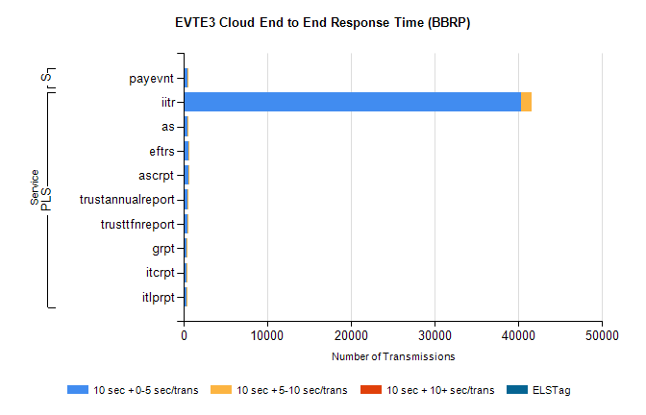
Stream | Service | 10 sec + 0-5 sec /trans | 10 sec + 5-10 sec /trans | 10 sec + >10 sec /trans | Processing Incomplete | ELStag | Total
PLS | iitr | 40282 | 1283 | 0 | 0 | 0 | 41607
PLS | as | 440 | 75 | 0 | 368 | 0 | 883
PLS | ascrpt | 588 | 30 | 0 | 0 | 0 | 618
PLS | eftrs | 588 | 30 | 0 | 0 | 0 | 618
PLS | trustannualreport | 508 | 29 | 0 | 0 | 0 | 539
PLS | trusttfnreport | 400 | 7 | 0 | 0 | 0 | 407
PLS | itlprpt | 294 | 15 | 0 | 0 | 0 | 309
PLS | itcrpt | 294 | 15 | 0 | 0 | 0 | 309
PLS | grpt | 294 | 15 | 0 | 0 | 0 | 309
STP | payevnt | 446 | 44 | 0 | 40 | 0 | 531

SBR2 External Vendor Testing Environment (EVTE3)

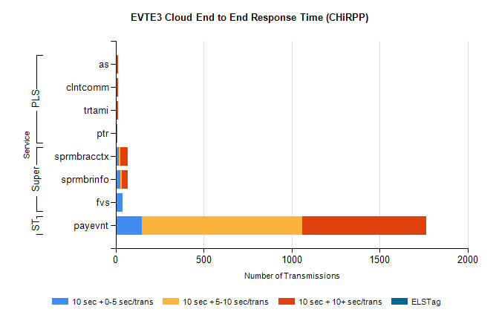
Stream | Service | 10 sec + 0-5 sec /trans | 10 sec + 5-10 sec /trans | 10 sec + >10 sec /trans | Total | % within 5 sec timing target
STP | payevnt | 149 | 911 | 704 | 2865 | 5.2%
Super | sprmbracctx | 17 | 8 | 44 | 81 | 21.0%
Super | sprmbrinfo | 26 | 8 | 33 | 75 | 34.7%
Super | fvs | 39 | 0 | 0 | 39 | 100.0%
PLS | as | 0 | 0 | 15 | 15 | 0.0%
PLS | clntcomm | 0 | 0 | 13 | 13 | 0.0%
PLS | trtami | 0 | 0 | 12 | 12 | 0.0%
PLS | ptr | 0 | 1 | 8 | 10 | 0.0%

