Transmission Timings Report Week - 4
19/01/2026 - 25/01/2026

SBR2 Cloud Production2 - Single | Bulk or Batch Requests | (SRP, BBRP & CHiRPP)

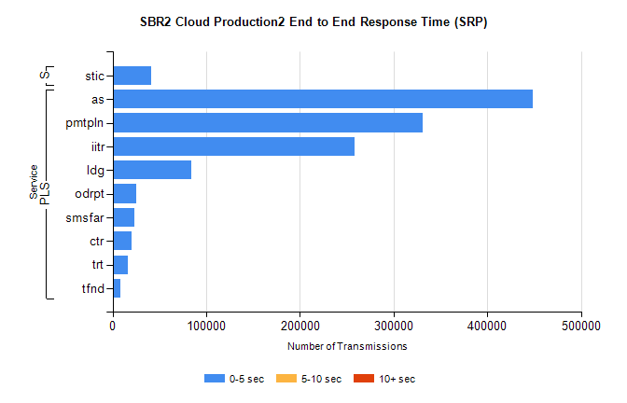
Stream | Service | 0-5 sec | 5-10 sec | >10 sec | Total | % within 5 sec timing target
PLS | as | 448636 | 0 | 0 | 448636 | 100.0%
PLS | pmtpln | 331007 | 0 | 0 | 331007 | 100.0%
PLS | iitr | 258068 | 0 | 0 | 258068 | 100.0%
PLS | ldg | 84474 | 0 | 0 | 84474 | 100.0%
PLS | odrpt | 25553 | 0 | 0 | 25553 | 100.0%
PLS | smsfar | 23821 | 0 | 0 | 23821 | 100.0%
PLS | ctr | 19994 | 0 | 0 | 19994 | 100.0%
PLS | trt | 16059 | 0 | 0 | 16059 | 100.0%
PLS | tfnd | 8128 | 0 | 0 | 8128 | 100.0%
Super | stic | 41232 | 0 | 0 | 41232 | 100.0%

SBR2 Cloud Production2 - Single | Bulk or Batch Requests | (SRP, BBRP & CHiRPP)

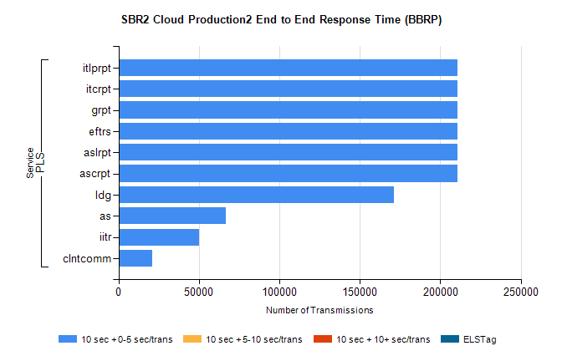
Stream | Service | 10 sec + 0-5 sec /trans | 10 sec + 5-10 sec /trans | 10 sec + >10 sec /trans | Processing Incomplete | ELStag | Total
PLS | ascrpt | 210406 | 0 | 0 | 0 | 0 | 210406
PLS | aslrpt | 210406 | 0 | 0 | 0 | 0 | 210406
PLS | eftrs | 210406 | 0 | 0 | 0 | 0 | 210406
PLS | grpt | 210406 | 0 | 0 | 0 | 0 | 210406
PLS | itcrpt | 210406 | 0 | 0 | 0 | 0 | 210406
PLS | itlprpt | 210406 | 0 | 0 | 0 | 0 | 210406
PLS | ldg | 170944 | 0 | 0 | 0 | 0 | 170944
PLS | as | 66822 | 0 | 0 | 0 | 0 | 66822
PLS | iitr | 50288 | 0 | 0 | 0 | 0 | 50288
PLS | clntcomm | 20696 | 0 | 0 | 0 | 0 | 20696

SBR2 Cloud Production2 - Single | Bulk or Batch Requests | (SRP, BBRP & CHiRPP)

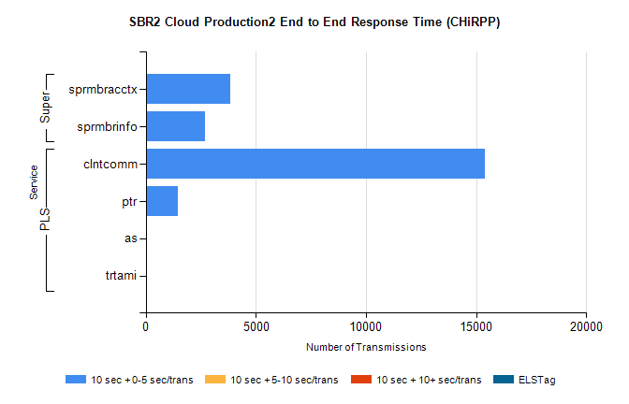
Stream | Service | 10 sec + 0-5 sec /trans | 10 sec + 5-10 sec /trans | 10 sec + >10 sec /trans | Total | % within 5 sec timing target
PLS | clntcomm | 15389 | 0 | 0 | 15389 | 100.0%
PLS | ptr | 1449 | 0 | 0 | 1449 | 100.0%
PLS | as | 39 | 0 | 0 | 39 | 100.0%
PLS | trtami | 38 | 0 | 0 | 38 | 100.0%
Super | sprmbracctx | 3839 | 0 | 0 | 3839 | 100.0%
Super | sprmbrinfo | 2694 | 0 | 0 | 2694 | 100.0%

SBR1 Production Transactions

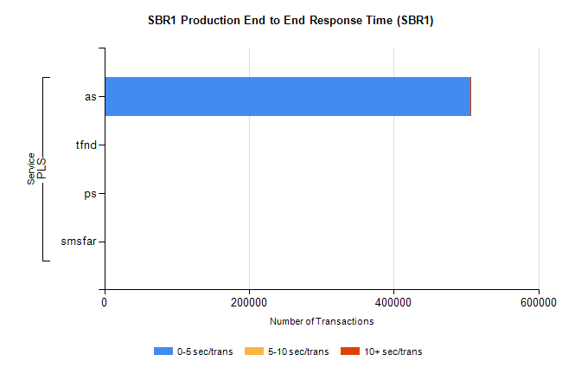
Stream | Service | 0-5 sec/trans | 5-10 sec/trans | 10+ sec/trans | Total | % within 5 sec timing target
PLS | as | 505696 | 203 | 524 | 506423 | 99.9%
PLS | tfnd | 247 | 47 | 10 | 304 | 81.3%
PLS | ps | 22 | 21 | 95 | 138 | 15.9%
PLS | smsfar |  | 5 |  | 5 | 0.0%

