Transmission Timings Report Week - 52
22/12/2025 - 28/12/2025

SBR2 External Vendor Testing Environment (EVTE3)

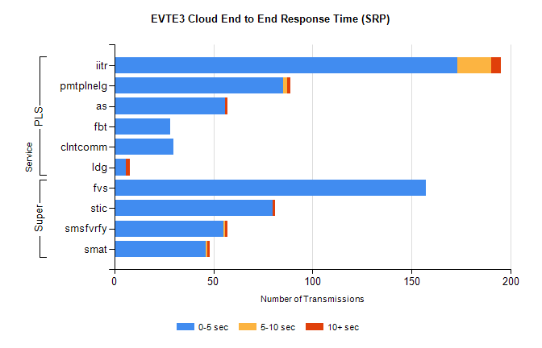
Stream | Service | 0-5 sec | 5-10 sec | >10 sec | Total | % within 5 sec timing target
PLS | iitr | 173 | 17 | 5 | 197 | 87.8%
PLS | pmtplnelg | 85 | 2 | 2 | 89 | 95.5%
PLS | as | 56 | 0 | 1 | 74 | 75.7%
PLS | fbt | 28 | 0 | 0 | 72 | 38.9%
PLS | clntcomm | 30 | 0 | 0 | 30 | 100.0%
PLS | ldg | 6 | 0 | 2 | 20 | 30.0%
Super | fvs | 157 | 0 | 0 | 157 | 100.0%
Super | stic | 80 | 0 | 1 | 81 | 98.8%
Super | smsfvrfy | 55 | 1 | 1 | 57 | 96.5%
Super | smat | 46 | 1 | 1 | 48 | 95.8%

SBR2 External Vendor Testing Environment (EVTE3)

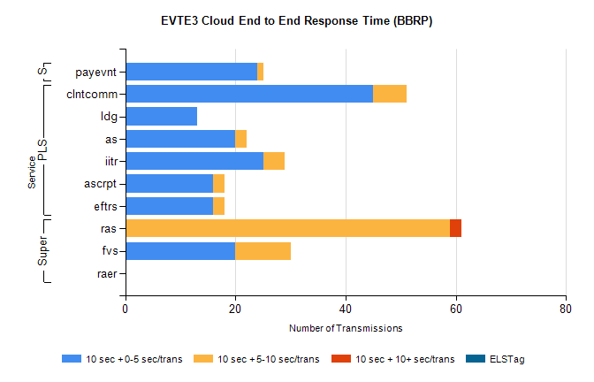
Stream | Service | 10 sec + 0-5 sec /trans | 10 sec + 5-10 sec /trans | 10 sec + >10 sec /trans | Processing Incomplete | ELStag | Total
PLS | clntcomm | 45 | 6 | 0 | 12 | 0 | 63
PLS | ldg | 13 | 0 | 0 | 33 | 0 | 46
PLS | as | 20 | 2 | 0 | 14 | 0 | 36
PLS | iitr | 25 | 4 | 0 | 0 | 0 | 29
PLS | eftrs | 16 | 2 | 0 | 0 | 0 | 18
PLS | ascrpt | 16 | 2 | 0 | 0 | 0 | 18
Super | ras | 0 | 59 | 2 | 0 | 0 | 65
Super | fvs | 20 | 10 | 0 | 3 | 0 | 33
Super | raer | 0 | 0 | 0 | 18 | 0 | 18
STP | payevnt | 24 | 1 | 0 | 19 | 0 | 44

SBR2 External Vendor Testing Environment (EVTE3)

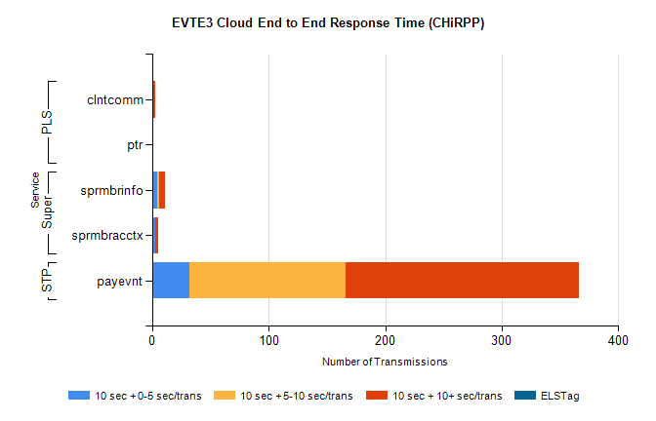
Stream | Service | 10 sec + 0-5 sec /trans | 10 sec + 5-10 sec /trans | 10 sec + >10 sec /trans | Total | % within 5 sec timing target
STP | payevnt | 32 | 134 | 200 | 480 | 6.7%
Super | sprmbrinfo | 4 | 2 | 5 | 12 | 33.3%
Super | sprmbracctx | 3 | 0 | 2 | 5 | 60.0%
PLS | clntcomm | 0 | 0 | 3 | 3 | 0.0%
PLS | ptr | 0 | 0 | 1 | 1 | 0.0%

