Transmission Timings Report Week - 52
22/12/2025 - 28/12/2025

SBR2 Cloud Production2 - Single | Bulk or Batch Requests | (SRP, BBRP & CHiRPP)

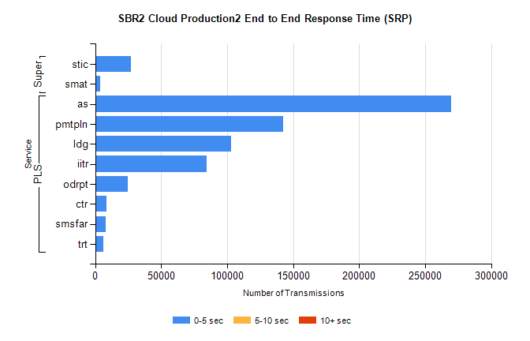
Stream | Service | 0-5 sec | 5-10 sec | >10 sec | Total | % within 5 sec timing target
PLS | as | 269596 | 0 | 0 | 269596 | 100.0%
PLS | pmtpln | 142267 | 0 | 0 | 142267 | 100.0%
PLS | ldg | 102890 | 0 | 0 | 102890 | 100.0%
PLS | iitr | 84337 | 0 | 0 | 84337 | 100.0%
PLS | odrpt | 24694 | 0 | 0 | 24694 | 100.0%
PLS | ctr | 8365 | 0 | 0 | 8365 | 100.0%
PLS | smsfar | 8313 | 0 | 0 | 8313 | 100.0%
PLS | trt | 6016 | 0 | 0 | 6016 | 100.0%
Super | stic | 27174 | 0 | 0 | 27174 | 100.0%
Super | smat | 3727 | 0 | 0 | 3727 | 100.0%

SBR2 Cloud Production2 - Single | Bulk or Batch Requests | (SRP, BBRP & CHiRPP)

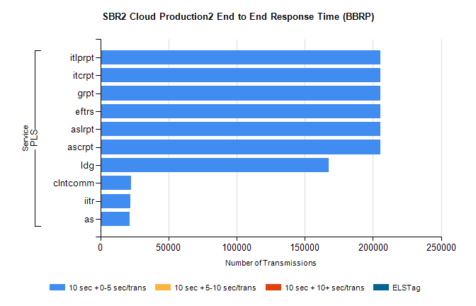
Stream | Service | 10 sec + 0-5 sec /trans | 10 sec + 5-10 sec /trans | 10 sec + >10 sec /trans | Processing Incomplete | ELStag | Total
PLS | ascrpt | 205666 | 0 | 0 | 0 | 0 | 205666
PLS | aslrpt | 205666 | 0 | 0 | 0 | 0 | 205666
PLS | eftrs | 205666 | 0 | 0 | 0 | 0 | 205666
PLS | grpt | 205666 | 0 | 0 | 0 | 0 | 205666
PLS | itcrpt | 205666 | 0 | 0 | 0 | 0 | 205666
PLS | itlprpt | 205666 | 0 | 0 | 0 | 0 | 205666
PLS | ldg | 167639 | 0 | 0 | 0 | 0 | 167639
PLS | clntcomm | 22516 | 0 | 0 | 0 | 0 | 22516
PLS | iitr | 21952 | 0 | 0 | 0 | 0 | 21952
PLS | as | 21240 | 0 | 0 | 0 | 0 | 21240

SBR2 Cloud Production2 - Single | Bulk or Batch Requests | (SRP, BBRP & CHiRPP)

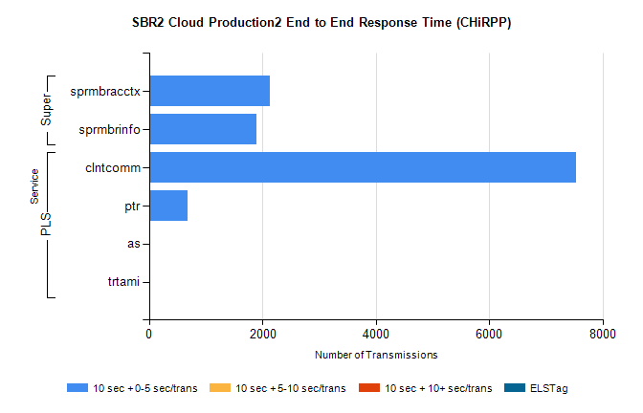
Stream | Service | 10 sec + 0-5 sec /trans | 10 sec + 5-10 sec /trans | 10 sec + >10 sec /trans | Total | % within 5 sec timing target
PLS | clntcomm | 7524 | 0 | 0 | 7524 | 100.0%
PLS | ptr | 678 | 0 | 0 | 678 | 100.0%
PLS | as | 16 | 0 | 0 | 16 | 100.0%
PLS | trtami | 2 | 0 | 0 | 2 | 100.0%
Super | sprmbracctx | 2123 | 0 | 0 | 2123 | 100.0%
Super | sprmbrinfo | 1889 | 0 | 0 | 1889 | 100.0%

SBR1 Production Transactions

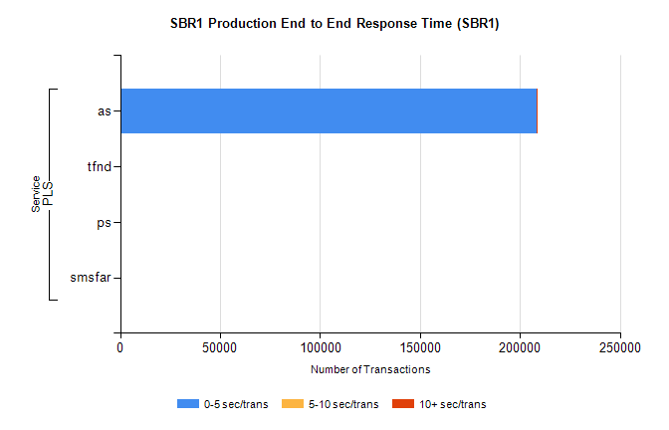
Stream | Service | 0-5 sec/trans | 5-10 sec/trans | 10+ sec/trans | Total | % within 5 sec timing target
PLS | as | 208129 | 172 | 88 | 208389 | 99.9%
PLS | tfnd | 102 | 44 | 9 | 155 | 65.8%
PLS | ps | 5 | 4 | 44 | 53 | 9.4%
PLS | smsfar |  | 5 |  | 5 | 0.0%

