Transmission Timings Report Week - 5
26/01/2026 - 1/02/2026

SBR2 External Vendor Testing Environment (EVTE3)

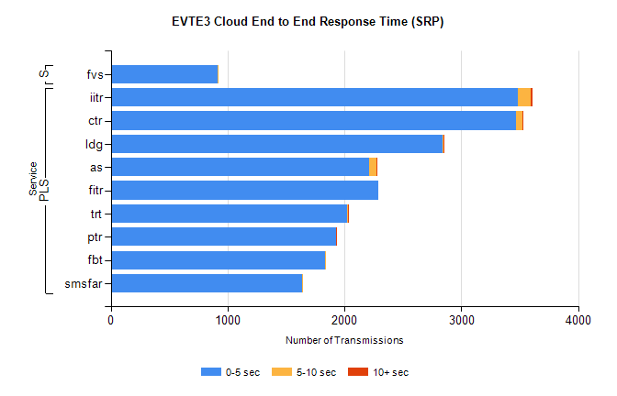
Stream | Service | 0-5 sec | 5-10 sec | >10 sec | Total | % within 5 sec timing target
PLS | iitr | 3486 | 107 | 14 | 3611 | 96.5%
PLS | ctr | 3465 | 57 | 3 | 3527 | 98.2%
PLS | ldg | 2841 | 4 | 4 | 2859 | 99.4%
PLS | as | 2212 | 62 | 6 | 2319 | 95.4%
PLS | fitr | 2293 | 0 | 0 | 2295 | 99.9%
PLS | trt | 2026 | 3 | 1 | 2030 | 99.8%
PLS | ptr | 1927 | 3 | 2 | 1935 | 99.6%
PLS | fbt | 1830 | 8 | 0 | 1839 | 99.5%
PLS | smsfar | 1637 | 1 | 0 | 1638 | 99.9%
Super | fvs | 917 | 1 | 0 | 918 | 99.9%

SBR2 External Vendor Testing Environment (EVTE3)

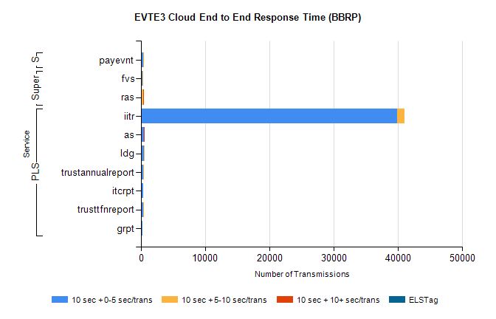
Stream | Service | 10 sec + 0-5 sec /trans | 10 sec + 5-10 sec /trans | 10 sec + >10 sec /trans | Processing Incomplete | ELStag | Total
PLS | iitr | 39888 | 1103 | 0 | 2 | 0 | 41044
PLS | as | 409 | 46 | 2 | 305 | 0 | 764
PLS | ldg | 433 | 120 | 0 | 9 | 0 | 566
PLS | trustannualreport | 395 | 5 | 0 | 0 | 0 | 400
PLS | itcrpt | 361 | 0 | 0 | 19 | 0 | 380
PLS | trusttfnreport | 298 | 5 | 0 | 0 | 0 | 303
PLS | grpt | 216 | 0 | 0 | 10 | 0 | 226
Super | fvs | 231 | 100 | 0 | 6 | 0 | 341
Super | ras | 0 | 291 | 3 | 0 | 0 | 304
STP | payevnt | 367 | 11 | 0 | 29 | 0 | 407

SBR2 External Vendor Testing Environment (EVTE3)

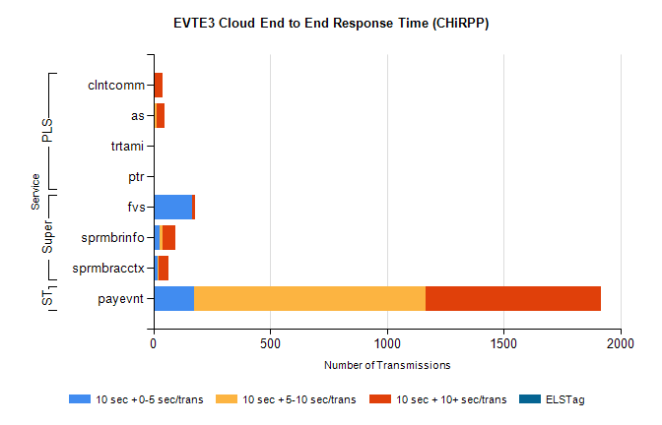
Stream | Service | 10 sec + 0-5 sec /trans | 10 sec + 5-10 sec /trans | 10 sec + >10 sec /trans | Total | % within 5 sec timing target
STP | payevnt | 174 | 992 | 749 | 2983 | 5.8%
Super | fvs | 164 | 3 | 11 | 228 | 71.9%
Super | sprmbrinfo | 28 | 10 | 57 | 105 | 27.2%
Super | sprmbracctx | 17 | 7 | 40 | 85 | 20.0%
PLS | clntcomm | 0 | 1 | 39 | 56 | 0.0%
PLS | as | 0 | 13 | 33 | 54 | 0.0%
PLS | trtami | 0 | 0 | 4 | 4 | 0.0%
PLS | ptr | 0 | 0 | 1 | 1 | 0.0%

