Transmission Timings Report Week - 5
26/01/2026 - 1/02/2026

SBR2 Cloud Production2 - Single | Bulk or Batch Requests | (SRP, BBRP & CHiRPP)

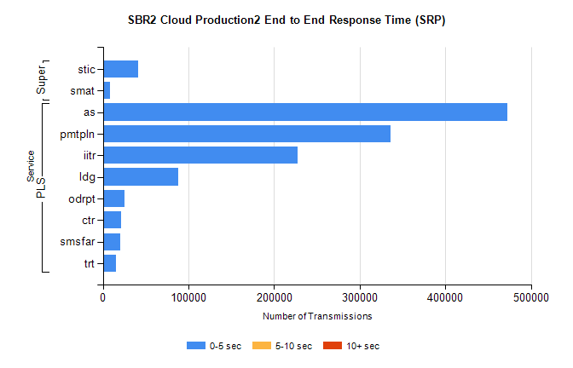
Stream | Service | 0-5 sec | 5-10 sec | >10 sec | Total | % within 5 sec timing target
PLS | as | 472302 | 0 | 0 | 472302 | 100.0%
PLS | pmtpln | 336163 | 0 | 0 | 336163 | 100.0%
PLS | iitr | 227157 | 0 | 0 | 227157 | 100.0%
PLS | ldg | 88341 | 0 | 0 | 88341 | 100.0%
PLS | odrpt | 25373 | 0 | 0 | 25373 | 100.0%
PLS | ctr | 21299 | 0 | 0 | 21299 | 100.0%
PLS | smsfar | 20795 | 0 | 0 | 20795 | 100.0%
PLS | trt | 15600 | 0 | 0 | 15600 | 100.0%
Super | stic | 41687 | 0 | 0 | 41687 | 100.0%
Super | smat | 7928 | 0 | 0 | 7928 | 100.0%

SBR2 Cloud Production2 - Single | Bulk or Batch Requests | (SRP, BBRP & CHiRPP)

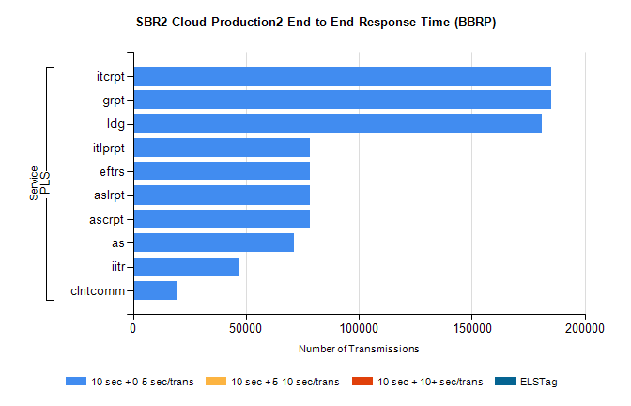
Stream | Service | 10 sec + 0-5 sec /trans | 10 sec + 5-10 sec /trans | 10 sec + >10 sec /trans | Processing Incomplete | ELStag | Total
PLS | grpt | 185173 | 0 | 0 | 0 | 0 | 185173
PLS | itcrpt | 185173 | 0 | 0 | 0 | 0 | 185173
PLS | ldg | 181050 | 0 | 0 | 0 | 0 | 181050
PLS | ascrpt | 78211 | 0 | 0 | 0 | 0 | 78211
PLS | aslrpt | 78211 | 0 | 0 | 0 | 0 | 78211
PLS | eftrs | 78211 | 0 | 0 | 0 | 0 | 78211
PLS | itlprpt | 78211 | 0 | 0 | 0 | 0 | 78211
PLS | as | 71396 | 0 | 0 | 0 | 0 | 71396
PLS | iitr | 46697 | 0 | 0 | 0 | 0 | 46697
PLS | clntcomm | 19774 | 0 | 0 | 0 | 0 | 19774

SBR2 Cloud Production2 - Single | Bulk or Batch Requests | (SRP, BBRP & CHiRPP)

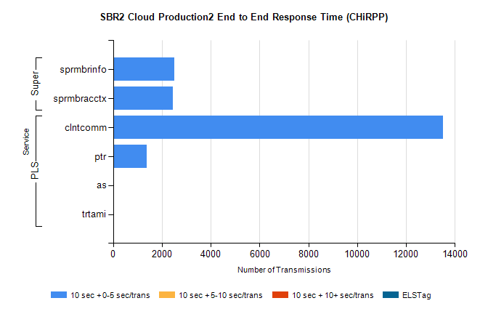
Stream | Service | 10 sec + 0-5 sec /trans | 10 sec + 5-10 sec /trans | 10 sec + >10 sec /trans | Total | % within 5 sec timing target
PLS | clntcomm | 13516 | 0 | 0 | 13516 | 100.0%
PLS | ptr | 1366 | 0 | 0 | 1366 | 100.0%
PLS | as | 30 | 0 | 0 | 30 | 100.0%
PLS | trtami | 13 | 0 | 0 | 13 | 100.0%
Super | sprmbrinfo | 2517 | 0 | 0 | 2517 | 100.0%
Super | sprmbracctx | 2459 | 0 | 0 | 2459 | 100.0%

SBR1 Production Transactions

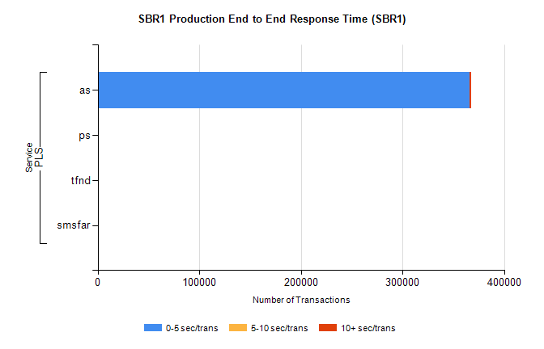
Stream | Service | 0-5 sec/trans | 5-10 sec/trans | 10+ sec/trans | Total | % within 5 sec timing target
PLS | as | 365862 | 149 | 1669 | 367680 | 99.5%
PLS | ps | 18 | 9 | 78 | 105 | 17.1%
PLS | tfnd | 35 | 20 | 4 | 59 | 59.3%
PLS | smsfar |  | 5 |  | 5 | 0.0%

